Economic, Social and Cultural Rights in the South of Scotland
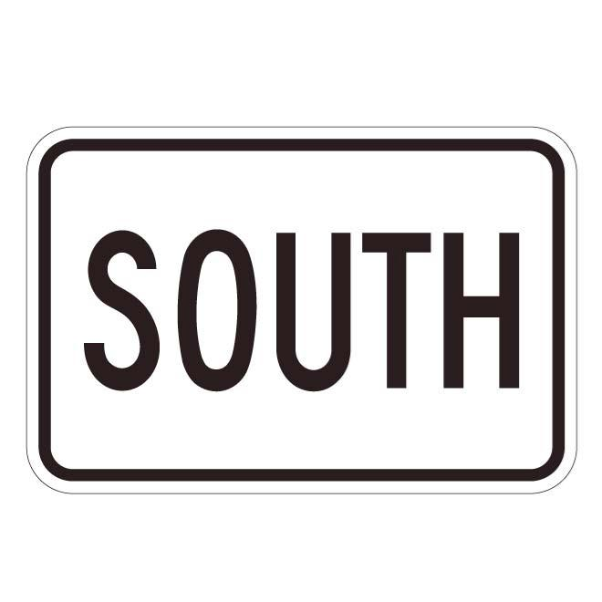

Easy Read

Report by the Scottish Human Rights Commission (SHRC) | 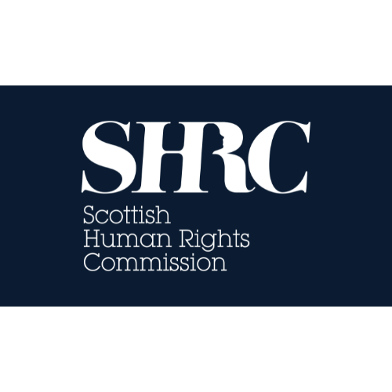

Contents page
Heading | Page number
What this report is about | Page 3
What we did | Page 5
What the report says | Page 7
What people told us | Page 8
What we think should change | Page 11

What this report is about
 | We are the Scottish Human Rights Commission. We are called SHRC for short.
 | In early 2026, we visited communities across the South of Scotland.
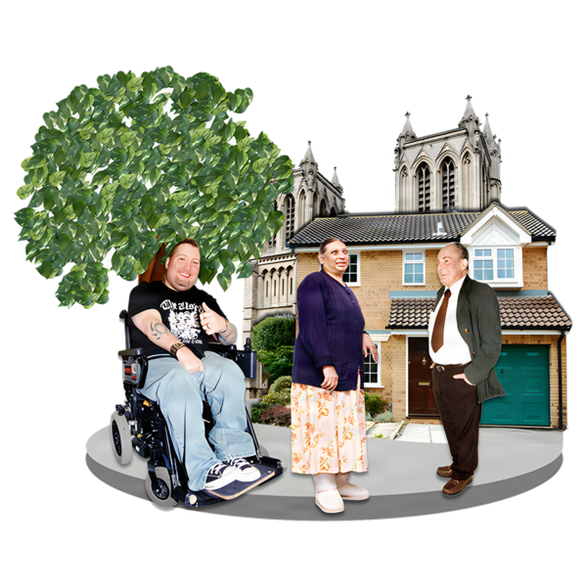 | We wanted to understand how people experience their economic, social and cultural rights in everyday life.
 | These rights include work, food, social security and housing.
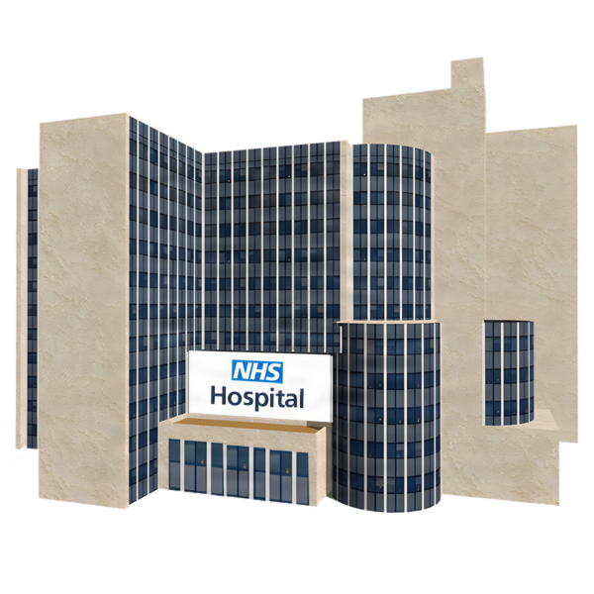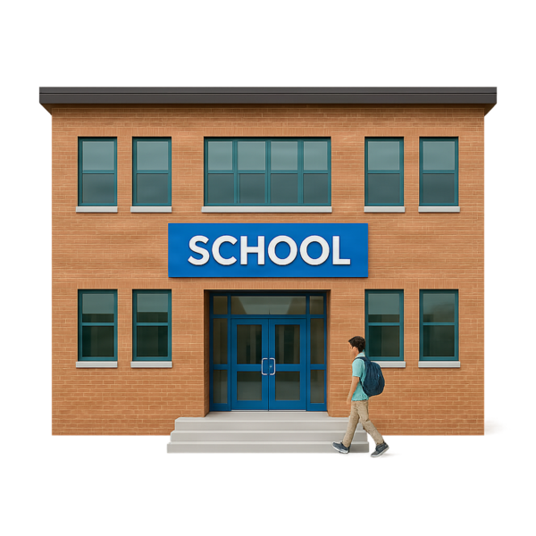 | They also include health care, social care, education and culture.
 | International law protects these rights.  It’s the Scottish Government and councils jobs to make sure people have their rights met.

What we did
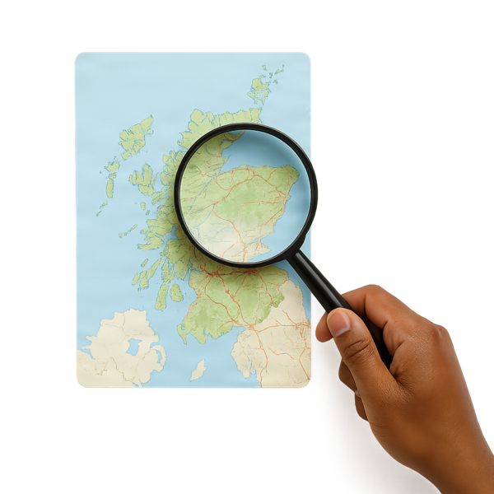 | Our work covered 8 local council areas.
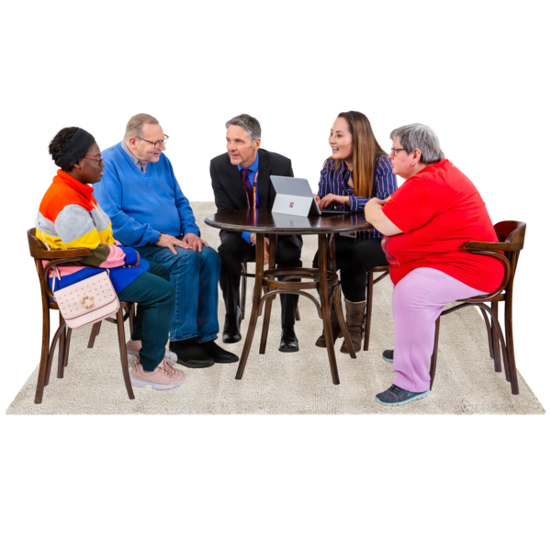 | We visited the South of Scotland. We invited people to talk to us about their lives.
 | We also asked people using an online survey.

What the report says
 | We found big challenges all the human rights we looked at.
 | Services and support were not always  - Available  - Easy to access  - Affordable  - good enough quality.
 | There is some good work happening in local areas.  But progress is not the same everywhere.
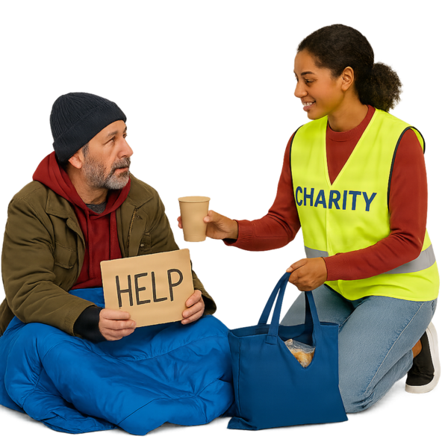 | Many good projects depend on charities and volunteers.
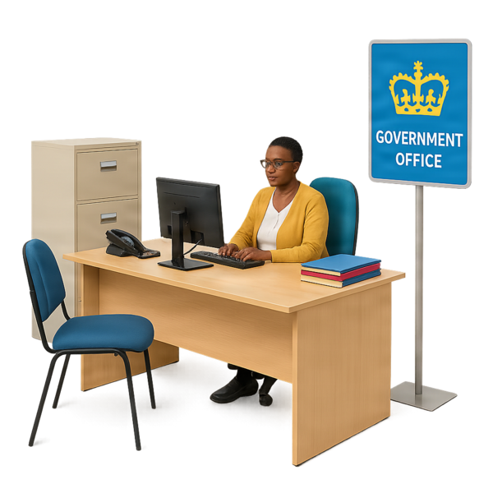 | Charities are good.  But they should not have to do the governments work for them.

What people told us
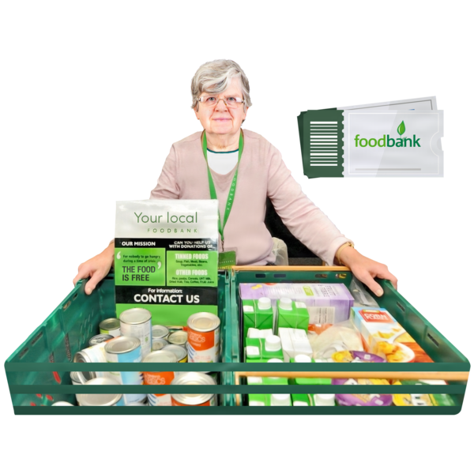 | People are struggling because costs are rising and incomes are low.  Food banks and other projects are helping. But healthy food is too expensive for some people.
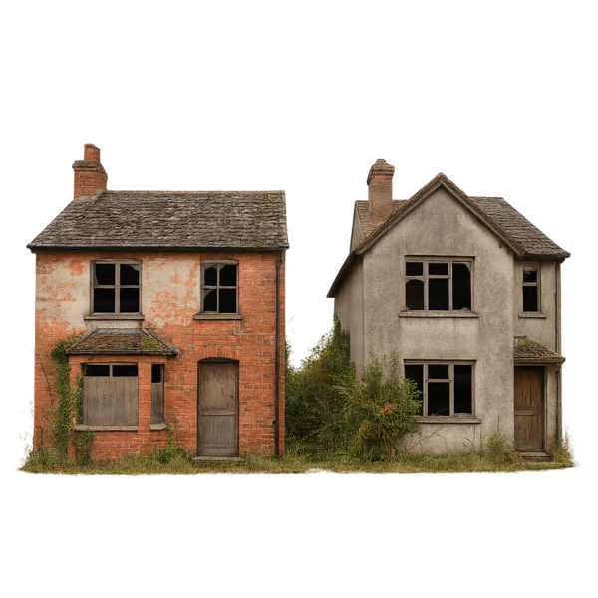 | People are worried that houses cost too much and are not good enough quality.  Too many people don’t have anywhere to live.
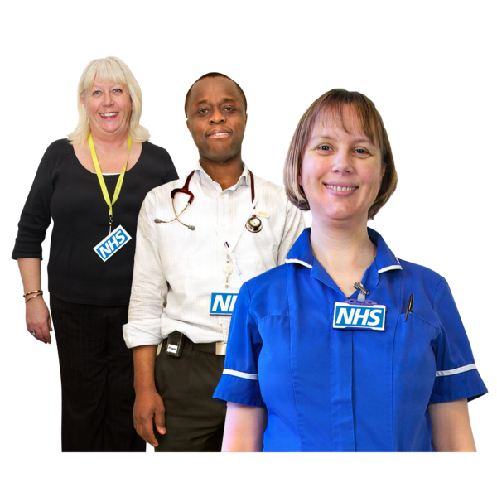  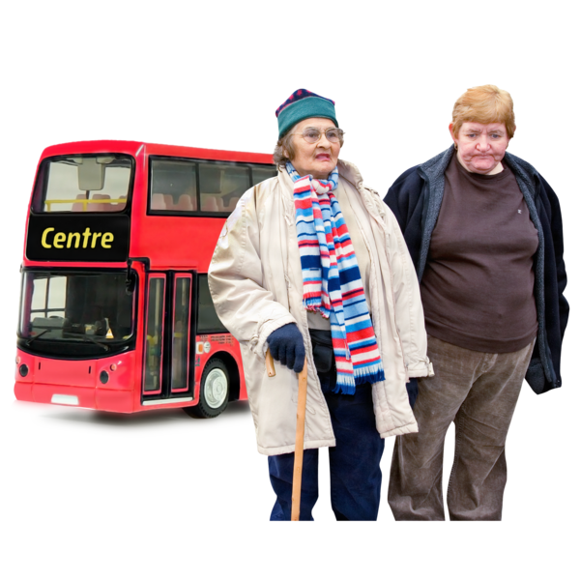 | Many people find it harder to access health services, including:  - GPs  - dentists  - mental health support  - specialist care  Travel and other costs can make free health services difficult for people to access.
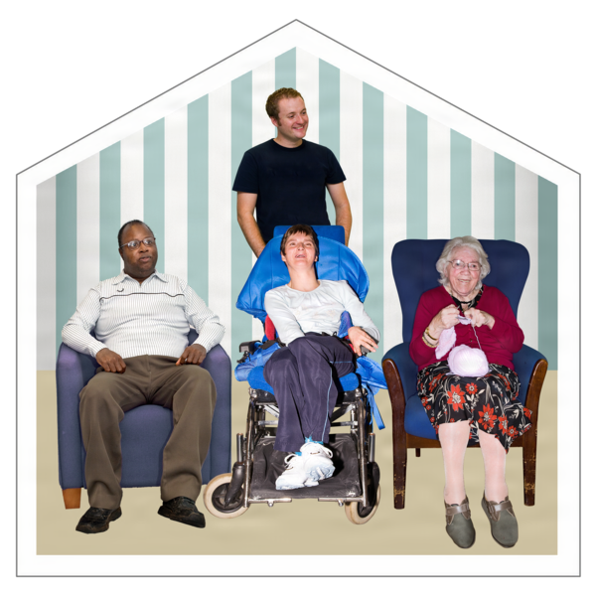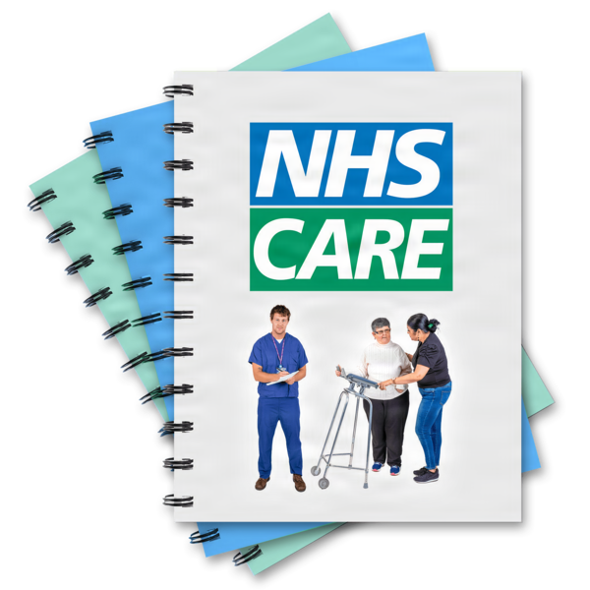 | Lots of people cannot get the social care they need.
 | Education is good for some people in the South of Scotland but not good for everyone.
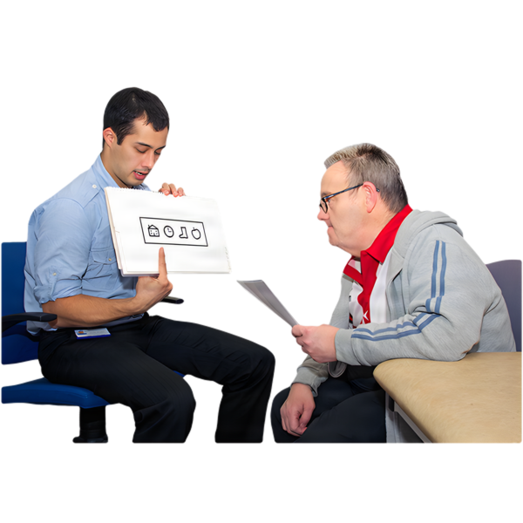 | It takes too long to get additional support for students.
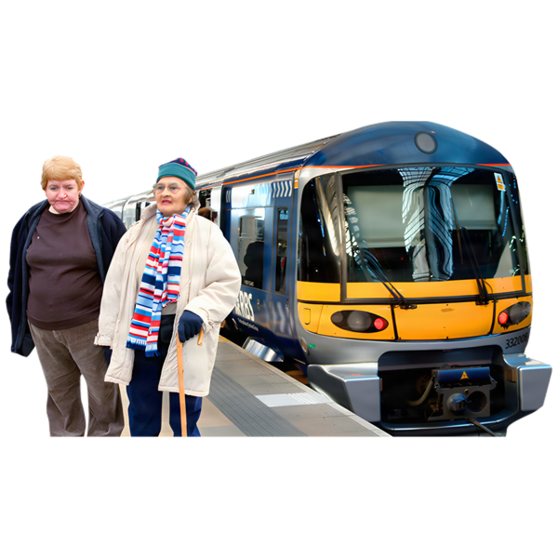 | Cultural services have got worse in many areas.  Cultural services include places like community hubs, sports clubs, and theatres.  They can cost too much and bad public transport makes them hard to get to.

What we think should change
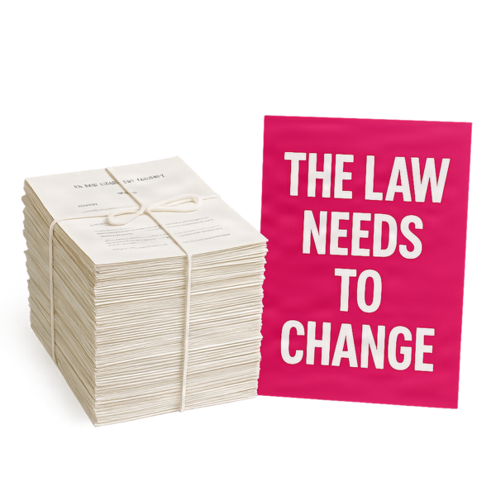 | There should be better laws to protect economic, social and cultural rights
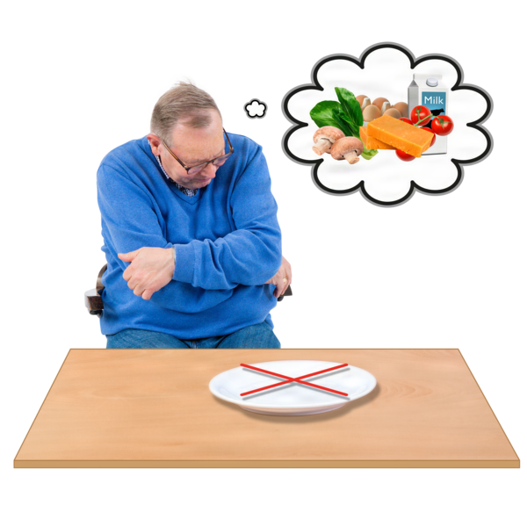 | The government should do more to stop hunger and homelessness.
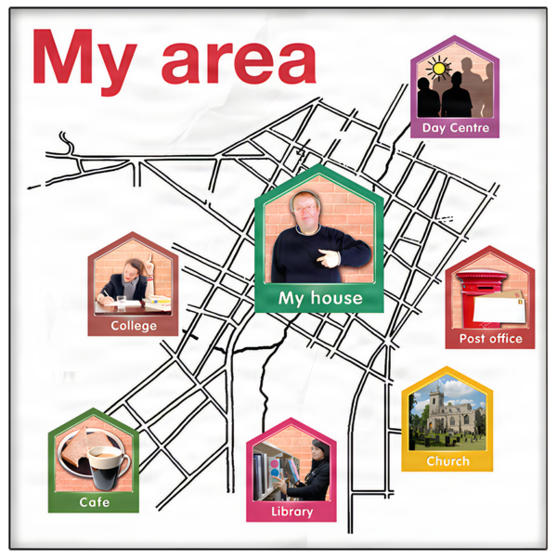 | Policies should be based on what local communities need..
 | The government should make clear plans to help people enjoy their rights.
 | The government should listen to people about what they need and use that to make services better.

