Human rights in mental health hospitals
Easy Read


 |  | 

Who we are
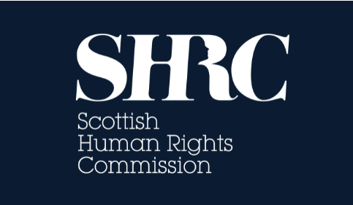 | We are the Scottish Human Rights Commission. We are called the SHRC for short.
 | Our job is to protect people’s human rights in Scotland.
 | Human rights are rights that every person has. For example, the right to be alive and the right to go to school.

What our paper is about
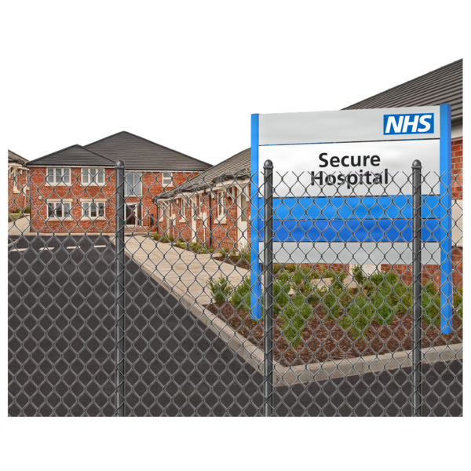 | This paper is about restrictive practices used in mental health hospitals.
 | Restrictive practices are ways that staff can stop people doing things they want to do.
 | An example of a restrictive practice is restraint.  Restraint means to hold someone’s body to stop them doing what they want, or to make them do something else. Like holding someone down on the ground.
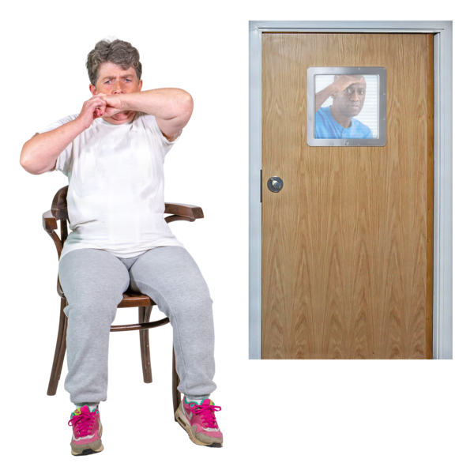 | Another restrictive practice is seclusion.  Seclusion means to keep someone away from other people.
 | In mental health hospitals, restrictive practices can be used on people to stop them from hurting themselves or other people.
 | They should only ever be used if there is no other choice.

How restrictive practices affect human rights
 | When restrictive practices are done wrong, it can stop people from having their human rights met.
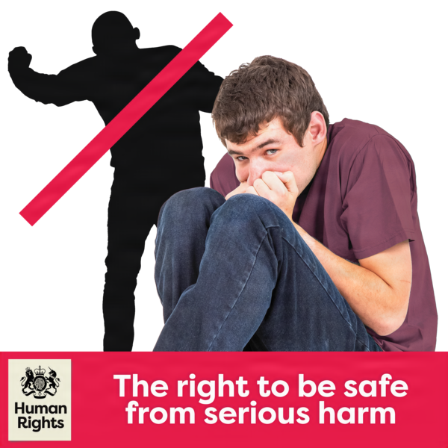 | For example, people’s right to be protected from serious harm.
 | Restrictive practices can also have an impact on people’s right to private and family life.
 | If done wrong, restrictive practices can be dangerous, so they can also impact people’s right to life.

What the law says about restrictive practices
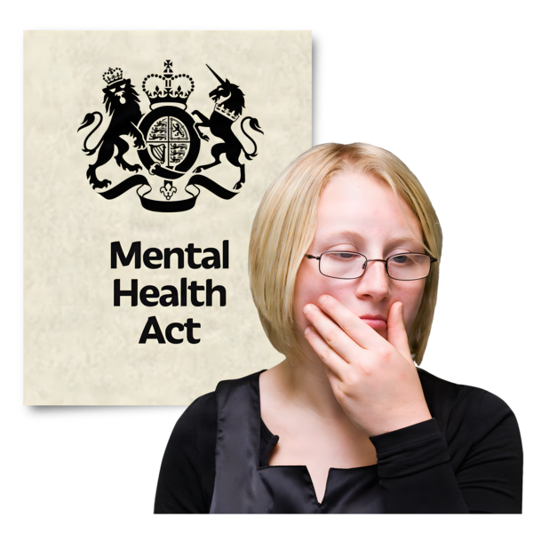 | In Scotland, the law does not say much to protect people when restrictive practices happen to them.
 | In England, there are more laws to protect people.

What the SHRC says about restrictive practices
 | The SHRC thinks we need to know more about what is happening in mental health hospitals.  Then we can know if people are protected from harm.
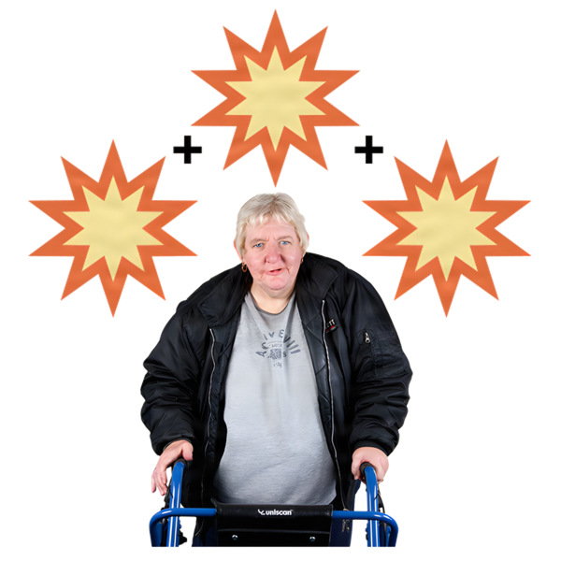    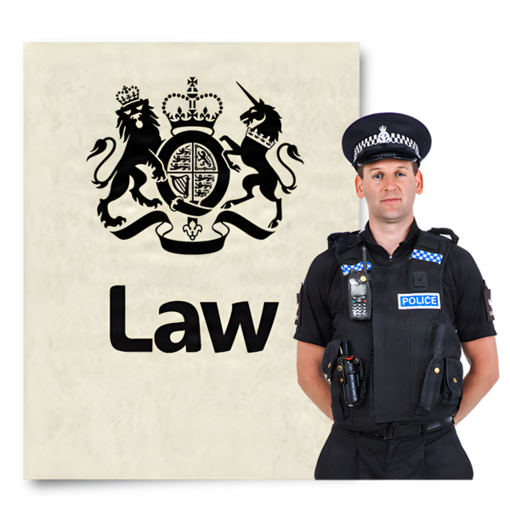   | The Scottish Government could do more to protect people. SHRC says they should:  - Find out what is really happening in mental health hospitals  - Put more laws in place  - Make sure the Mental Welfare Commission can do more when hospitals do the wrong thing.
 | SHRC is asking the Scottish Government to agree to do these things by the end of the year.

