Report on human rights for Gypsy Travellers in Scotland
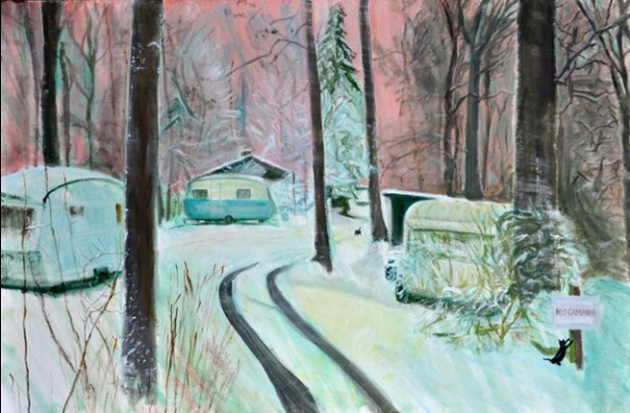

Easy Read

Report by the Scottish Human Rights Commission (SHRC) | 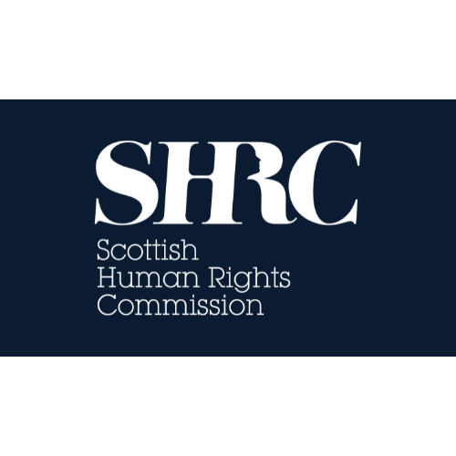

Contents page
Who we are | Page 3
What the report is about | Page 4
Why we did the report | Page 5
What the report says | Page 8
Forced assimilation | Page 9
Right to adequate housing | Page 10
Right to private and family life | Page 11
Rights to health, education and employment | Page 12
Redress and reparations | Page 13
Recommendations | Page 15

Who we are
 | We are the Scottish Human Rights Commission. We are called SHRC for short.
 | Our job is to protect people’s human rights in Scotland.
 | Human rights are rights that every person has.  For example, the right to be alive and the right to go to school.

What the report is about
The report is the SHRC’s human rights analysis of the Tinker Experiment.
“Tinker” is an offensive word used against Gypsy Travellers.
 | The ‘Tinker Experiment’ is the name for a group of laws, policies and other ways that the Scottish Government and local councils used to stop Gypsy Travellers from travelling and try to force them to become part of the settled community. The experiment started in the 1940s.
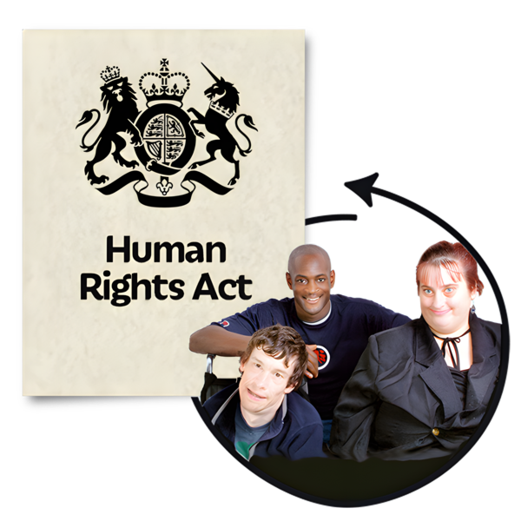 | This report looks at the human rights impacts of the Tinker Experiment by checking it against today’s human rights standards.
 | A key part of the report is victims’ own experiences.
 | The report makes 20 key findings which have been summarised in this easy read.

Why we did the report
 | Concerns about the Tinker Experiment were first raised in the Scottish Parliament in 2010.
 | Since then, victims of the Tinker Experiment have campaigned for an apology from the State.
 | In 2023, the Scottish Government paid the Third Generation Project at St Andrews University to do independent research on the Tinker Experiment.
 | Researchers at St Andrews University found that a range of organisations took part in the Tinker Experiment.
 | In June 2025, the First Minister John Swinney publicly apologised to the victims of the experiment.
In 2023, the SHRC met with victims and visited places where the experiment had happened. The victims told us about the long-term impact of forced assimilation.
Forced assimilation means to try and force people to join your culture, by stopping them from having their own.
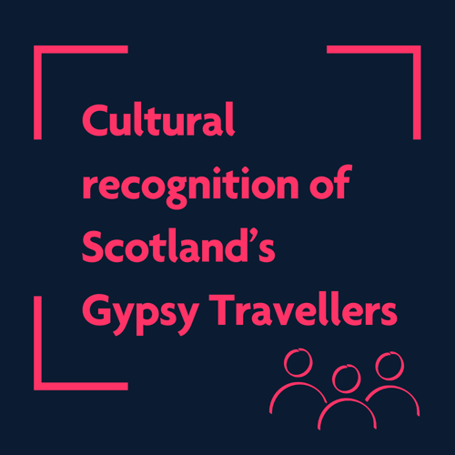 | In 2024, the SHRC began a spotlight project which focused on the human rights of Scotland’s Gypsy Travellers.
 | As part of this project the SHRC produced a report called “No man’s land”: A human rights assessment of the ‘Tinker Experiment’ and redress for its victims.

What the report says
 | In this report the SHRC have made key findings on 6 topics. These topics are  - Forced Assimilation.  - The Right to Adequate Housing.  - The Right to a Private and Family Life.  - The Rights to Health, Education and Employment.  - The Right to Cultural Life.  - Redress and Reparations.

Forced assimilation
  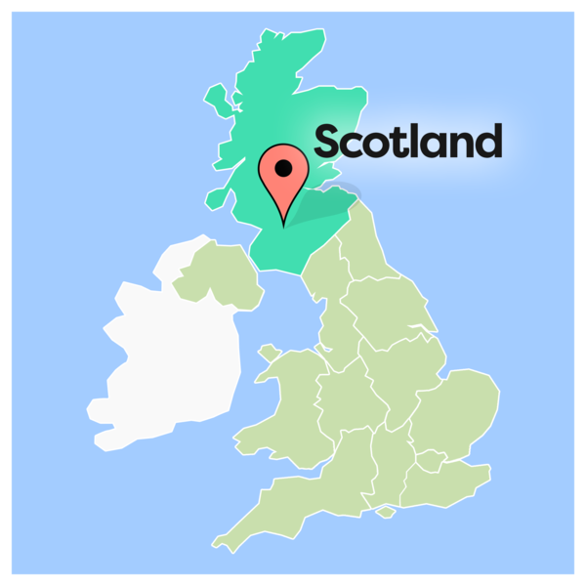 | The State forced the assimilation of Scotland’s Gypsy Travellers.  The State did this by stopping Gypsy Travellers from travelling.
 | They also removed Gypsy Traveller children from their families.
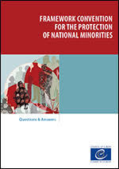 | The acts of forced assimilation carried out by the State are not in line with the Framework Convention for the Protection of National Minorities.  That means the State was not upholding human rights.

Right to adequate housing
 | In the past, the State has failed to provide Gypsy Travellers with access to good quality housing. The report found that they are still failing to do this.
 | Places where Gypsy Travellers settled are called sites.  Gypsy Traveller sites like Bobbin Mill were built with bad quality materials and did not have basic utilities like electricity.
 | By forcing Gypsy Travellers to live in bad accommodation, the State hoped that Gypsy Travellers would accept council housing so that they would become part of the settled community.
 | Today, Gypsy Traveller sites such as Bobbin Mill, Double Dykes and Tarvit Mill remain below acceptable standards.
 | Gypsy Travellers living in sub-standard sites means they are not getting the fair treatment compared to other people.

Right to private and family life
 | The State removed Gypsy Traveller children from their families to stop there from being too many people living at Bobbin Mill.  Taking children away from their parents goes against the human right to family life.
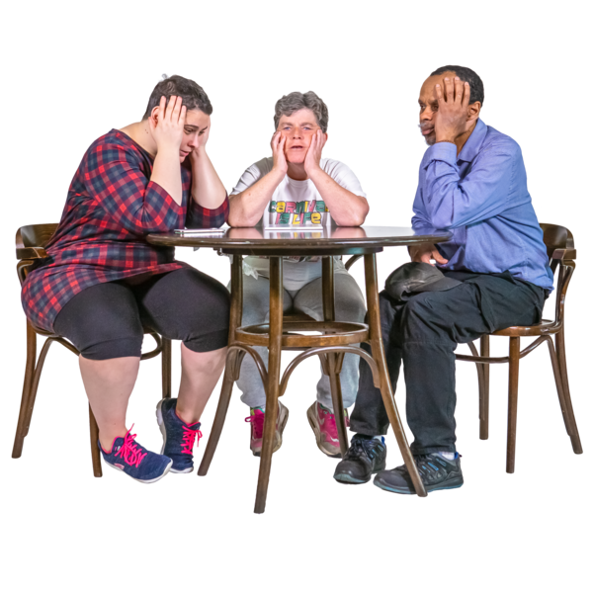 | Gypsy Travellers were threatened to have their children removed. This put pressure on families to assimilate.
 | Gypsy Traveller children where placed in children’s homes like Kippen House.

Rights to health, education and employment
 | Living in poor accommodation and being forced to give up travelling made Gypsy Travellers less healthy and made it harder for them to go to school and get good jobs.

Redress and reparations
 | The SHRC says that Gypsy Traveller should have redress and reparations.  Redress is a process make something wrong right by giving a solution.  Reparations are a way of making it up to the people who have been wronged, for example giving them money.
 | Gypsy Travellers have asked for apologies, financial compensation, investment in culture, and improvements in accommodation.
 | The SHRC thinks that the apology the Scottish Government gave Gypsy Travellers in 2025 does not meet human rights standards.
 | Other groups have had different experiences of receiving apologies from the State.

Recommendations
 | The SHRC thinks that Gypsy Travellers and victims of the ‘Tinker Experiment’ should get transformative reparations from the State.
 | Transformative reparations means that victims should lead in designing and shaping their reparations.
 | Transformative reparations also means:  - Victims should be able to say what reparations they want  - The State should review laws that still cause Gypsy Travellers harm.  - The State should recognise what happened to the victims.  - The State should make sure any reparations process does not cause victims any more harm.
 | To make sure transformative reparations happen the SHRC think that the State should make sure that:
 | - Victims and families get financial compensation
 | There is better accommodation for victims and Gypsy Travellers and investment in Gypsy Traveller culture and empowerment.
 | - The State gives more apologies to victims
 | - There is more work to find out about what happened to Gypsy Traveller children who were removed from their families.
 | - Laws and policies change to make sure the harms to Gypsy Travellers stop.
 | - Everyone can get equal access to justice by following guidance from the United Nations.

