State of the Nation 2025
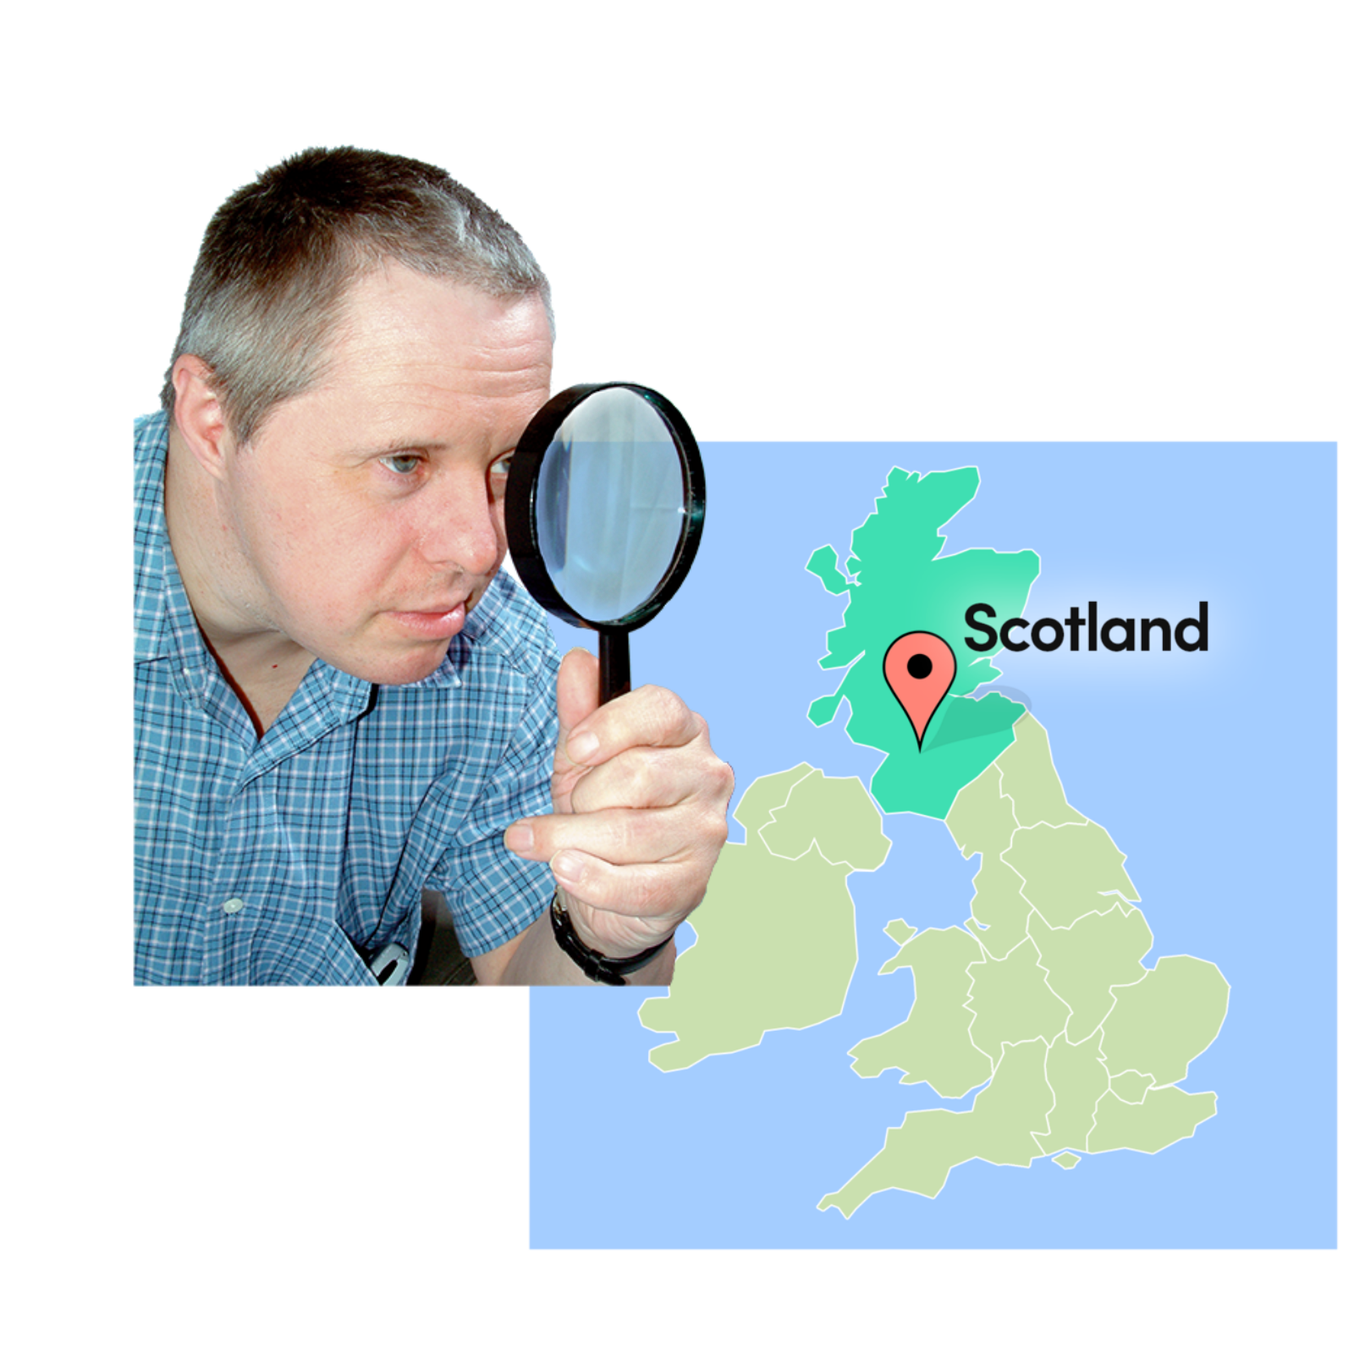

Easy Read
Report by the Scottish Human Rights Commission (SHRC) | 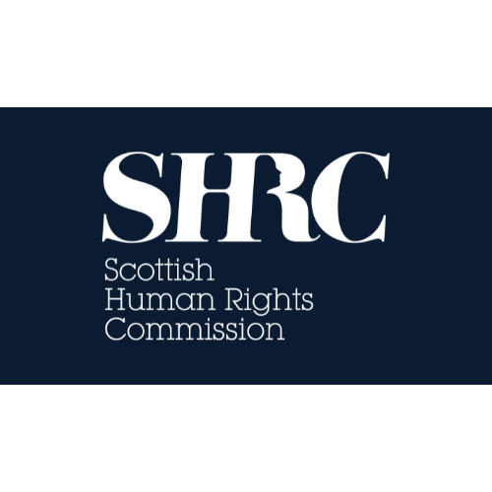


Contents page
Who we are | Page 4
What this report is about | Page 5
What economic, social and cultural rights are | Page 7
Why ESC rights matter | Page 9
Ten key problems in Scotland | Page 10
Real-life stories | Page 15
Why it matters for everyone | Page 17

Who we are
 | We are the Scottish Human Rights Commission. We are called SHRC for short.
 | Our job is to protect people’s human rights in Scotland.
 | Human rights are rights that every person has. For example, the right to be alive and the right to go to school.

What this report is about
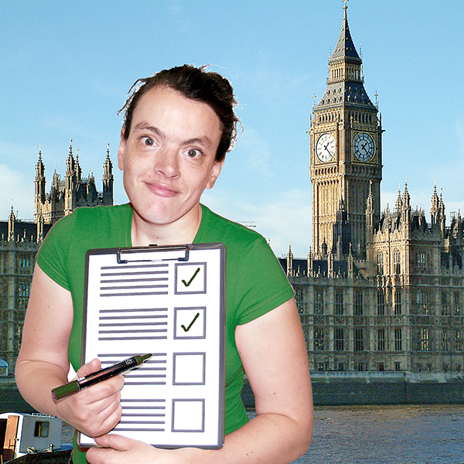 | This report looks at how well Scotland is meeting Economic, Social and Cultural Rights.  This is sometimes shortened to ‘ESC rights.’
 | ESC rights are the rights that enable us to live with dignity.  Dignity means that everyone is respected and valued as a person.
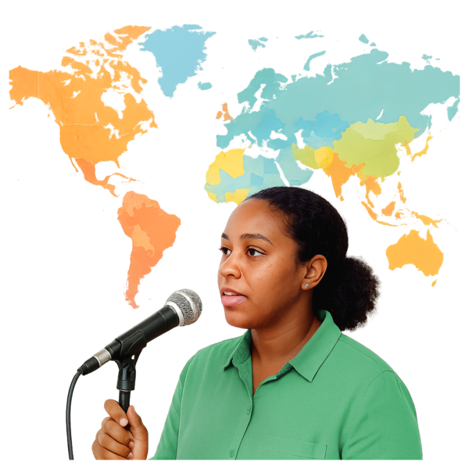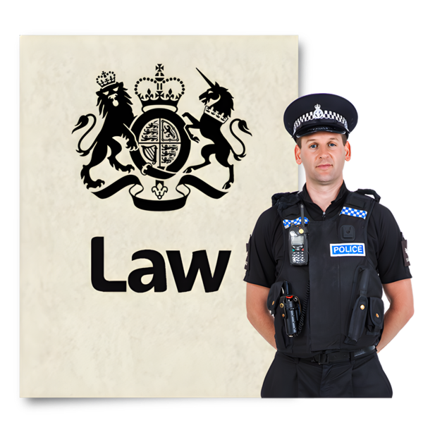 | These rights are protected under international law.  This means Governments have promised to protect these rights.
 | Many people in Scotland feel their ESC rights are not being met in Scotland.

What economic, social and cultural rights are
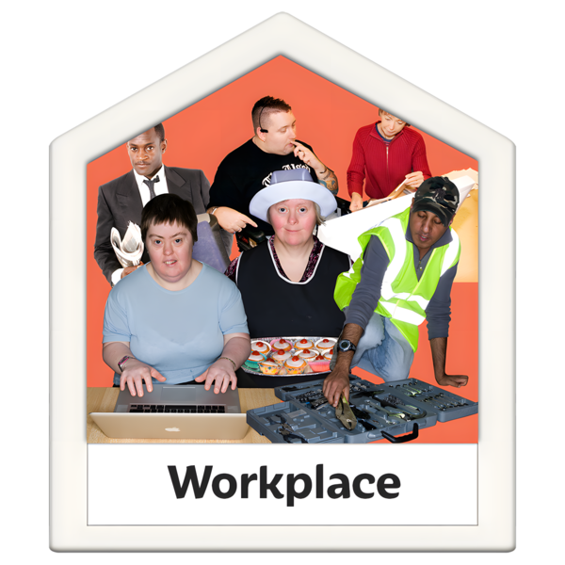 | ESC rights include:  - The right to work and fair conditions.
 | - The right to social security or benefits.
 | - The right to an adequate standard of living—housing, food, water, clothing.
 | - The right to health
 | - The right to education, including to go to school.
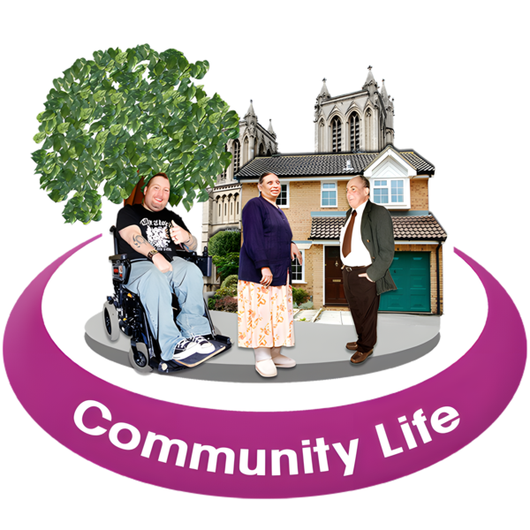 | The right to take part in cultural life.  Cultural life includes being included in community, taking part in art and culture or playing sports.
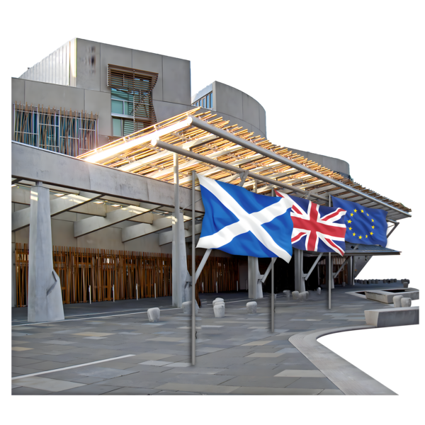 | It is the Scottish Parliament’s job to make these rights real in law and everyday life.

Why ESC rights matter
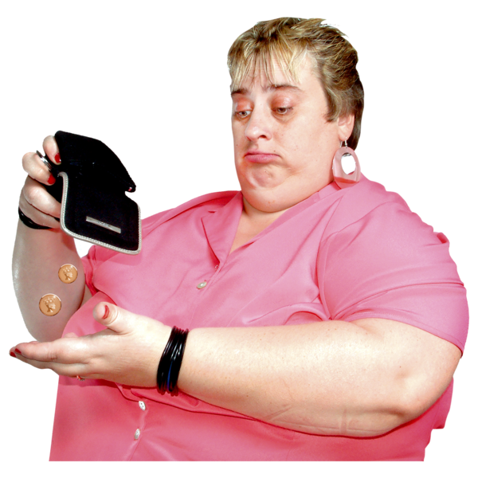 | If people cannot afford food, heat their homes, or access healthcare, their human rights are being denied.
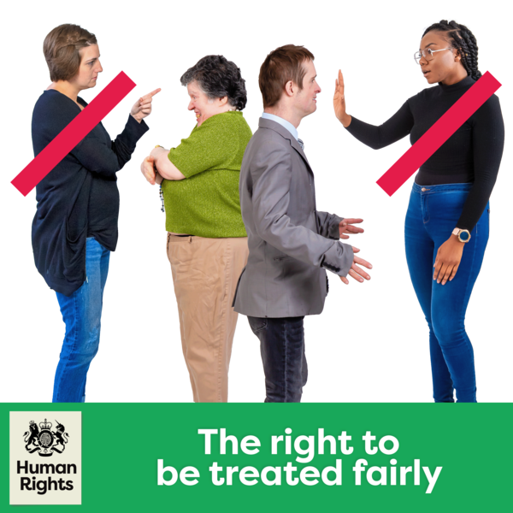 | This affects everyone, but it can be worse for some people, like disabled people, carers, women, and people living in poverty.
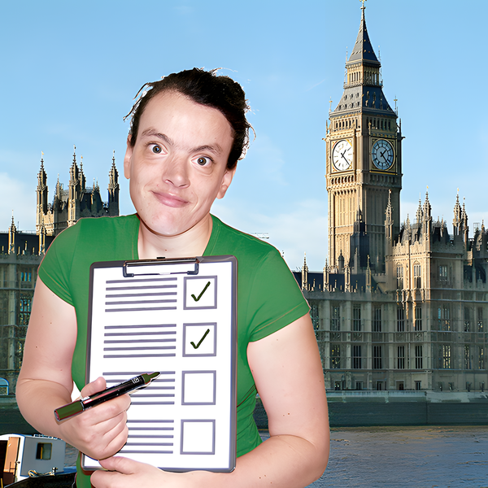 | The government has a duty in law to follow ESC rights.

Ten key problems in Scotland
 | The report highlights problems with ESC rights in Scotland.
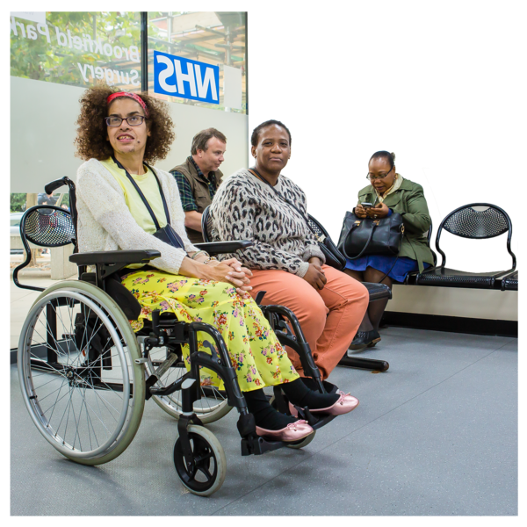 | - Healthcare gaps  There are long waits for healthcare. Some people have to travel a long way to access healthcare, especially in rural areas. Some healthcare is not good quality.
 | - Support for independent living  Many people with learning disabilities and autism can’t access housing and support.  People have a right to live independently.
 | - Disability benefits  Benefits should cover the extra costs of being disabled, but many people do not get enough money to pay for their needs.
 | - Housing crisis  Many people are homeless or live in poor-quality homes because housing is so expensive.
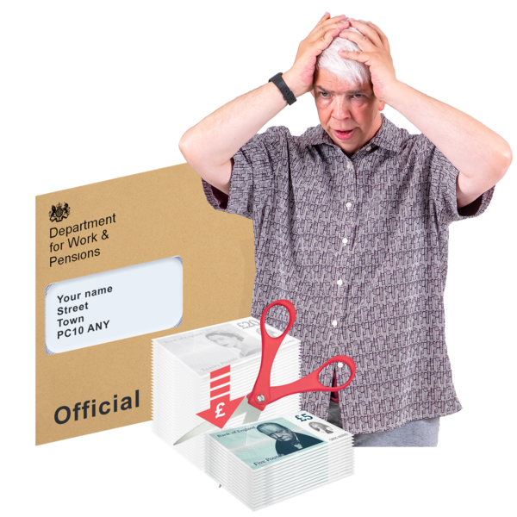 | - Unfair social security system  The benefits system does not treat people fairly.
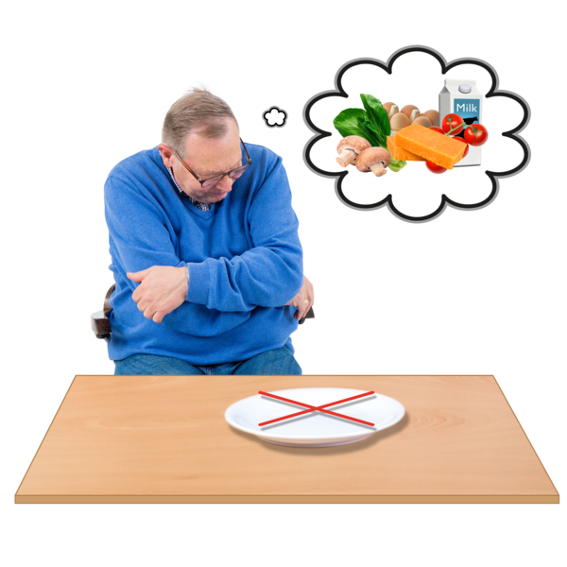 | - Food insecurity  People need to use food banks or go hungry because they cannot afford to buy healthy food.
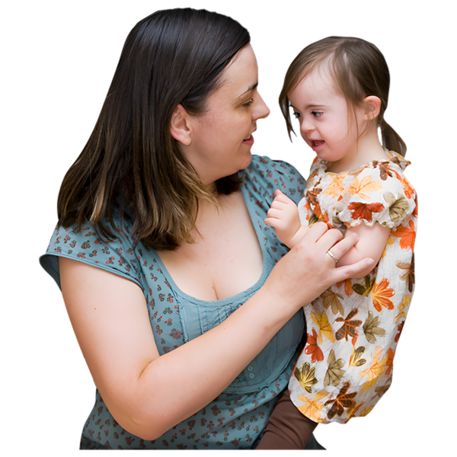 | - Unpaid care  Women are doing most of the care for children, disabled people and older adults without enough support.
 | - People cannot afford the things they need  Many people cannot afford the cost of energy, heating, and basic goods.
 | - No easy way to access justice  ESC rights are not part of the Scottish law and there is not enough funding for advocacy services. This means people cannot access justice when things go wrong
 | - Budgets don’t match needs  The government does not pay enough attention to human rights when they decide what to spend on on housing, health, social security and food.

Real-life stories
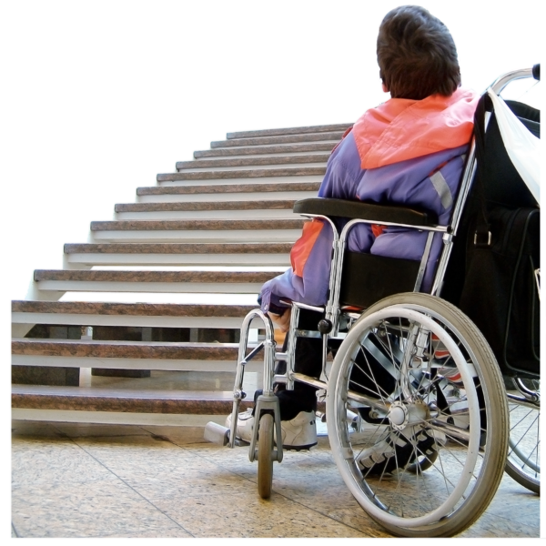 | Derek: A disabled man fought for years to get accessible housing and support to work.
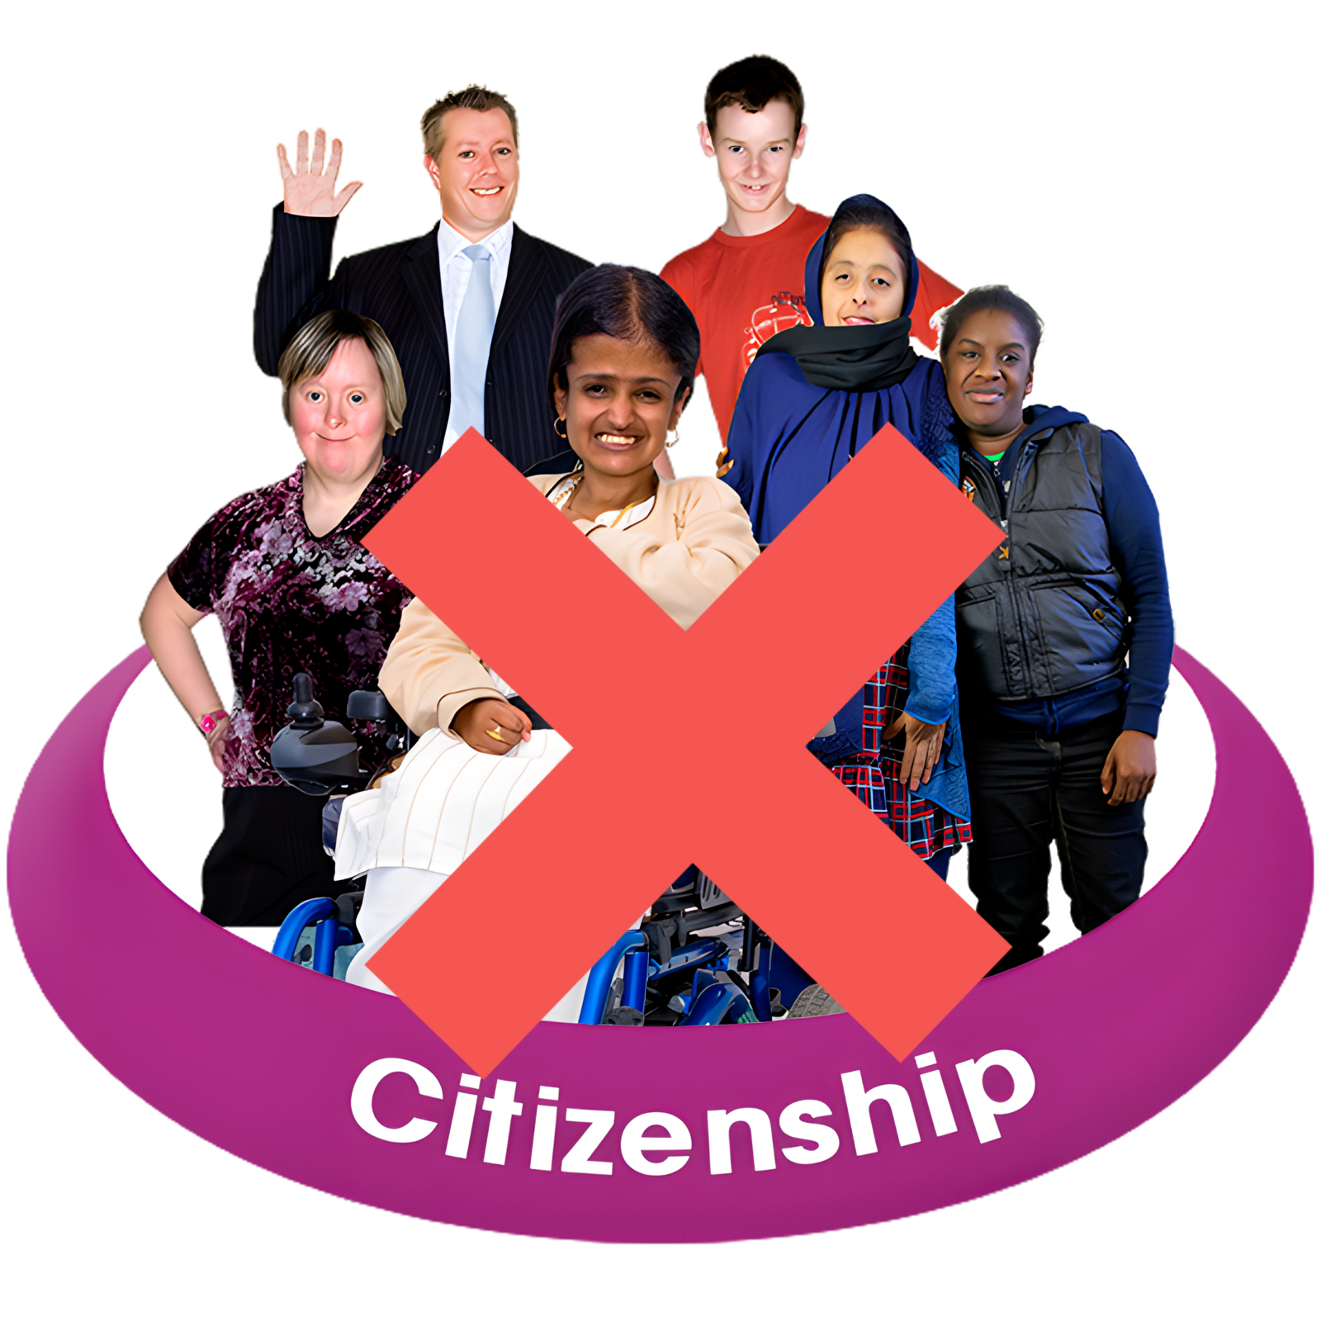 | Nada: An asylum seeker living in overcrowded housing with her family, waiting years for citizenship.
 | Anne: As activist campaigning for the right to affordable food for her community.
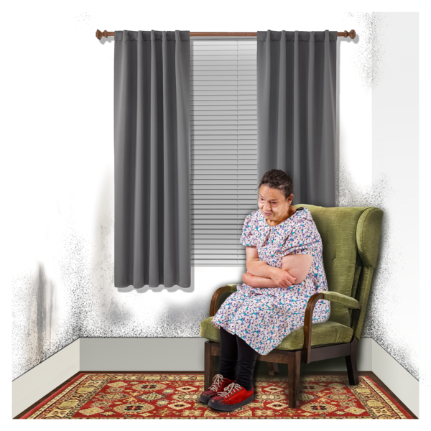 | Shamus: A Scottish Gypsy Traveller living in inadequate conditions, denied cultural rights.
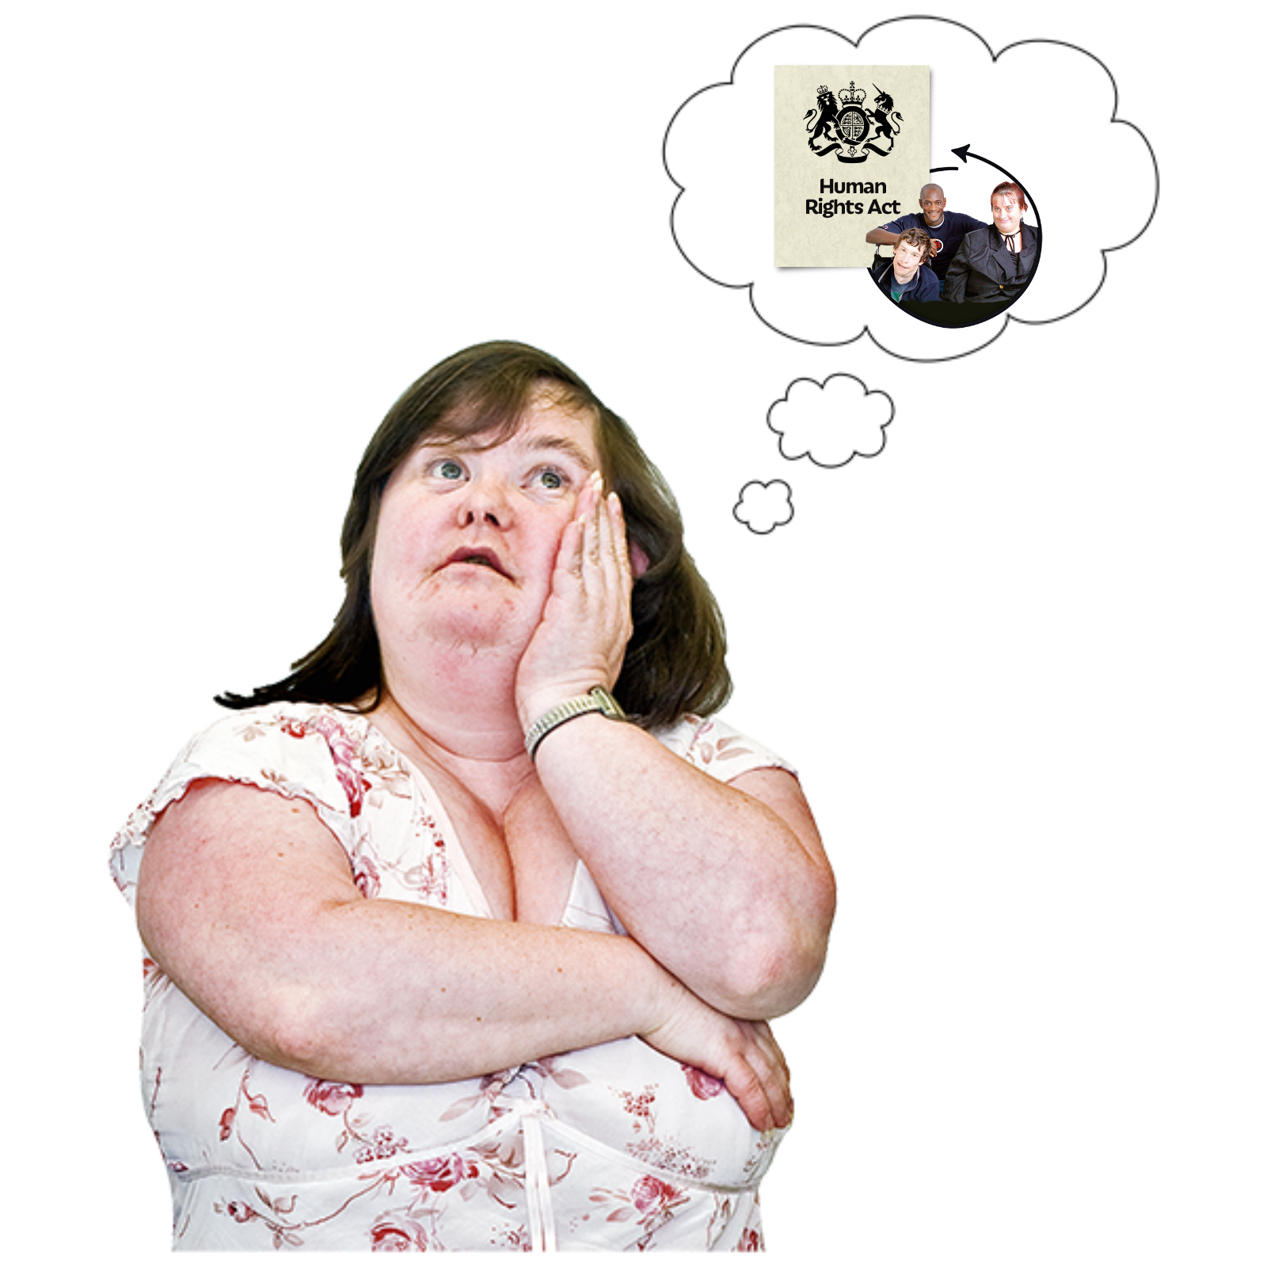 | These stories show how rights failures affect daily life.

Why it matters for everyone
 | Human rights are for all of us. These rules are always there, even in tough times.
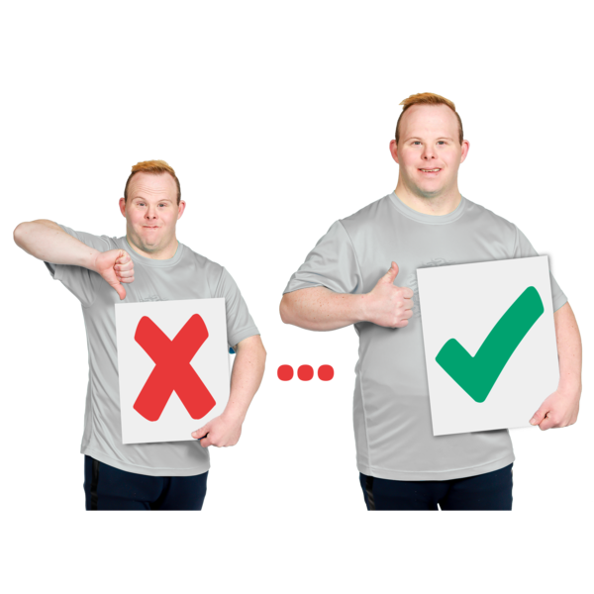 | Making these rights real will reduce poverty, improve health, and make our communities stronger.
 | The Scottish Parliament and Government must act now to embed human rights in law, policy, and budgets.

