Annual Report 2024-2025
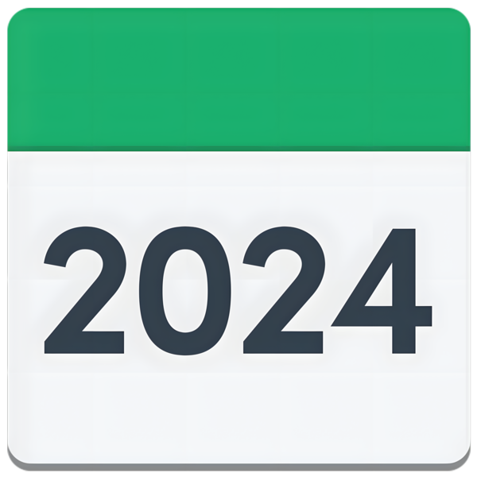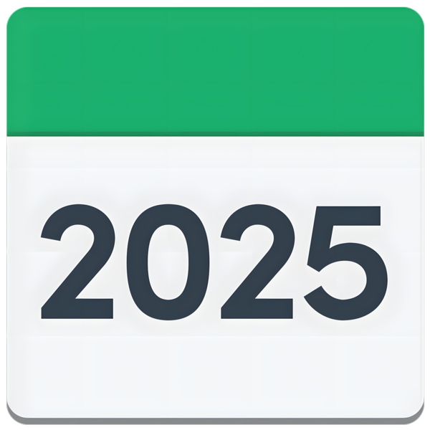
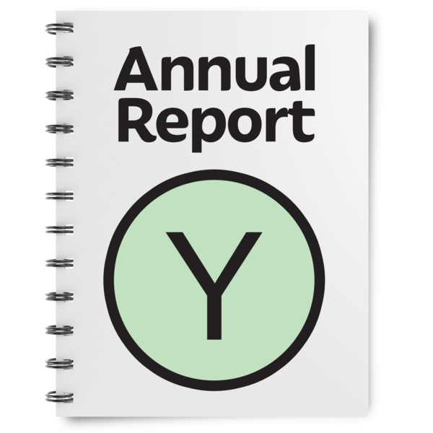

Easy Read

Report by the Scottish Human Rights Commission (SHRC) | 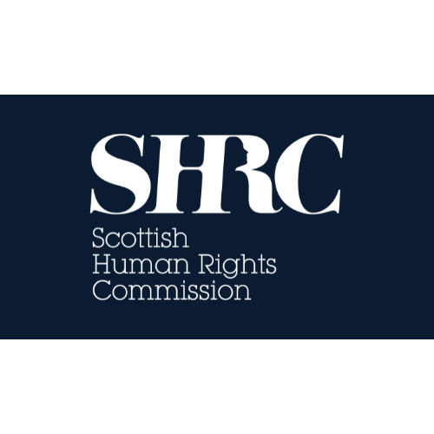

Contents page
Heading |  | Page number
Who we are |  | Page 4
The work we do |  | Page 5
Our main work in 2024 to 2025 |  | Page 7
Key reports |  | Page 9
Making our work better |  | Page 11
Budget |  | Page 12
Find out more |  | Page 13

Who we are
 | We are the Scottish Human Rights Commission. We are called SHRC for short.
 | We make sure everyone’s human rights are respected in Scotland.
 | We are independent and work with people, communities and public authorities.

The work we do
 | We monitor human rights in Scotland. Monitor means to look closely and see if anything changes.
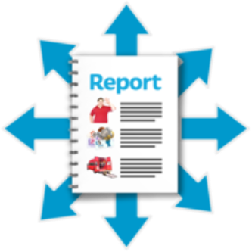 | We write reports about how to make human rights stronger so that people have better lives.  We send the reports to  - the Scottish Parliament  - the United Nations  - the Council of Europe
 | We can suggest changes to laws and policies. Policies are written documents that say the rules about how we do things.
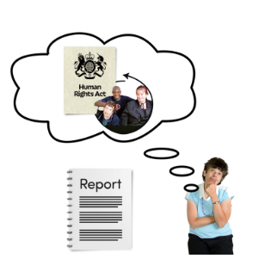 | Our reports also help people to learn more about human rights.
 | This report is a summary of our work from April 2024 to March 2025.

Our main work in 2024 to 2025
 | We worked across Scotland and internationally to make human rights stronger, fairer, and better understood.
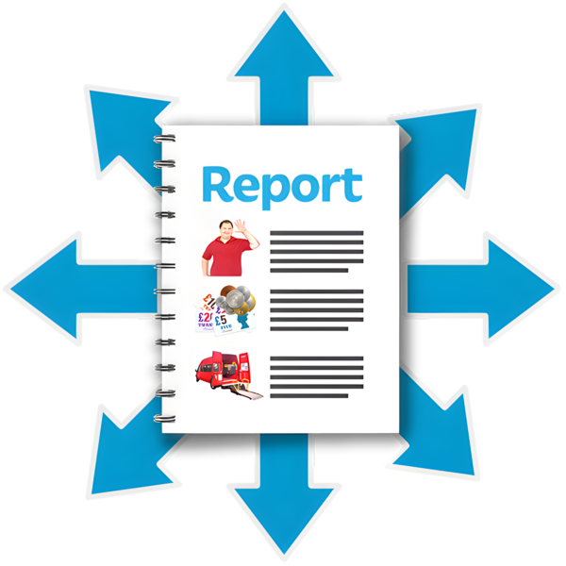 | We found problems with housing, healthcare, transport, and food access in the Highlands and Islands.  To find out more about this, read our Easy Read report on the Highlands and Islands.
 | We found that many disabled and autistic people still live in institutions.  To find out more about that, read our Easy Read report called Moving People from Institutions into the community.
 | We checked human rights conditions in prisons and hospitals and shared ideas on how to make it better.
 | We are working on a report about the human rights of Scottish Gypsy Travellers.

Key reports
 | We shared our first State of the Nation report. We wrote it to help the Scottish Parliament to do their job protecting rights.
 | We now have new powers to act on children’s rights.
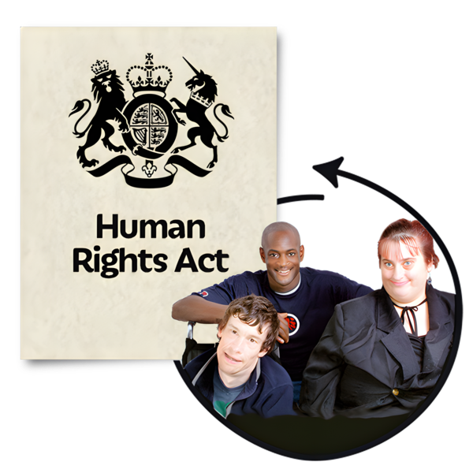 | We are disappointed the new Human Rights Bill has been delayed until 2026.

Making our work better
 | We made stronger rules and clearer systems inside the organisation.
 | We made our work more accessible, including making new British Sign Language and participation plans.
 | We welcomed new members Rosemary Agnew and Aaliya Seyal.

Budget
 | Our budget this year was almost one and a half million and we used a little less than that.

Find out more

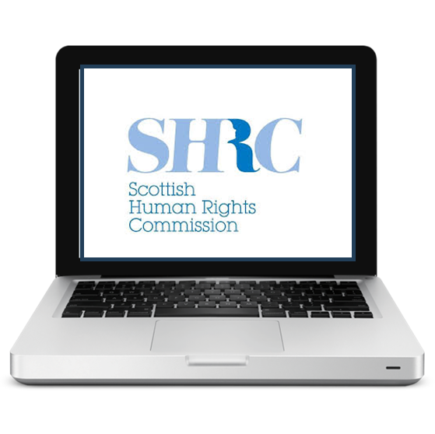 | You can find out more on our website:  www.scottishhumanrights.com
 | email: hello@scottishhumanrights.com

