# Access to Justice: Prison Complaints

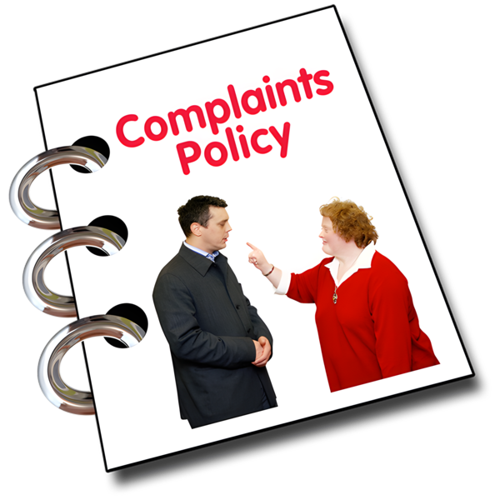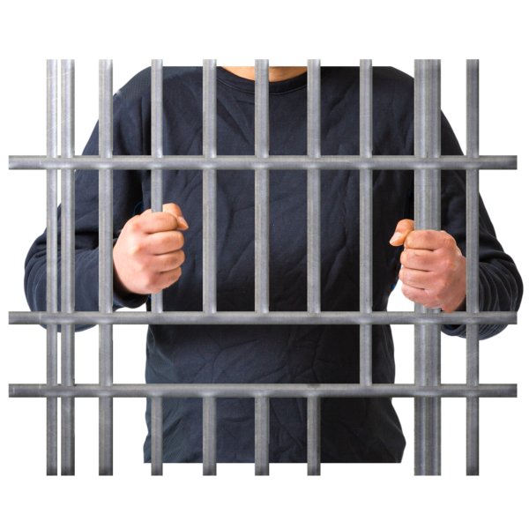

# Easy Read

|  |  |
| --- | --- |
| Report by the Scottish Human Rights Commission (SHRC) |  |

Easy Read logo of woman smiling and reading an Easy Read
 

## Contents page

|  |  |
| --- | --- |
| Who we are | Page 3 |
| What our project is about | Page 4 |
| Our Research | Page 6 |
| What our research found | Page 8 |
| What we want to happen next | Page 9 |

## Who we are

|  |  |
| --- | --- |
| Scottish Human Rights Commission logo | We are the Scottish Human Rights Commission. We are called SHRC for short. |
| People in a circle around a woman protecting her underneath a Scotland flag. | Our job is to protect people’s human rights in Scotland. |
| Woman pointing to herself | Human rights are rights that every person has. For example, the right to be alive and the right to go to school. |

## What our project is about

|  |  |
| --- | --- |
| A booklet called 'Guidance' showing an image of a sign post pointing in lots of different directions. A woman stands in front of it. It looks like she is thinking.A woman on the telephone | We are running a project which looks at where people go for help when they have a problem with their human rights. |
| A magnifying glass. Looking through the magnifying glass you can see different groups of people | We are focusing on why getting help for human rights and making complaints might be harder for some groups of people. |
| Picture of the Human Rights Act legislation with people next to itA person behind prison bars holding on to the bars | One of the groups that find it harder to get help for human rights is people who are in prison. |
| A picture of a prison officer standing in front of a prison cell. The officer has their arms crossed.  A  Rule Book with symbols of a tick and a cross on the front | The government and people in charge of prisons are responsible for making sure that people in prison’s rights are protected. |
| A person who doesn't look happy. In front of her is a picture of a complaints policy. She has thought bubbles showing  images of food and health related itemsFood in a thought bubbleA first aid kit in a thought bubbleA complaints policy booklet | Anyone in prison should be able to make a complaint if they have a problem.  They might want to make a complaint about things like their health, food, property, conditions in prison like the size of their cell or the way that staff treat them. |
| A man standing in front of a large list where every item is ticked. The man is holding a thumbs up sign | The complaints system is very important for making sure everyone is safe in prison.  It is also important for making sure prisons can learn from mistakes and get better. |

## Our Research

|  |  |
| --- | --- |
| A man presenting his laptop. On his laptop is an image of a report with the title 'Our Research Report'An image of a written report | We did some research about how the prison complaints system works.  We wrote a report about what we found. |
| A man sitting at t desk being interviewed by two people | We did desk research and we also interviewed professional people who know about prisons and complaints. |
| An image of a man looking at a piece of paper which says 'checklist'.  He is reading the items on the checklistAn image of  a question mark | We looked at how the system works now and looked at if it meets human rights standards on complaints. |
| The logo for the Council of Europe | We used standards published by the European Committee Against Torture (This is called CPT for short).  These standards are a checklist for making sure complaints are handled properly. |

## What our research found

|  |  |
| --- | --- |
| A complaints policy bookletA person with a hand on their head looking confused. There is a question mark next to the man. In front of the man is a picture of a complaints policy. | We found that the prisons complaints process is complex.  Some prisoners find the complaints process hard to understand.  Some people in prison do not have access to help and advice to make a complaint. |
| A magnifying glass with a graph  A hand with thumb down | We also found that there is not enough data available about complaints.  Not having enough data makes it hard to keep track of what is happening in prisons. |
| A person holding a clipboard and a pen  On the clip board is a check list. Several items have a cross next to them.  The woman looks unhappy. | We think the prison complaints system in Scotland does not meet human rights standards on access to justice. The system should be made better. |

## What we want to happen next

|  |  |
| --- | --- |
| Green tickAn image of the Human Rights Act legislation with three people next to itAn image of a complaints policy | We think the Scottish Government and people in charge of prisons should change the way the complaints system in prisons operates.  The complaints system should be based on human rights. |
| Logos for the Scottish Human Rights Commission and the Citizens Advice BureauAn image of a report called 'Your Rights Under the Scottish Prison Rules'. | We worked with Parkhead Citizens Advice Bureau to make a guide to help people in prison to understand what their rights are under the Scottish Prison Rules.  We think the people in charge of prisons should give the guide to all prisoners and translate it into other languages.  We also think they should make an Easy Read version of the guide so that everyone can understand it. |
| A hand showing the thumbs up signA magnifying glass with a graph | We think there should be more clear data on prison complaints. |