# Invitation for free webinars on human rights in Scotland

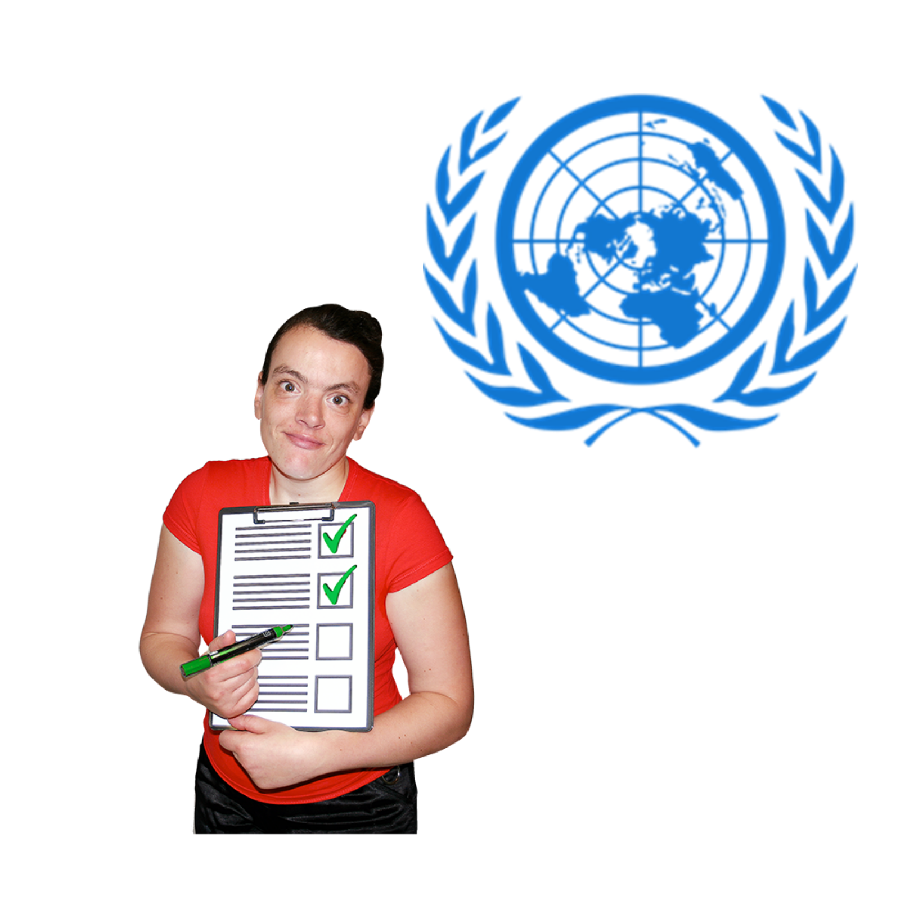

# Easy Read

Easy Read logo of woman smiling and reading an Easy Read
 

## Contents page

|  |  |
| --- | --- |
| Who we are | Page 3 |
| What we are doing | Page 4 |
| When the events are happening | Page 6 |
| How to let us know if you want to come | Page 9 |
| What happens after the webinars | Page 11 |

## Who we are

|  |  |
| --- | --- |
| Scottish Human Rights Commission logo | We are the Scottish Human Rights Commission. We are called SHRC for short. |
| People in a circle around a woman protecting her underneath a Scotland flag. | Our job is to protect people’s human rights in Scotland. |
| Woman pointing to herself | Human rights are rights that every person has. For example, the right to be alive and the right to go to school. |

## What we are doing

|  |  |
| --- | --- |
| A woman smiles while participating in a virtual meeting on a tablet. | The SHRC is inviting you to some online events (webinars) to learn more about human rights at the United Nations. |
| The United Nations logo. A map of the world in a circle with two olive branches wrapping around. | The United Nations is where countries and human rights experts work together to protect human rights. |
| Woman speaking into a microphone in front of a colourful world map.Map highlighting Scotland in the UK with a location pin and label. | We want to talk to you about how the United Nations' work can help us in Scotland. |
| A pile of cash crossed out to show there is no moneyA woman smiles while participating in a virtual meeting on a tablet. | The webinars will be online and free to attend.  We will be using Teams for the webinar and will send you information on how to use it. |

## When the events are happening

|  |  |
| --- | --- |
| Modern classroom with eight desks and blue chairs arranged in two rows facing a large white projection screen.A healthcare professional taking the blood pressure of a smiling patient. | Webinar 1 is about Economic, Social and Cultural rights, like the right to go to school, the right to be healthy and the right to get benefits like the Adult Disability Payment. |
| Calendar icon showing September 9.A round clock and a digital display both showing 12:00. | Webinar 1 is on Tuesday 9 September 2025 from 12pm to 1pm. |
| Three people, one in a wheelchair, stand beside a 'UN Disability Rights' sign. | Webinar 2 is about Disabled Peoples' Human Rights |
| Calendar displaying September 23A round clock and a digital display both showing 12:00. | Webinar 2 is on Tuesday 23 September 2025 from 12pm to 1pm. |
| A photograph of Asian woman being harassed by two white people. Above her text reads 'no racism'. Below this image a UN flag with a blue background and a map of the globe encircled by olive branches reads 'Convention on the Elimination of all forms discrimination. Next to this is part of a photograph of two hands shaking, one with Black skin and one with white skin. | Webinar 3 is about Human Rights and Racism |
| Calendar displaying September 30A round clock and a digital display both showing 12:00. | Webinar 3 is on Tuesday 30 September 2025 from 12pm to 1pm. |
| A joyful woman in a wheelchair with arms outstretched, a red heart with an EKG line behind her, and a banner reading 'The right to life'. | Webinar 4 is about Civil and Political Rights, like the right to life and the right to not to be tortured. |
| Digital calendar icon showing October 7A round clock and a digital display both showing 12:00. | Webinar 4 is on Tuesday 7 October 2025 from 12pm to 1pm. |

## How to let us know you want to come

|  |  |
| --- | --- |
| Laptop screen displaying an envelope with the word 'e-mail' on a blue background. | If you want to come, you can email us at [events@scottishhumanrights.com](mailto:events@scottishhumanrights.com) to tell us.  British Sign Language (BSL) users can contact us by using [Contact Scotland BSL](https://contactscotland-bsl.org/). |
| Hand holding a pen over an open planner showing dates in August 2009. | You can come to all the events or just some of them. |
| Woman in a wheelchair on a ramp pointing at an 'easy read' document with a stopwatch and speech bubble. | We will ask you about anything we can do to make it easier for you to come. |
| Person with glasses in a purple cardigan holding out their hand with the word 'Rights' below. | There will be a British Sign Language (BSL) interpreter at all the events. |
| Laptop screen displaying an envelope with the word 'e-mail' on a blue background. | If you want to come, we will send you an email with information on how to join the webinar. |

## What happens after the webinars

|  |  |
| --- | --- |
| A diverse group of five people engaged in discussion around a round table. | We want to keep talking to people about how United Nations human rights work can make human rights in Scotland better. |
|  | We are planning a workshop to bring people who work on human rights together to learn from each other. |
| Calendar icon displaying November 26Analog clock and digital display both showing 10:00. | The workshop is in Glasgow on Wednesday 26 November 2025 from 10am to 3pm. |
| Hands typing on a virtual keyboard composing a new email message. | Contact us if you would like to come to the workshop or if you want to get involved in a different way.  You can email us at [events@scottishhumanrights.com](mailto:events@scottishhumanrights.com) to talk about how we can work with you.  British Sign Language (BSL) users can contact us by using [Contact Scotland BSL](https://contactscotland-bsl.org/). |