# Operational Plan 2024 to 2025

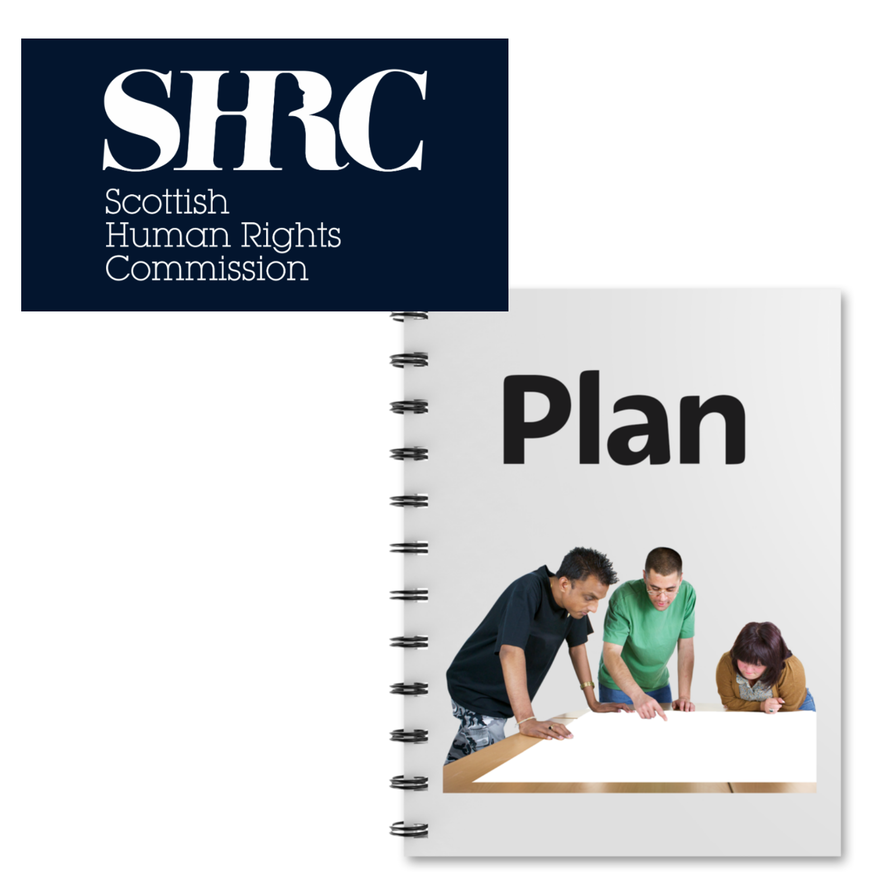

# Easy Read



## Contents

| **Heading** | **Page number** |
| --- | --- |
| What this plan is about | Page 2 |
| Who we are | Page 3 |
| What we will do this year | Page 5 |
| How to find out more about the plan | Page 8 |

## What this plan is about

|  |  |
| --- | --- |
| Scottish Human Rights Commission Plan | This is the Scottish Human Rights Commission’s **Operational** Plan. Operational means what we do every day. |
| Human rights in Scotland | The plan explains what we will do this year for human rights in Scotland. |
| Woman pointing to herself | Human rights are rights that every person has. For example, the right to be alive and the right to get an education. |
| 2024 to 2025 | The plan covers April 2024 to March 2025. |

## Who we are

|  |  |  |
| --- | --- | --- |
| Scottish Human Rights Commission logo | We are the SHRC which means the Scottish Human Rights Commission. | |
| People in a circle around a woman protecting her underneath a Scotland flag. | Our job is to protect people’s human rights in Scotland. | |
| Report with arrows going in lots of directions | We write reports about human rights and send them to   * the Scottish Parliament * the United Nations * the Council of Europe | |
| Law and policy | We can suggest changes to laws and **policies**. Policies are written documents that say the rules about how we do things. | |
| Report and a person thinking about human rights | Our reports also help people to learn more about human rights. | |
| A group of people with their hands up and speech bubbles around them | We believe people should take part in decisions about their rights. |

## What we will do this year

|  |  |
| --- | --- |
| A report next to a person behind bars in prison | We will look at human rights in prisons and publish a report about it. |
| Report next to a woman giving advice on the phone. In her speech bubble is signposts pointing to support,  help and advice. | We will look at how to get help when you have a human rights problem in Scotland. We will publish a report about it. |
| A group of disabled people next to the document on UN Disability Rights | We will look at the human rights of people with learning disabilities and autism in Scotland. |
| Woman reading a report. On the report is a crossed out hospital and a person at home with a tick. | We will publish a report about disabled people's rights to live independently. |
| Report next to a map of the UK with Scotland highlighted. A hand is pointing to the top of the map where the Highlands and Islands are | We will publish a report about human rights in the Highlands and Islands. |
| Two people at a whiteboard and a work policy with ticks | We will also train our staff and create new policies to help us do our job. |
| Calculator | The Scottish Parliament gives us money to help us do our job and to pay our staff team. This year they gave us around 1 and a half million pounds. |

## How to find out more about the plan

|  |  |
| --- | --- |
| Email on a laptop | If you would like to know more about our plans for 2024 to 2025, you can email us at [hello@scottishhumanrights.com](mailto:hello@scottishhumanrights.com) |