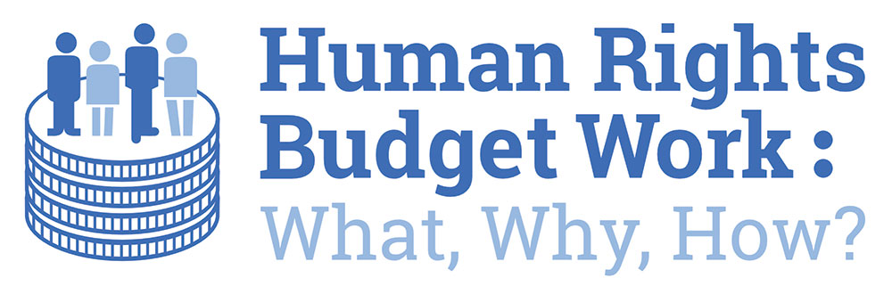

**Open Budget Survey 2023**

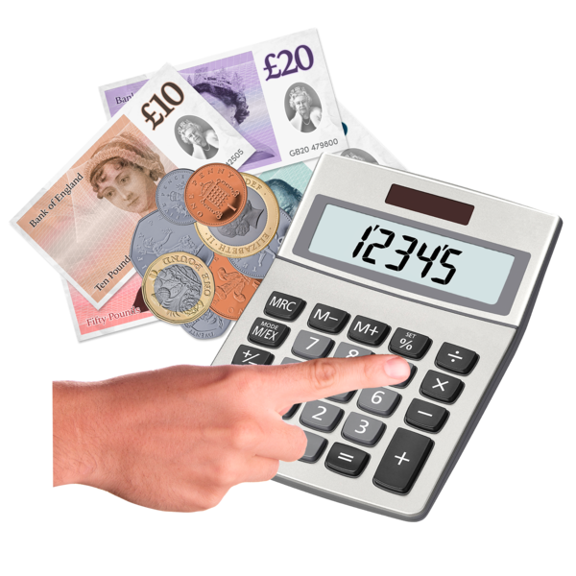

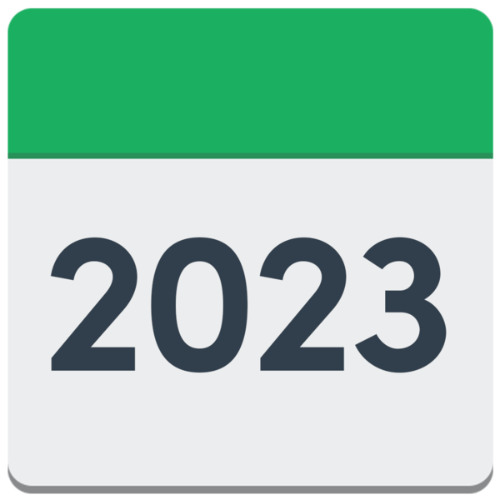

**Easy Read**

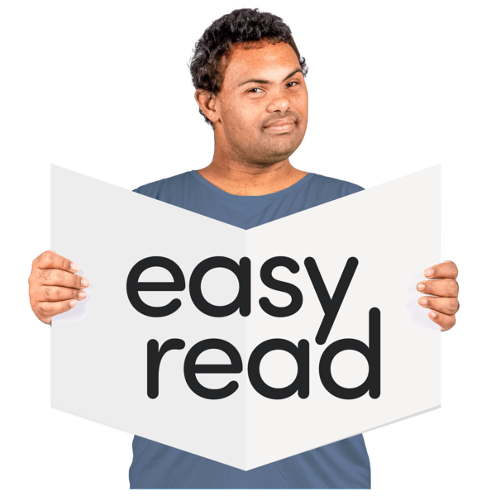



## 

## Published with thanks to the Health and Social Care Alliance Scotland (the ALLIANCE) ALLIANCE Health and Social Care ALLIANCE Scotland written in black text with 'people at the centre' written below in purple text

## What are human rights?

|  |  |
| --- | --- |
| a group of people next to the Human Rights Act law document | Human rights are freedoms that are protected in law.  They make sure we are treated:   * fairly * with **dignity**   **Dignity** means being treated in a way that is as thoughtful as possible.  The Scottish Human Rights Commission works in Scotland to:   * look after people’s rights * check that the Scottish Government and its organisations are looking after people’s rights |
| 2 groups of people meeting and talking | This report is part of a Human Rights Budget Work project made by:   * the Scottish Human Rights Commission * the Health and Social Care ALLIANCE * and university partners |

## What is the Open Budget Survey? (OBS)

|  |  |
| --- | --- |
| money - coins and notes - and a finger pushing buttons on a calculator, above a plan documenta thinking man with a thumbs up and thumbs down in thought bubbles above his head | A **budget** is a plan for how money will be spent.  It is important to spend money in good ways on what matters.  This is done well when governments give the public:   * information * ways to take part in making decisions about how the money is spent |
| a thinking woman with a green tick and red cross in a thought bubble above her head | The Open Budget Survey checks:   * **transparency** - being honest, clear and open, and making sure the public can easily get budget information * **public participation** - ways for the public to take part in the national budget process * **budget oversight** - ways to check that money is being spent well |
| a world map, money - coins and notes - and a finger pushing buttons on a calculator, and the year 2021 on a calendar page with a red arrow pointing to the year 2022 on a calendar page | This is the 9th Open Budget Survey.  It covers 125 countries in all parts of the world.  This report has scores for Scotland based on the Scottish Budget 2021 to 2022.    It shows how things have changed since the OBS 2019 which was based on the Scottish Budget of 2017 to 2018. |

## Transparency

|  |  |
| --- | --- |
| a woman writing on a list of conditions, next to a large green tick | The Open Budget Index is a score from 0 to 100 about transparency, given to each country in the survey. |
| a man looking closely at something and a woman writing information down | This is based on the answers to 109 questions that look at 8 important budget documents to check:   * if they are online in good time * if they have all the information that is needed |
| a woman giving the thumbs up and holding a clipboard with a green tick on it | A transparency score of 61 or more shows that a country is publishing enough material to give the public budget information.  In this document, **publishing** means putting it online. |
| a man holding a computer tablet with a score of 60 on the screena smiling woman giving the thumbs up in front of the Scottish Saltire flag | Scotland has a transparency score of 60.  This tells us that the Scottish Budget 2021-22 only shared some information, and not enough.  This is called 'limited information'.  Scotland is doing better than **average**.  **Average** means the middle score for all the countries. |

## 

## What changed in OBS 2023 from OBS 2019?

|  |  |
| --- | --- |
| the year 2019 on a calendar page with a red arrow pointing to a score of 41the year 2023 on a calendar page with a red arrow pointing to a score of 60 | In 2019 Scotland scored 41 for transparency.  In 2023 Scotland scored 60 for transparency.  This means Scotland is doing better now. |
| A person holding an Easy Read document, in front of a computer with the ScotGov logo on the screen | Scotland has shared more budget information by:   * publishing a **citizen’s budget**   A **citizen’s budget** presents the main budget information in a clear and accessible way.   * publishing a **mid-year review**   The **mid-year review** checks what the government is spending money on compared to the plans of the original budget.  **Mid-year** means 6 months into a financial year - usually September. |
| money - coins and notes - and a finger pushing buttons on a calculatorA person in a suit thinking about money  a target with a black arrow pointing to the centrea group of diverse peopleMonths on calendar pages | * publishing good or better information on:   + exactly where money has come from that is not from taxes   + sharing more details about what we think we will spend and what we may have spent already   + our aims and targets   + information about how policies might change the lives of some groups of people - especially those who have more challenges in life   + a budget **timetable** – when things will happen |
| a frowning man holding a checklist with red crosses on itdocuments with a red line through it | Things that have not gone well are:   * it has taken a long time to get some information online * some financial information and documents that were provided in 2017 and 2018 have not be available for this report |

## Transparency recommendations – what we think should happen

|  |  |
| --- | --- |
| A person looking at his watch next to documentA person giving a thumbs up next to a list with green ticks on it and the year 2019 on a calendar page, with a red line through the image | * write and publish a **pre-budget** statement and **in-year reports** on time   **In-year reports** are short monthly reports that show how well a country is doing in spending their budget.  **Pre-budget** means before the budget has happened.  This was a recommendation from 2019 that has still not happened. |
| a thinking woman with a green tick and a red cross in a thought bubble above her head | * do **impact assessments** and share any changes to the budget when they happen   An **impact assessment** checks how policies will affect people. |
| a complicated document with a red cross over it, next to an Easy Read document with a green tick over itA computer with the ScotGov logo on the screen, next to months on calendar pagesa group of people standing in a line holding a document in front of them | * publish a more accessible version at the same time as each main document   This was a recommendation from 2019 that has still not happened.   * make a better document that shows when all budget documents will be published   This should be on a webpage with all other budget documents.  The same information should be collected for each budget year so it is easy to compare.   * make sure the draft budget and supporting documents like mid-year reports have enough information |
| an interpreter talking to a woman, next to speech bubbles with different languages in them Website Link on a computer screen | * make budget information in accessible, simple formats and different languages   Include community groups in this.   * all budget documents should have **weblinks** to other budget documents.   A **weblink** is a word or sentence in blue text that can be clicked on to take you to another document. |

## Public participation – taking part

|  |  |
| --- | --- |
| 2 groups of people meeting and talking | It is important that the public can take part in the budget process.  This shows how the public want the government to get and spend its money. |
| 2 people looking at a document | The OBS uses 18 different ways to check how the public can be involved in the different stages of the budget process. |
| **43**  **20** | In 2019 Scotland’s public participation score was 20.  In 2023 its score was 43.  This means the 2021 to 2022 Scottish Budget still does not have many ways for the public to take part in the budget process. |
|  | Only a few countries got better at public participation.  Scotland is one of them. |

## What changed in OBS 2023 from OBS 2019?

|  |  |
| --- | --- |
| Easy Read Logo 2 | The main reason for the better score is because an accessible document was written called ‘Your Scotland, Your Finances: 2021 to 2022 Scottish Budget. |
| Scottish Parliament | Scotland could get more people taking part by:   * writing and sharing accessible versions of all the main budget documents   More must be done to make sure people have access to information before decisions are made.   * be clear about the way that information is shared between Cabinet Ministers and Parliamentary Committees   The information that is shared should be in one place online that is easy to access. |
| Working Together ServicesShare Information 1 | * work with the public more after the early budget stages * give better feedback and accessible information to people who work with Parliamentary Committees |
| Assessment FinancialLaw Human RightsWorking Together Services | Good progress was made by Audit Scotland since OBS 2019 on ways for the public to give information to **audits**.  An **audit** looks at financial records to make sure they are correct.  Audit Scotland did a check to understand how they make sure human rights are protected in their work.  This has supported them to understand why it is important for the public to give information to their audits. |

## Recommendations on public participation

|  |  |
| --- | --- |
| a smiling man holding an Easy Read documentWebsite Link on a computer screen | * make a more accessible version of each of the main documents   This was a recommendation from 2019 that has still not happened.   * documents that are published before the budget should include links for how to be part of the budget process |
| a group of people in an online meetingScottish Parliament buildinga thinking man with a thumbs up and a thumbs down in thought bubbles above his head | * there should be more chances for people to be included in budget decisions   This was a recommendation from 2019 that has still not happened.   * the Scottish Government should publish:   + how information is shared from Parliament’s pre-budget evidence sessions and Parliamentary Committees   + how this information helps them to make decisions   This was a recommendation from 2019 that has still not happened. |
| A group of staff next to money | * Parliament and government consultations should include information on what the work will cost and what money, materials and staff it needs.   This was a recommendation from 2019 that has still not happened. |

## Budget oversight

|  |  |
| --- | --- |
| a woman looking closely at something and a woman writing things down | The OBS checks how laws and audit organisations are involved in the budget process and how they provide oversight.  It uses 18 questions to check this and give each country a score out of 100. |
| the year 2021 on a calendar page with a red arrow pointing to a score of 85the year 2023 on a calendar page with a red arrow pointing to a score of 91 | In 2019 Scotland’s budget oversight score was 85.  In 2023 its score was 91  Scotland has the best score of any country in the OBS. |

## What changed in OBS 2023 from OBS 2019?

|  |  |
| --- | --- |
| a woman giving the thumbs up and holding a sign with a large green tick on ita report document next to a computer with the ScotGov logo on it, and a red line is through both of them | Budget oversight was the strongest part of the Scottish Budget Process.  There was no more improvement because:   * there was no Pre-Budget Statement * in-year reports were not online |
| A group of people giving the thumbs up in front of a map of Scotland | * Scotland’s **National Outcomes** are not well connected to budget documents   The **National Outcomes** describe the type of country we want Scotland to be.  The budget should show how it links to the National Outcomes. |
| a woman shrugging her shoulders with a question mark beside her heada group of people next to the Human Rights Act law documenta thinking woman with a green tick and red cross in a thought bubble above her head | There is not enough information to check how the budget supports people’s rights.  This is important for the Commission, as the Scottish Government is about to bring new rights into Scots law.  We need to know if the government is helping human rights to happen if we are to support these new laws. |

## Oversight recommendations

|  |  |
| --- | --- |
| a man at a desk working on a computera man appealing to a woman who is writing information down | * people doing budget oversight should:   + be able to see all the right budget documents for Scotland   + should put pressure on the government to write those documents for future budgets   This was a recommendation from 2019 that has still not happened. |
| a group of people with their hands raised to ask questions | * when Parliamentary committees ask the government what they plan to spend money on, they should ask more questions about:   + what outcomes they want to see   + how they plan to spend money for that to happen   This was a recommendation from 2019 that has still not happened. |
| a man with his hand raised to ask a question, next to the Scottish Parliament building | * Parliament needs to get better at asking the government questions about how the budget is working, after it is put in place |

## Important things that are not in the OBS 2023

|  |  |
| --- | --- |
| a smiling woman holding a checklist with 2 green ticks on ita woman pointing to the top of a list, next to money | Work that has gone well since the research period for OBS 2023 includes:   * a better **Medium Term Financial Strategy** – this explains:   + the government’s financial plans   + the most important things that the government wants to spend money on in the next 5 years   If this strategy had more details in it, it could be a pre-budget statement. |
| a plan document next to the year 2023 on a calendar page with a red arrow pointing to the year 2028 on a calendar page | * the start of a 5-year plan to improve transparency about how government spends its money |
| 2 people shaking hands next to a plan document with a green tick on it | * the Open Government Action Plan: 2021 to 2025 should include agreements on:   + being open and honest about how money is spent   + public participation in budgets |
| a smiling man giving the thumbs up next to a list with green ticks on it and the year 2023 on a calendar pagea checklist with a green tick at the top | * the Scottish Government has agreed to review the findings and recommendations of OBS 2023 * publication of the Equality and Human Rights Budget Advisory Group 2021 recommendations * publication of the Scottish Government response to these recommendations in September 2023 |
| 2 men either side of a flipchart on a stand, showing money | * a Ministerial workshop on the Equality and Fairer Scotland Budget Statement, to discuss the impacts of budget decisions |
| a man holding a clipboard with an image of a pile of money on ita woman pointing to the top of a list | However, better links are needed between the Programme for Government and the budget.  This must include an assessment of how the decisions on what to spend money on affect equalities.  The Programme for Government is a document that says what the government thinks is its most important work that year. |

## … and finally

|  |  |
| --- | --- |
| a woman holding a list, and giving the thumbs up | Scotland’s budget decisions must:   * be open, clear and honest * involve the public * be able to be looked and checked |
| a man holding a sign with a green tick on it, in front of a world map | It is very encouraging that Scotland has made progress across all 3 areas of Open Budgeting since 2019.  Scotland's 3 scores are higher than the average of all countries. |
| a frowning woman holding a checklist with red crosses on it | There are still not enough ways:   * for the public to be involved in budget decisions * to check if the budget protects people’s human rights |
| a Scottish map and a world map - inbetween them is a hand giving the thumbs up | Scotland can:   * share they ways they do budget oversight well * learn what other countries do well to be more transparent and to be better at public participation |
| a woman giving the thumbs up next to a list with green ticks on it | When this is checked again in the 2027 report – for budget year 2025-26 - it will show:   * what progress has been made * if the recommendations in this report have been followed |

