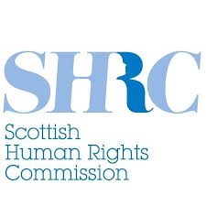
Scottish Human Rights Commission

Our Strategic Plan
2024 to 2028

About this document
This is an Easy Read document.

It is a plan.

A plan sets out what an organisation is going to do.

This new plan sets out what the Scottish Human Rights Commission is going to do.

It is also called a Strategic Plan.

The plan lasts from 2024 to 2028.

About the Scottish Human Rights Commission
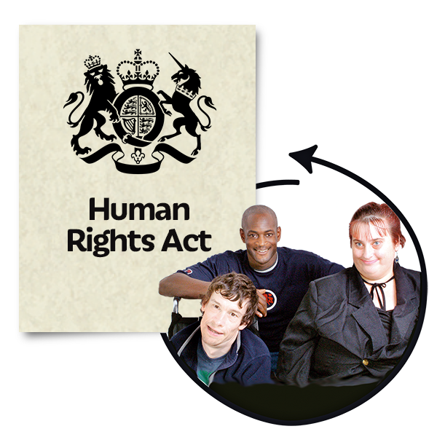 | Human rights are the basic rights and freedoms that belong to everyone.
The Scottish Human Rights Commission is an important organisation for human rights in Scotland.

We protect people’s human rights in Scotland.

We look closely at:

- the Scottish Government

- public organisations – like the police, local councils and hospitals

The Scottish Human Rights Commission reports to:

- the Scottish Parliament

- the United Nations

- the Council of Europe

 | The United Nations is a group of many countries working together to make the world a safer and better place.
 | The Council of Europe is a human rights organisation with many countries in Europe working together to make human rights better in Europe.
We can:

- suggest changes to laws
- suggest changes to policies
- suggest changes to what happens

 | We help more people to understand about human rights.
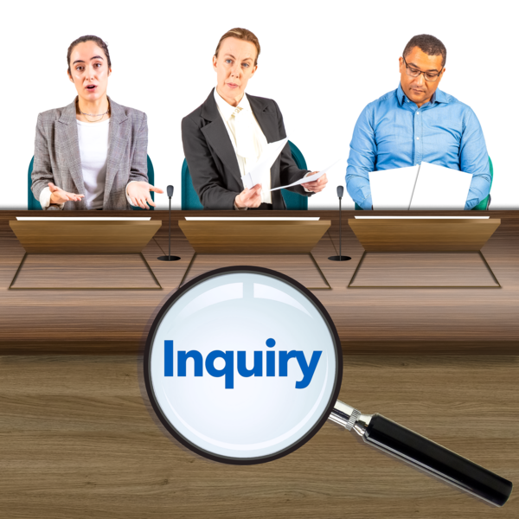 | We can also do inquiries into the policies and practices of public organisations – like hospitals, councils and police.
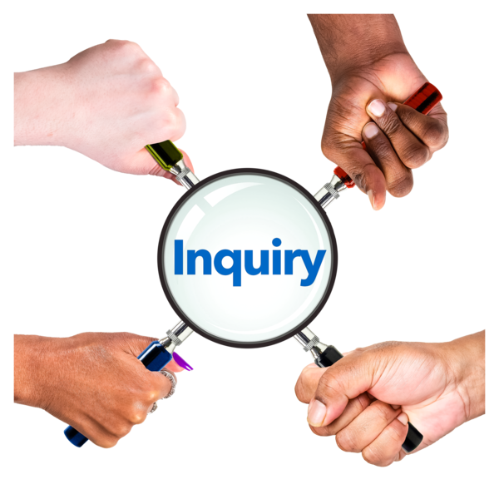 | An inquiry is a review into what went well and what could have been done better.

Our Values

We believe that people should take part in decisions that are about their rights.

We believe that human rights should be checked to see if they are being protected.

And if they are not, there should be changes made.

We believe we must stop it when someone is treated unfairly.

Being treated unfairly is also called discrimination.

We believe everyone should understand their rights.

And that everyone should be able to take part in decision that affect them.

We believe that the laws on human rights should be followed.

We also call our values the PANEL principles.

Our Plan for 2024 to 2028
To help make our plan, we asked people in Scotland what they thought.

We sent out a questionnaire.

We organised events so that we could hear people’s thoughts.

We asked people in Scotland what human rights mean to them in their work and in their lives.

We used people’s answers to help us write 3 main aims.

We will work on these 3 aims from 2024 to 2028.

1. Purpose
 | In this document, purpose means that we will keep using our powers to make human rights better in Scotland.
 | We will make sure there are strong human rights protections for everyone.
When things go wrong we will make sure that justice happens.

Justice means getting help from the police or courts to find out what happened and make it right when something has gone wrong.

Some of the things we will do are:

- to give advice to the Scottish Parliament and train its staff

 | - to give advice to public organisations, like local councils and the NHS
 | - to work with the United Nations and the Council of Europe to see if the Scottish Government is doing the right things
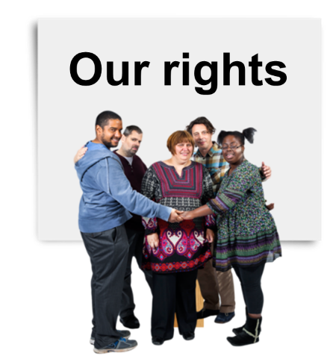 | - to look carefully at the Scottish Government’s new Human Rights Bill
 | The Human Rights Bill is a new set of human rights laws that may be happening in Scotland.

2. People

We will talk to as many people as we can across Scotland.

We will find out more about human rights in their lives.

Some of the things we will do are:

- to make new ways for people to join in with our work

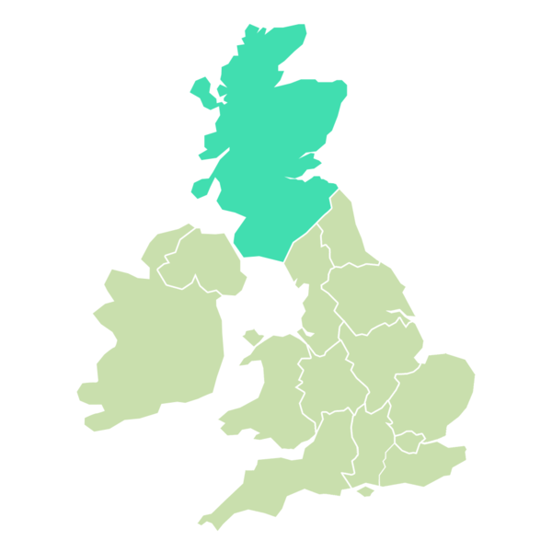 | - to visit communities across Scotland and build a team of people who help others with their human rights
- to work on these areas:

  - poverty – people who do not have enough money for the basic things they need to live

  - prisons

  - getting justice when things have gone wrong

  - groups with special protections – like disabled people and Gypsy Traveller communities

3. Performance

 | In this document, performance means how well something is happening.
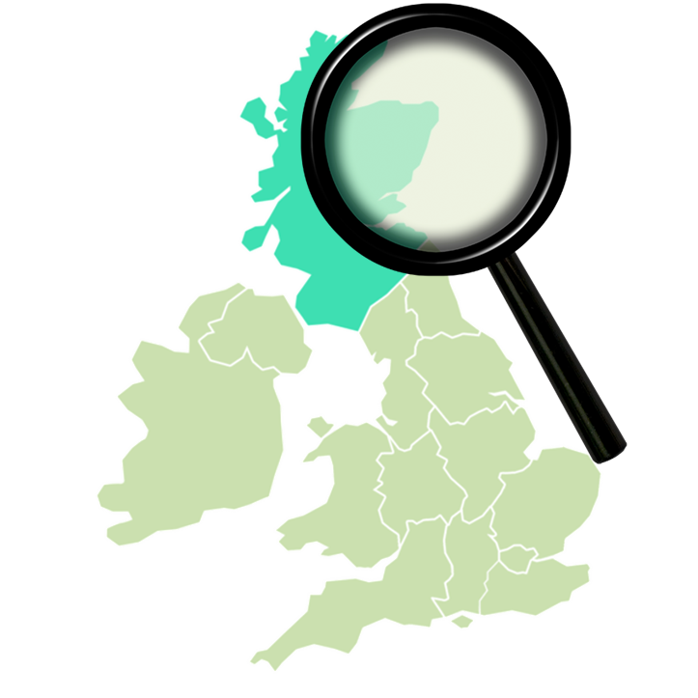 | We will check on how well human rights are happening in Scotland.
Some of the things we will do are:

- to collect more information about how human rights are happening in Scotland

 | - to write a report called State of the Nation
 | - to join groups which look more closely at human rights in prisons
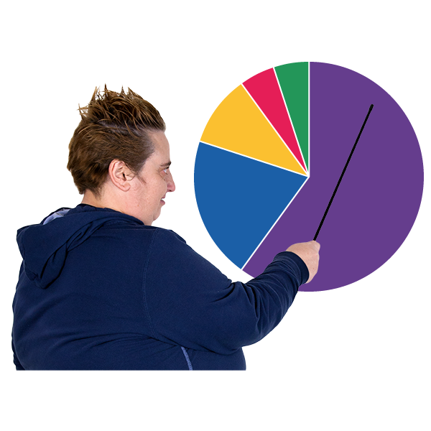 | - to put on our website our findings about what people think of human rights in Scotland

Getting stronger
Our new plan from 2024 to 2028 says we will get better at sharing what we do.

We want more people in Scotland to know about human rights.

Our plan also checks that we are a good place to work with good leadership.

We will share a plan for each year with lots of details about what we are going to do.

These yearly plans will be on our website.

If you want to see the full Strategic Plan you can find it on our website here. It is also available in BSL on our YouTube channel here.

