Scottish Human Rights Commission

Attitudes to human rights in Scotland
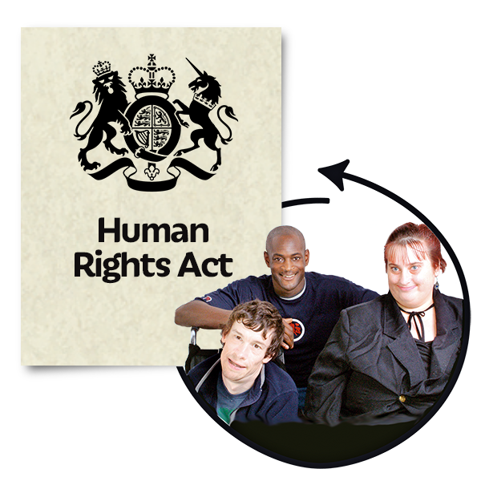

December 2023

Easy Read

What are human rights?
Human rights are freedoms that are protected in law.

They make sure we are treated fairly and with dignity.

Dignity means being treated in a way that is as thoughtful as possible.

Attitudes are what people think and feel about something.

We wanted to find out what people think about human rights in Scotland.

We asked an organisation called YouGov to do this research.

Research means getting facts, figures and information about something.

The figures represent Scottish adults aged over 16.
This report updates information from a study we had done in 2017.

It gives us a more detailed picture of how views on human rights in Scotland have changed over time.

Understanding what people know about human rights
To find out what people thought there was:

- an online survey of more than 1 thousand people aged 16 and over in Scotland

- 4 online groups

What do people in Scotland think about human rights?
We found 4 groups of attitudes to human rights in Scotland – they are people who are:

- supportive – people who believe that human rights are a good thing - nearly half of all people (48 per cent)

- conflicted – people who are not sure - nearly 1 in 3 people (30 per cent)

- opposed – they do not think people should have their human rights protected - 1 in 10 people (10 per cent)
- disengaged – they are not interested - a bit more than 1 in 10 people (13 per cent)

The main things we found out
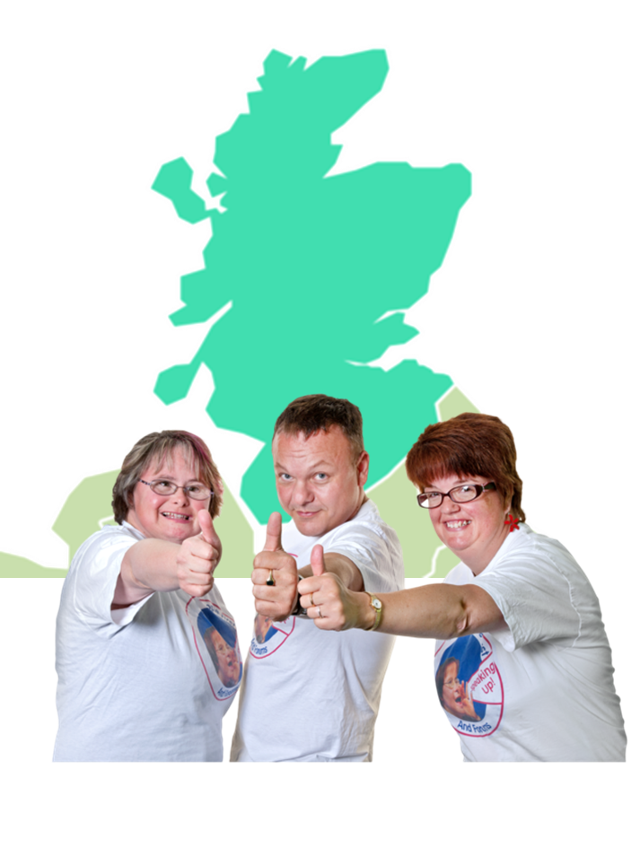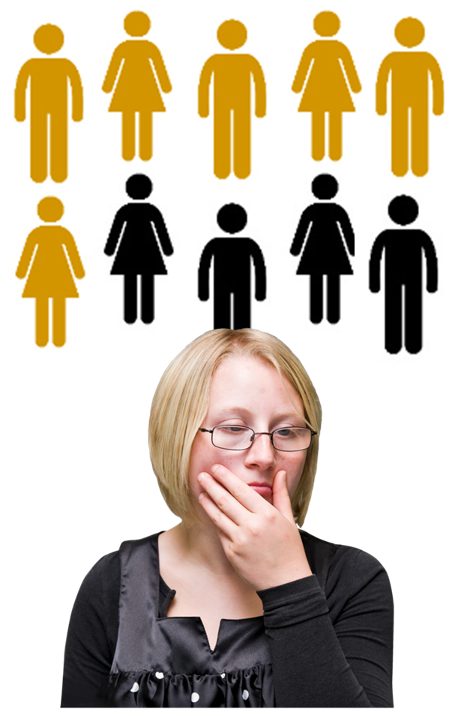 | People in Scotland are more likely to support human rights than not.  - support for human rights has increased since 2017 and is now nearly half of all people (48 per cent)  The supportive group is the largest group in each Scottish region.  - More people are worried that they have less human rights  6 out of every 10 people were worried now (60 per cent).  A bit more than 5 out of every 10 people were worried in 2017 (52 per cent).
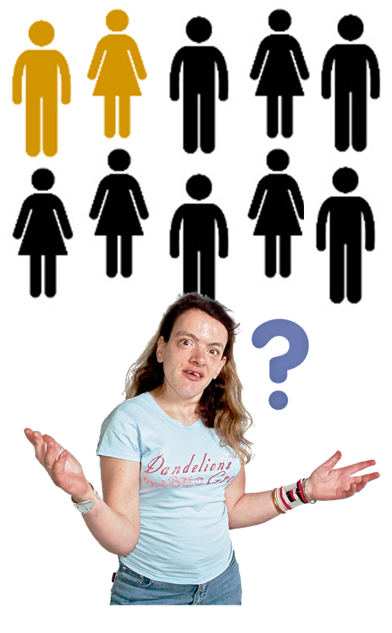 | - less people would know who to contact about a human rights issue  A bit more than 2 out of 10 people (22 per cent) know who to contact now.  A bit less than 3 out of 10 people (27 per cent knew who to contact in 2017.
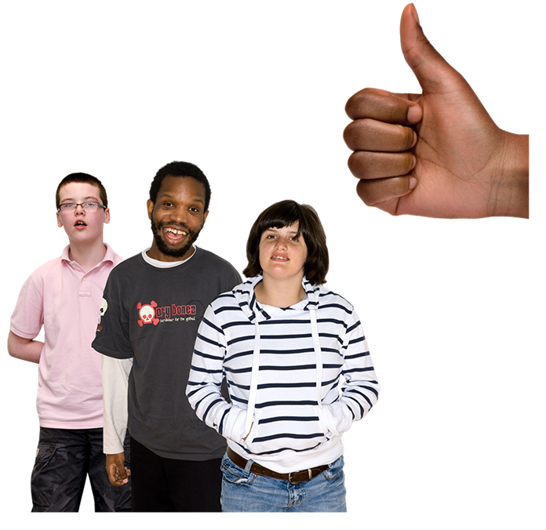 | - a person’s age had a big effect on how they felt about human rights  Younger people were more likely to support human rights.  Older people were more likely to be opposed to human rights.  Most people get their information about human rights from TV news.

Improving human rights
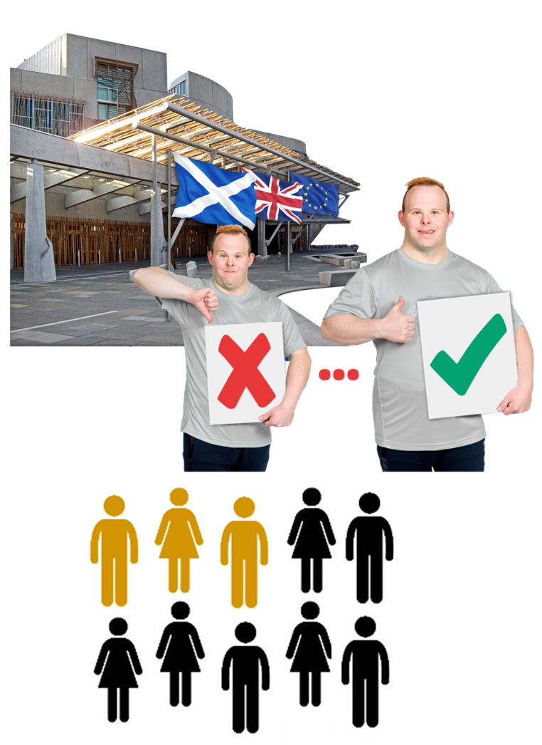 | - a bit more than 3 out of every 10 people (33 per cent) think the Scottish Government should do more about their responsibility for human rights  Slightly less people (32 per cent) think the Scottish Government is doing enough about this.
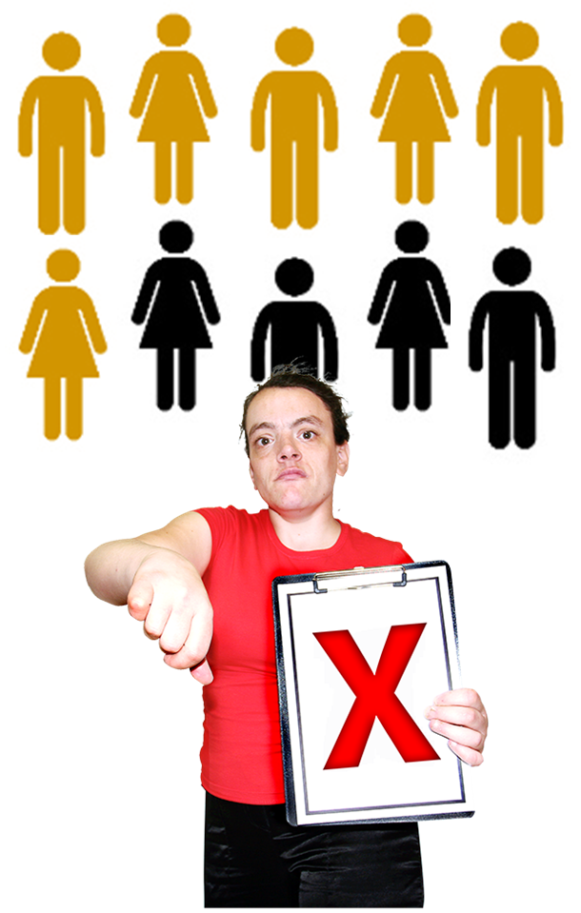 | - there are more people in the supportive group who think the Scottish Government should do more, rather than people who think they are doing enough  This was the other way around in 2017.  - most people in the opposed group think the Scottish Government should do less work on human rights  This was a bit more than 6 out of 10 people. (61 per cent)  This has gone up from nearly 5 out of 10 people (46 per cent) in 2017.

Where do people get information about human rights?

More than 3 out of every 4 people (78 per cent) would not know who to go to if they had a question about human rights.

To find out more about human rights:

- half of people (50%) would look up information online

- nearly 4 out of every 10 people (36%) would get information from a human rights organisation

People were not likely to get information from chat groups on social media.

Only 5 out of 100 people (5 per cent) would look for information in this way.

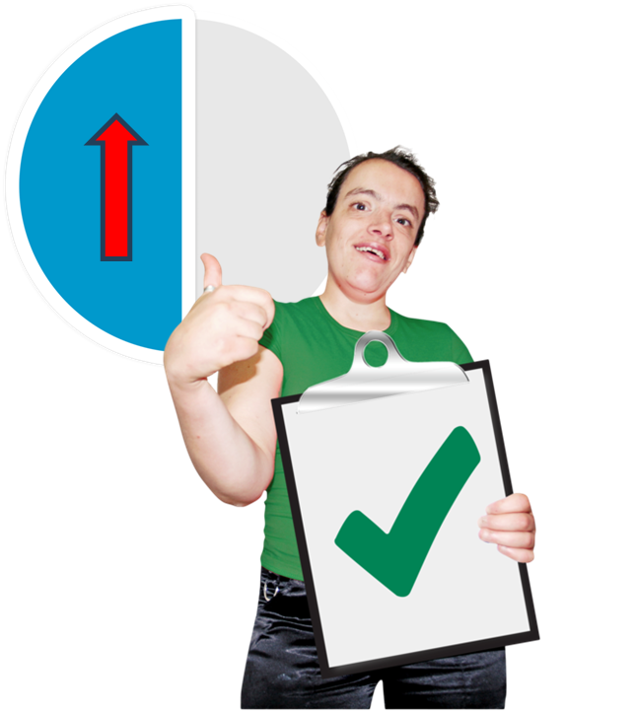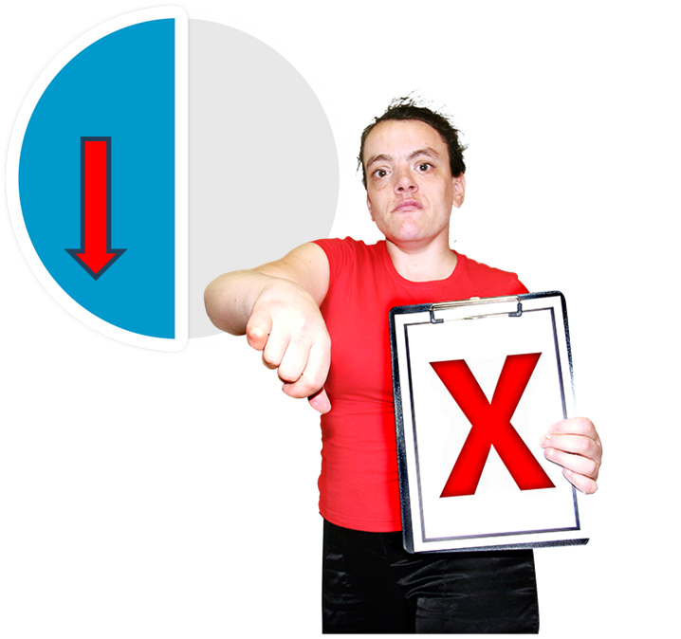 | People who would do their own research were:  - a bit more than half (58 per cent) of the Supportive group  - half (50 per cent) of the Conflicted group  - less than half (41 per cent) of the Opposed group  Less than half (42 per cent) of the Disengaged group did not know.
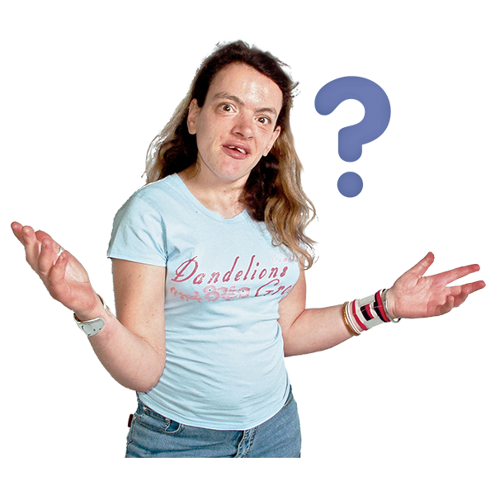 | People are not sure what the Scottish Human Rights Commission does.  People in the Supportive group had a fair understanding and awareness of the SHRC.  Most people in the Conflicted and Disengaged groups had not heard of it.

Rights of minorities

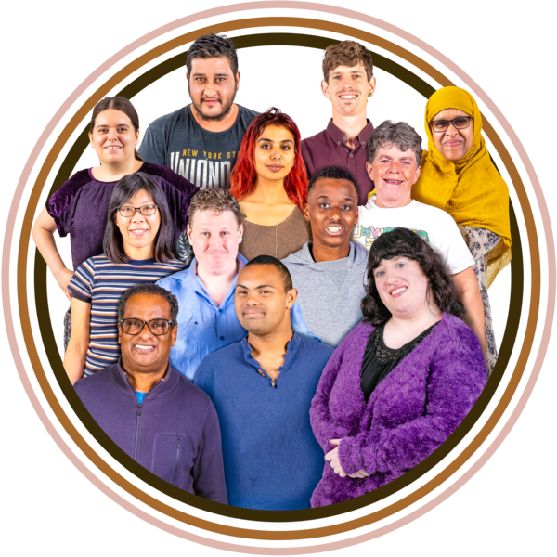 | Minorities are small groups of people who may face more difficulties getting their rights.  Many Scots are worried about the human rights protections of people who are at risk of harm.  They think that the rights of minorities and people living in poverty are not being protected.
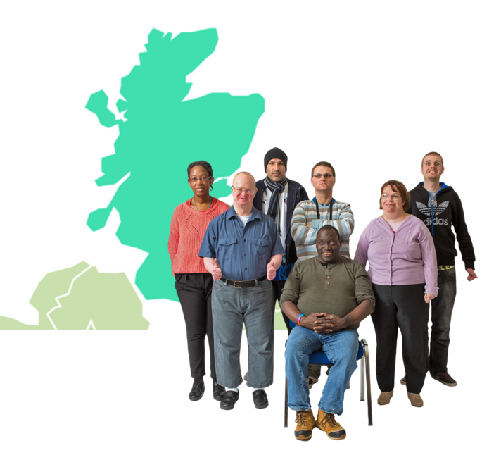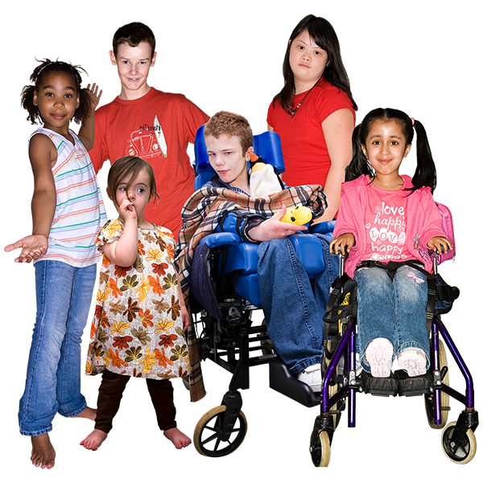 | Scots are most likely to believe human rights work well for:  - people born in Scotland  A bit more than 6 out of every 10 people think this works well (61%)  - children and young people (60%)  6 out of every 10 people think this works well
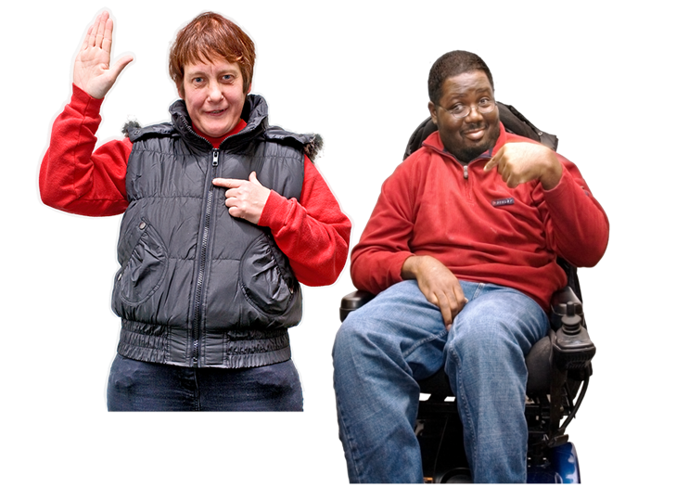 | - people like them (60%)  6 out of every 10 people think this works well.
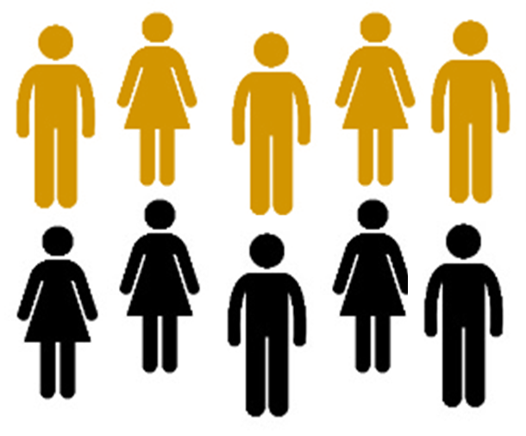 | The number of people who believe human rights work well for people of minority ethnic backgrounds has gone down.  Half of people (50%) thought this worked well this year.  Nearly 6 out of every 10 people (58%) thought this worked well in 2017.
The number of people who believe human rights work well for prisoners has gone down.

A bit more than 5 in every 10 people (54%) thought this worked well this year.

A bit more than 6 in every 10 people (62%) thought this worked well in 2017.

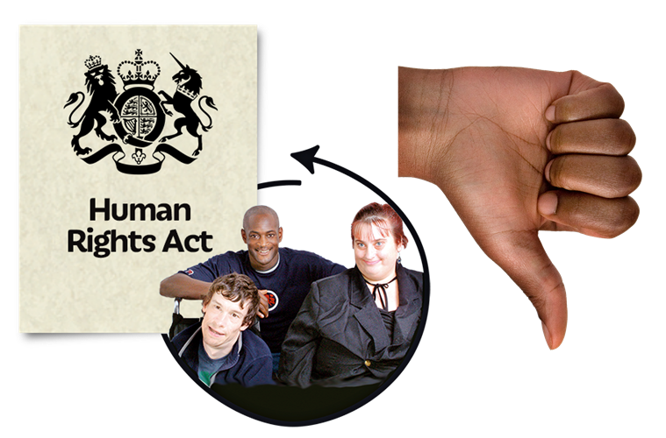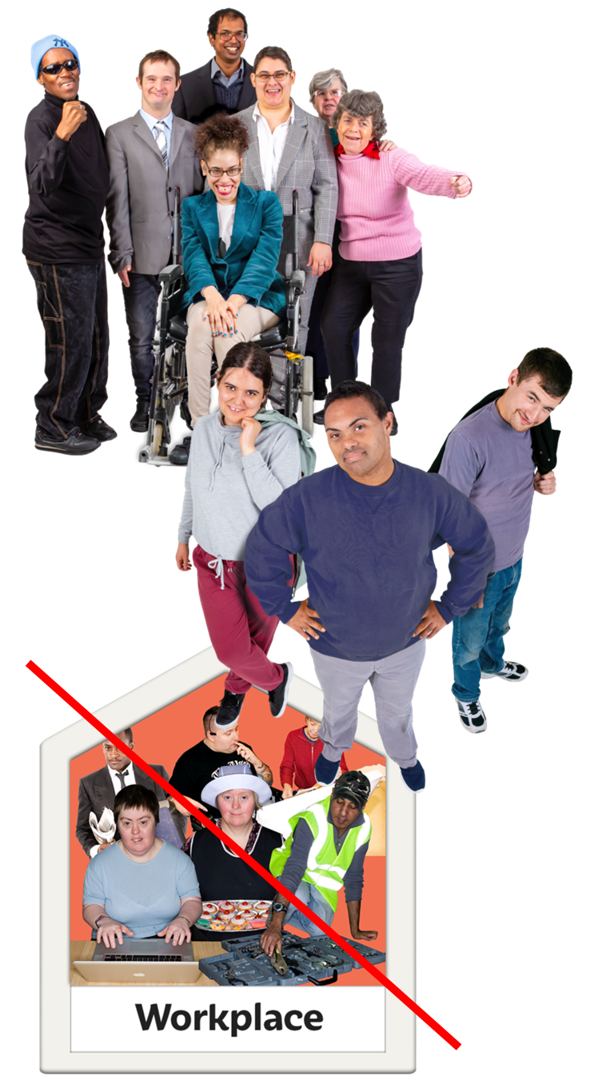 | Scots are most likely to believe human rights do not work well for:  - disabled people – nearly 4 out of every 10 people (38%) think this  - Scottish gypsy travellers – a bit more than 3 out of every 10 people (32%) think this  - unemployed people – a bit more than 3 out of every 10 people (32%) think this
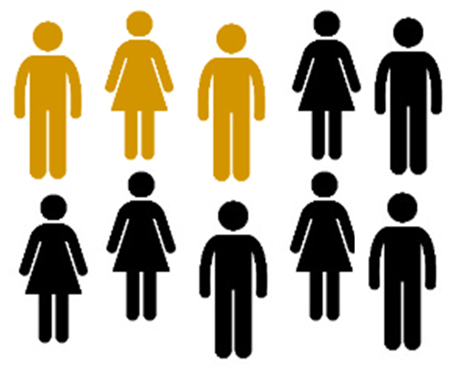 | The number of people who believe human rights do not work well for people from minority ethnic groups has gone up.  A bit less than 3 in every 10 people (28 per cent) thought this did not work well now.  A bit more than 2 in every 10 people (21 per cent) thought this did not work well in 2017.

Who are the Scottish Human Rights Commission?

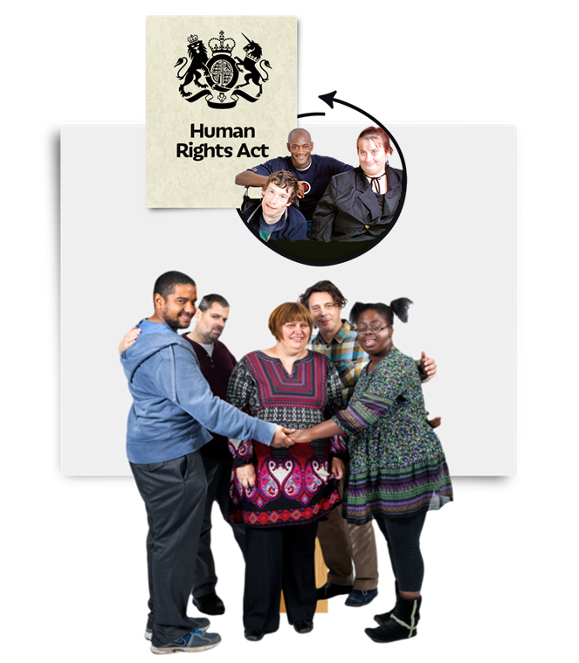 | The Scottish Human Rights Commission works in Scotland to:  - look after people’s rights  - check that the Scottish Government and its organisations are looking after people’s rights  - tell more people about their human rights
For more information about the Commission visit our website: www.scottishhumanrights.com

Email us at: hello@scottishhumanrights.com

