Recruitment Information
Business Support: Information, Records, Data
Part time 0.4 FTE (14 hours 48 minutes per week)

August 2021

About the Scottish Human Rights Commission
The Scottish Human Rights Commission is an independent public body with a broad statutory remit to promote and protect human rights in Scotland. We are accredited within the United Nations system as an A-Status National Human Rights Institution.
The Commission works on a range of legal, policy and practical issues which affect people’s human rights in Scotland. This includes economic, social and cultural rights such as rights to food, housing, social security and health. We also work on issues such as policing, prisons, climate justice, and business and human rights.
As well as monitoring law, policy and practice, the Commission also promotes awareness, understanding and respect for human rights. We produce resources to support other organisations to take a human rights based approach to their work, and to help build understanding of human rights among the wider public.
The Corporate Services team supports the wider office to deliver the Commission’s mandate through the provision of strong corporate and supporting services.

About the Job

General
Job Title: | Business Support: Information, Records, Data
Working Pattern: | 0.4 FTE (14 hours 48 minutes per week) worked flexibly
Duration: | Permanent
Team: | Corporate Services
Reports to: | Head of Corporate Services
Location: | Based in Bridgeside House, 99 McDonald Road, Edinburgh  Currently remote working is in place.
Salary banding: | Grade 2  FTE salary £23,243 - £27,204  Pro-rata 0.4 FTE salary £9,297 - £10,882  Pay award pending  Appointments will usually be made at the bottom of the salary band. A higher starting salary may be agreed with exceptional candidates.

Overall purpose
The Business Support – Information, Records and Data role provides day to day administration that supports the Information, Records and Data Management function of the Corporate Services team.
The role holder works collaboratively with the Head of Corporate Services and other teams across the Commission to promote compliance and best practice in relation to Information, Records and Data Management and provides support where required to achieve compliance and good performance.
The role holder provides occasional leave and absence cover for other members of the Corporate Services Team.
This role is an administrative and service role within the Corporate Services team. The role exists within a small collaborative team of Business Support professionals led by the Head of Corporate Services.

Budgets Controlled
The Corporate Services budget is managed by the Head of Corporate Services. Team member have day to day responsibility for lines within that budget as delegated to them by the Head of Corporate Services

Core Areas of Responsibility and Key Activities

Information
- Log, acknowledge and draft responses to simple Freedom of Information and Environment Information Requests, undertaking information searches where required and to seek authorisation of drafts before sending responses.
- Escalate Freedom of Information and Environment Information Requests that are of a more complex nature to the Head of Corporate Services or other colleagues as appropriate for response.
- Support periodic review and updating of the Commission’s Model Publication Scheme.
- Submit required statistics on Freedom of Information Request via the online portal.
- Provide administration support to reviewing and managing information to ensure information is held appropriately and in accordance with relevant policies.
- Work under the direction of the Head of Corporate Services on information security and cyber resilience tasks.

Records
- Undertake administrative work to ensure ongoing compliance with the Commission’s Records Management Plan (RMP).
- Support the implementation and ongoing support requirements of moving the Commission’s records to an eRDM. Undertaking the role of IMSO with appropriate training.
- Work under the Direction of the Head of Corporate Services and other team managers to undertake work on policy, procedures and systems to support Commission-wide compliance with the RMP.
- Provide administration support to reviewing and managing records to ensure information is held appropriately and in accordance with relevant policies.

Data
- Undertake administrative work to ensure ongoing compliance with the UK General Data Protection Regulations (GDPR) and Data Protection Act 2018. This is a varied set of tasks including work such as information and data audits, recording information and data held, reviewing information against retention and disposal requirements.
- Draft privacy notices for specific projects and for the Commission as a whole.
- Provide support in the preparation of Data Impact Assessments.
- Attend meetings of the Data Protection working group with staff members from other office-holders and the shared office-holder Data Protection Officer (DPO).
- Liaise with the Commission’s shared DPO as requested by the Head of Corporate Services to seek advice or guidance.
- Assist the Head of Corporate Services with reporting and responding in the event of a data breach.
- Assist the Head of Corporate Services with responding to Subject Access Requests within statutory timescales.
- Work under the direction of the Head of Corporate Services and other team managers to support implementation of policies and systems to manage data.

Corporate Policy Review and Development
- Provide support to the Head of Corporate Services in undertaking corporate policy review and development work to support the information governance of the Commission. Delegated tasks include undertaking research, initial drafting and first level reviews of existing policies.

General Administration
- Provide occasional administration support and work collaboratively to assist others outwith the usual duties of the role when needed, particularly at peak periods around large scale events or to meet priority team deadlines.

Other
- Providing leave and absence cover to staff the Corporate Services desk as required.
- Providing administrative support to team or Commission projects.
The above areas of responsibility and key activities are not intended to be exhaustive. They do highlight the core areas of responsibility of the role as well as the key activities the post holder may be reasonably expected to undertake.

Person Specification

Formal Qualification/s
Standard Grade / GCSE English and Maths (A-C) (E)
Qualification in a relevant subject ie Information, Records or Data administration or management (D)

Knowledge
Working knowledge of the requirements of one or more of the following: Freedom of Information (Scotland) Act, the Public Records (Scotland) Act or the General Data Protection Regulations / Data Protection Act 2018 (D)

Experience
Experience of working in an administrative capacity (E)
Considerable experience of using Microsoft Office software (Outlook, Word, Excel, PowerPoint) (E)
Experience of working with paper and electronic filing and information management systems (D)
Experience of working in an Information / Records / Data role or other similar compliance and standards role (D)
Experience working in a public sector organisation or an organisation in the human rights and related fields (D)

Skills
Ability to work independently as well as in a small team (E)
Organisational skills with particular strength in managing a wide range of tasks through to completion (E)
High levels of accuracy in maintaining files, information, data and logs (E)

Other
Combines a concern for quality and attention to detail with a customer service awareness (E)

Additional Information
Normally, travel will be required within Scotland on occasion either to support the Commission’s large scale events (a couple of times per year), to participate in training and development activities (a couple of times per year) or to attend meetings (adhoc throughout the year and normally in Edinburgh).

Potential for Flexible Working
See below.

Review
Every job description in the Commission will be subject to a review in the following situations:
- on an annual basis at the time of the annual appraisal meeting;
- as a result of a change in strategic direction;
- as a result of a team/ operational requirements;
- as a result of agreed performance appraisal needs and objectives; or
- within six months of appointment

Appendix 1: Organisational Structure
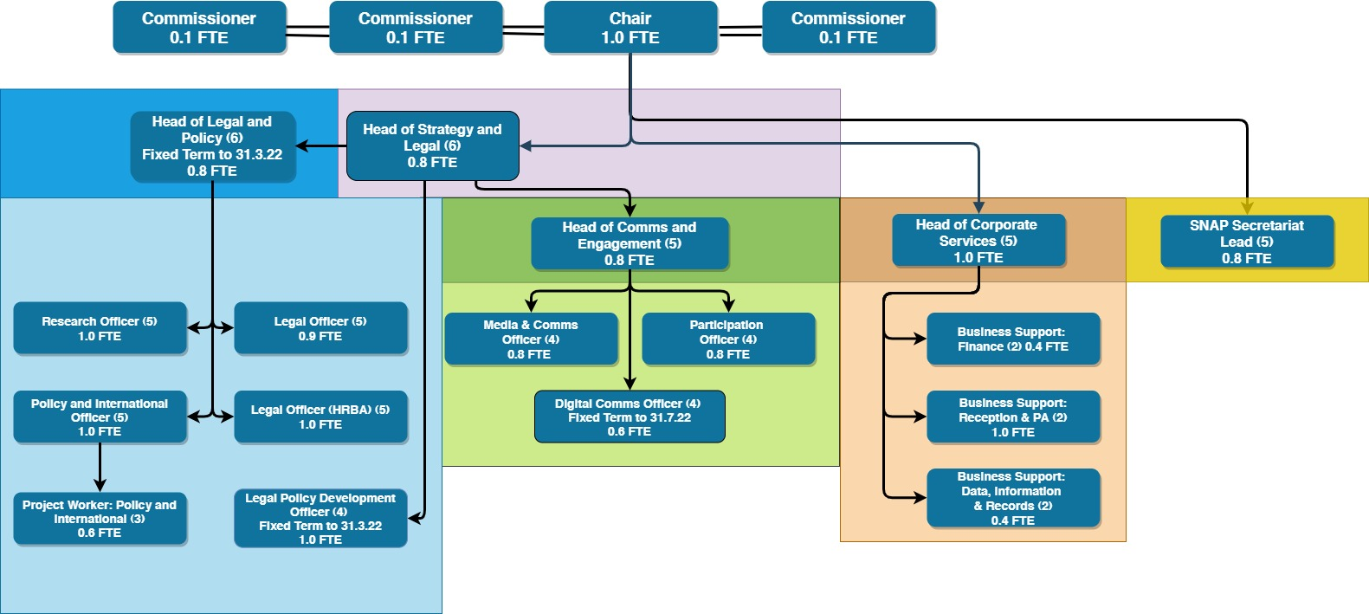

Benefits

Working Hours

Flexible working
The Commission is a flexible employer and is committed to going beyond its statutory obligations in relation to flexible working. We are open to flexible working requests. Currently all staff are working fully remotely, and this is expected to continue at least in part for some time.

Pay structure
This Business Support: Information, Records, Data role is a grade 2 role within our pay structure.
Grade 2 (£23,243 - £27,204 pro rata) (pay award pending)

Pension
Commission employees are eligible to join the Civil Service Pension scheme. From 1 April 2015, a new Civil Service pension scheme - Alpha - was introduced. Alpha is a Career Average pension scheme.

Annual Leave
30 days annual leave plus 11.5 public holidays (pro rata for part time hours)

Commitment to CPD
The Commission has a strong commitment to training and professional development and you will have access to training courses in core skills as well as policies to support continuing professional development.

How to Apply
To apply for this position, please send a completed application form to the Commission, either:
By email: recruitment@scottishhumanrights.com
By post: FAO Corporate Services
Scottish Human Rights Commission
Bridgeside House
99 McDonald Road
Edinburgh
EH7 4NS
You must complete an application form, CV’s will not be accepted. Applications should demonstrate how you meet the criteria for the role as outlined in the job description and person specification.
If you need to provide information in a different format please contact us to discuss.

Key Dates
The deadline for applications is 9am on 23 August 2021.
Interviews will take place via video conference, dates may be subject to change but are likely to take place during the week commencing 13 September 2021.

Participation in interview
The Commission’s office is currently closed and all interviews will take place via video conference. If there are any barriers to you taking part in an interview in this form please contact us at recruitment@scottishhumanrights.com.
Applicants must have the right to work in the UK to be eligible to apply.

Equality and Diversity
If you would like to discuss adjustments to the recruitment process that would enable your participation please contact us at recruitment@scottishhumanrights.com

Disclosure and Pre-Appointment Checks
The successful candidate for this post will be asked to apply for Baseline Security Clearance and a Basic Level Disclosure Scotland Certificate and/ or a country equivalent if the candidate has lived in another country in the past three years. We will undertake pre-appointment checks of references, ID, permission to work in the UK and any education certificates listed in the application form. Confirmation of employment will be subject to these checks being completed satisfactorily. The Commission will facilitate and cover the cost of the checks and certificates. If you want to discuss this requirement, in confidence, at any time please contact us at recruitment@scottishhumanrights.com.

