Recruitment Information
Secretariat Lead: Scotland’s National Action Plan for Human Rights (SNAP)
Fixed Term – 9 month contract
Part time 0.8 FTE (29 hours 36 minutes per week)

June 2021

About Scotland’s National Action Plan for Human Rights (SNAP)
In 2013, Scotland’s first National Action Plan for Human Rights was launched, fulfilling key recommendations from both the United Nations and the Council of Europe. Known as SNAP, it was and remains the first and only such initiative in any part of the UK. Praised internationally for its collaborative, multi-stakeholder approach, SNAP has been cited regularly in reports to the United Nations on Scotland’s implementation of its international human rights obligations.
SNAP delivered over 50 actions in four years in areas as diverse as criminal justice, housing, health and social care. Actions included pilot projects to test human rights based approaches in practice; national innovation forums to spark creative action on complex human rights issues; and action research projects on specific rights concerns.
Many SNAP actions seeded longer term programmes of work that continue to drive improvements in Scotland’s human rights laws, policies and practices today. The current work of the National Taskforce on Human Rights Leadership can be traced back directly to SNAP action in this area. Making Rights Real, Scotland’s new grassroots human rights organisation, is firmly rooted in the Housing Rights in Practice pilot project pioneered through SNAP. A Reference Group of people with lived experience of poverty, first brought together as part of SNAP, now works with the Scottish Human Rights Commission on a permanent basis.
Since late 2017, work has been taking place to develop detailed plans and proposals for Scotland’s second National Action Plan for Human Rights – SNAP 2. This work has drawn heavily on lessons identified from an independent evaluation of the first SNAP, as well as a National Participation Process involving over 1,000 people. Planning has been led by a Development Working Group of around 15 people from civil society and the public sector. Detailed proposals for SNAP 2 were published for wider engagement in autumn 2019, with broadly widespread and positive feedback received, as well as areas for refinement and improvement.
A business case for resources and implementation of SNAP 2 was developed in partnership with and approved by Scottish Ministers in May 2021 (following a delay due to COVID-19).
This means that we are now moving forward with the following steps:
- Scottish Government participation at senior level in a new SNAP 2 Leadership Panel to be established in autumn 2021.

- Initial Scottish Government resourcing of a Secretariat Lead in 2021-22, to be hosted by the Scottish Human Rights Commission, as the first step in establishing a full independent SNAP 2 Secretariat to support ongoing development, implementation and monitoring of actions.

- Refining, prioritising and identifying resources to support SNAP 2 actions.
Scotland’s second National Action Plan for Human Rights is now set to become a reality, moving off the page and into implementation. This will mean that practical actions to improve the realisation of human rights in people’s lives can be delivered in a collaborative, coordinated way, enabling Scotland to both better fulfil its international human rights obligations and to evidence this progress. It will also provide a ready-made, practical means to deliver implementation of, and accountability for, the recent recommendations of the National Taskforce on Human Rights Leadership.
More information about SNAP’s history and development is available on the SNAP website.

About the Scottish Human Rights Commission
The Scottish Human Rights Commission has coordinated and facilitated the development of SNAP over a number of years. It is now hosting the independent Secretariat for SNAP on an initial and interim basis until summer 2022. Funding for the post of Secretariat Lead has been provided by the Scottish Government.
The Scottish Human Rights Commission is an independent public body with a broad statutory remit to promote and protect human rights in Scotland. We are accredited within the United Nations system as an A-Status National Human Rights Institution.
The Commission works on a range of legal, policy and practical issues which affect people’s human rights in Scotland. This includes economic, social and cultural rights such as rights to food, housing, social security and health. We also work on issues such as policing, prisons, climate justice, and business and human rights.
As well as monitoring law, policy and practice, the Commission also promotes awareness, understanding and respect for human rights. We produce resources to support other organisations to take a human rights based approach to their work, and to help build understanding of human rights among the wider public.

About the Job
Job Title: | Secretariat Lead - Scotland’s National Action Plan for Human Rights
Working Pattern: | 0.8 FTE (29 hours 36 minutes per week) worked flexibly
Duration: | Fixed term – 9 months with possibility of extension subject to funding.  Secondments can be considered.
Team: | Scotland’s National Action Plan for Human Rights
Reports to: | Chair of the Commission
Location: | Based in Bridgeside House, 99 McDonald Road, Edinburgh  Currently remote working is in place (expected to continue at least in part for the duration of the contract).
Salary banding: | Grade 5  FTE salary £45,431 - £55,888  Pro-rata 0.8 salary £36,345 - £44,710  Pay award pending  Appointments will usually be made at the bottom of the salary band. A higher starting salary may be agreed with exceptional candidates.

Overall purpose
This strategic development role has overall responsibility for establishing and leading an independent Secretariat for SNAP. This will include working with SNAP partners to develop and secure long-term resources, operating arrangements and a small staff team for the Secretariat.
Establishing and working closely with the SNAP Leadership Panel, the post-holder will also coordinate the ongoing development and refinement of priority SNAP actions, and a SNAP monitoring and evaluation framework.
The role also involves engaging and building constructive, collaborative relationships with a wide range of external stakeholders including senior government colleagues, public sector and civil society leaders, and people with lived experience of human rights issues.
The role is currently employed and hosted by the Scottish Human Rights Commission, with funding from the Scottish Government. This is an interim arrangement for the duration of the initial contract.

Budgets Controlled
Programme budget for Scotland’s National Action Plan for Human Rights

Core Areas of Responsibility and Key Activities
Key responsibilities for the role would include:
- Provide strategic and practical leadership to establish and support the effective functioning of the SNAP Leadership Panel, adopting a professional, systematic and effective approach to engaging and liaising with all key stakeholders to ensure effective collaboration.

- Using participatory and collaborative methods, develop and ensure the effective delivery of appropriate and empowering ways of working for the SNAP Leadership Panel.

- Provide strategic advice to the Co-Chairs of the SNAP Leadership Panel on all areas of SNAP’s development including action prioritisation, resources and the external policy and stakeholder context for SNAP.

- Develop, build and maintain strategic relationships with diverse stakeholder groups including senior government and public sector leaders and officials, senior leaders from civil society, and people with lived experience of a wide range of human rights issues.

- Manage and coordinate a process to ensure the continued development and refinement of priority SNAP Actions and a SNAP Monitoring and Evaluation Framework.

- Manage and coordinate a process to develop, agree and secure resources for a long-term operating model for SNAP and the SNAP Secretariat.

- Provide strategic leadership, oversight and effective management of the SNAP Secretariat functions as they evolve.

- Lead, direct and manage the delivery of SNAP 2 communications and stakeholder engagement activity including events, meetings and online engagement.

- Oversee and contribute to the development and production of SNAP progress and accountability reports to the Scottish Parliament, Scottish Government and others as required.

- Ensure SNAP Secretariat compliance with all relevant legislation including freedom of information, data protection, equality, health and safety and other as appropriate.

- Manage the SNAP programme budget effectively, ensuring that finance policies and procedures are followed and a robust audit trail is maintained at all times.

- Represent SNAP at relevant external engagements, including public speaking as required.

- Develop personal understanding of human rights, including through regular interaction with SNAP stakeholders, and use this knowledge to inform all work strands.

Person Specification

Formal Qualification/s
- A relevant undergraduate degree or relevant experience (E).
- A relevant post graduate qualification (D).

Experience
- Significant work experience including at least some senior-level experience within a public policy, public affairs, project or programme management context (E).
- Experience of developing and maintaining effective relationships with a wide range of stakeholders including public bodies, civil society and individuals from a wide range of backgrounds (E).
- Proven experience of project management to achieve target outcomes under pressure of time and budget (E).
- Experience of facilitating partnership working and/or collaborative decision-making processes (E)
- Proven experience of writing accessible and inclusive communications for a variety of audiences (E).
- Proven experience of leading a small team (E).
- Experience of developing business plans, business cases or resource bids (D).
- Experience of participatory models of governance (D)
- Experience within the Human Rights field. (D).
- Budget management experience (D).

Skills
- Excellent project or programme management skills (E)
- Excellent oral and written communication skills (E).
- Excellent IT skills (E).
- Confidential and sensitive approach (E)
- Excellent interpersonal and group facilitation skills (E).
- Well-developed organisational skills (E).
- Presentation skills, including confident public speaking and presentation preparation (D).

Other
- Able to work independently but also within a small team (E).
- Flexible approach (E).
- Awareness of Scottish political and civic context (E).

Additional Information
Although this post is based in Edinburgh, the job holder will be required to travel across Scotland and more widely on occasion.
The post holder can request flexible working arrangements in line with the Commission’s flexible working policy.
The post holder is required to be available for occasional evening and weekend work.

Potential for Flexible Working
See below.

Review
Every job description in the Commission will be subject to a review in the following situations:
- on an annual basis at the time of the annual appraisal meeting;
- as a result of a change in strategic direction;
- as a result of a team/ operational requirements;
- as a result of agreed performance appraisal needs and objectives; or
- within six months of appointment

Appendix 1: Organisational Structure

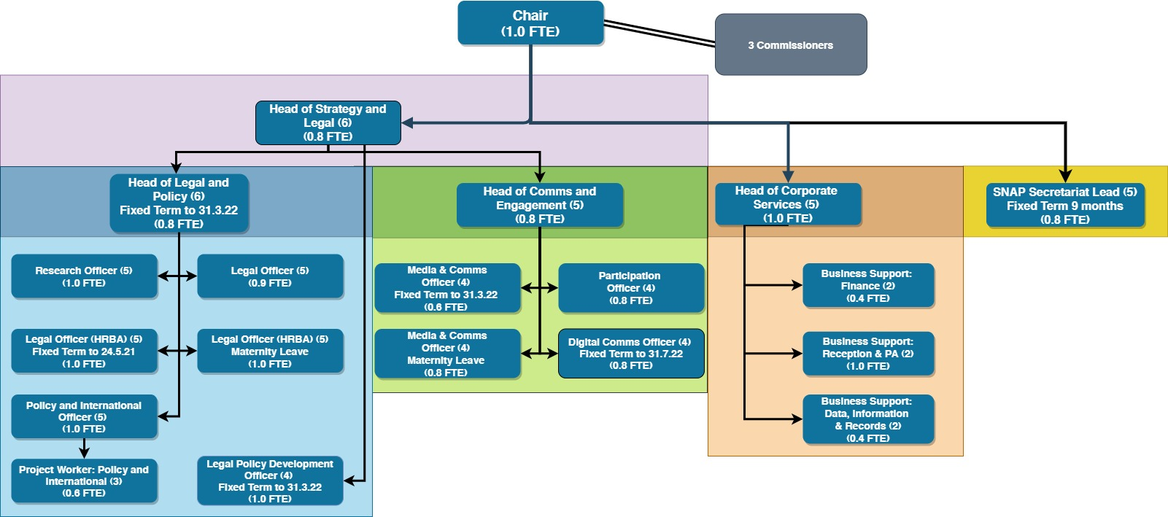

Benefits

Working Hours

Flexible working
The Commission is a flexible employer and is committed to going beyond its statutory obligations in relation to flexible working. We are open to flexible working requests. Currently all staff are working fully remotely, and this is expected to continue at least in part for the duration of the contract.

Pay structure
This role is a grade 5 role within our pay structure.
Grade 5 FTE Salary £45,431 - £55,888 (pay award pending)

Pension
Commission employees are eligible to join the Civil Service Pension scheme. From 1 April 2015, a new Civil Service pension scheme - Alpha - was introduced. Alpha is a Career Average pension scheme.

Annual Leave
30 days annual leave plus 11.5 public holidays (pro rata for part time hours)

Commitment to CPD
The Commission has a strong commitment to training and professional development and you will have access to training courses in core skills as well as policies to support continuing professional development.

How to Apply
To apply for this position, please send a completed application form to the Commission, either:
By email: recruitment@scottishhumanrights.com
By post: FAO Corporate Services
Scottish Human Rights Commission
Bridgeside House
99 McDonald Road
Edinburgh
EH7 4NS
You must complete an application form, CV’s will not be accepted. Applications should demonstrate how you meet the criteria for the role as outlined in the job description and person specification.
If you need to provide information in a different format please contact us to discuss.

Key Dates
The deadline for applications is 9am on 2 August 2021.
Interviews will take place via video conference, dates may be subject to change but are likely to take place during the week commencing 30 August 2021.

Participation in interview
The Commission’s office is currently closed and all interviews will take place via video conference. If there are any barriers to you taking part in an interview in this form please contact us at recruitment@scottishhumanrights.com.
Applicants must have the right to work in the UK to be eligible to apply.

Equality and Diversity
If you would like to discuss adjustments to the recruitment process that would enable your participation please contact us at recruitment@scottishhumanrights.com

Disclosure and Pre-Appointment Checks
The successful candidate for this post will be asked to apply for Baseline Security Clearance and a Basic Level Disclosure Scotland Certificate and/ or a country equivalent if the candidate has lived in another country in the past three years. We will undertake pre-appointment checks of references, ID, permission to work in the UK and any education certificates listed in the application form. Confirmation of employment will be subject to these checks being completed satisfactorily. The Commission will facilitate and cover the cost of the checks and certificates. If you want to discuss this requirement, in confidence, at any time please contact us at recruitment@scottishhumanrights.com.

