Recruitment Information
Legal Policy Development Officer
Fixed - term post for 12 months (with possibility of extension)
Full time (37 hours per week)

August 2020

About the Scottish Human Rights Commission
The Scottish Human Rights Commission is an independent public body with a broad remit to promote and protect human rights for everyone in Scotland. We are independent of government and parliament.
The Commission works on a range of legal, policy and practical issues which affect people’s human rights in Scotland. Current areas of work include housing, social security, health and social care, policing and prisons, business and human rights, and biometrics.
As well as monitoring law, policy and practice, the Commission also promotes awareness, understanding and respect for human rights. We produce resources to support other organisations to take a human rights based approach to their work, and to help build understanding of human rights among the wider public.

About the Job

General
Job Title: Legal Policy Development Officer
Working Pattern: 37 hours per week worked flexibly
Duration: Fixed term for 12 months (with possibility of extension)
Team: Legal and Policy
Reports to: Head of Strategy and Legal
Location: Based in Bridgeside House, 99 McDonald Road, Edinburgh, EH7 4NS. Currently remote working is in place.
Salary banding: Grade 4 (£35,586 - £44,322)
Appointments will usually be made at the bottom of the salary band.

Overall purpose
This role will provide legal policy support mainly in the area of economic, social and cultural rights for the organisation with a specific and dedicated focus on supporting the Commission’s work on the National Task Force on Human Rights Leadership.

Budgets Controlled
No specific budget responsibility

Core Areas of Responsibility and Key Activities
To work with the Head of Strategy and Legal to provide detailed legal policy briefings on issues related to the mandate of the National Task Force on Human Rights Leadership.

To work with the Policy and Legal Officers to develop position papers and submissions to consultations across all areas of the Commission’s work.

To build relationships with key stakeholders to ensure the Commission’s work is relevant and appropriately focused.

To participate in events, seminars and other outreach activities organised by or supported by the Commission with public authorities, governments, private actors and civil society, to raise public awareness of the Commission and of human rights.

To support the development of training and capacity building in human rights as appropriate.

To undertake other tasks in support of the over-all role of the Legal and Policy team, the work of the Head of Strategy and Legal and the Commission, as appropriate.

Person Specification

Formal Qualification/s
Law degree or demonstrably equivalent human rights legal policy knowledge. (E)

Knowledge
Demonstrable in depth and up-to-date knowledge and understanding of international human rights law, general human rights issues and the Scottish context and legal system. (E)

Experience
At least 3 years of progressively responsible experience in the human rights field. (E)

Skills
Strong organisational skills. (E)
Ability to formulate clear, concise and coherent policies based on a detailed understanding of human rights. (E)
Ability to work independently but also within a small team. (E)
Strong interpersonal skills and a confidential and sensitive approach. (E)
Excellent IT skills. (D)

Other
Attention to detail. (E)
Flexible approach. (D)

Additional Information
None

Potential for Flexible Working
A Flexible Working Role Assessment has been prepared and is available separately.

Review
Every job description in the Commission will be subject to a review in the following situations:
- on an annual basis at the time of the annual appraisal meeting;
- as a result of a change in strategic direction;
- as a result of a team/ operational requirements;
- as a result of agreed performance appraisal needs and objectives; or
- within six months of appointment

Appendix 1: Organisational Structure
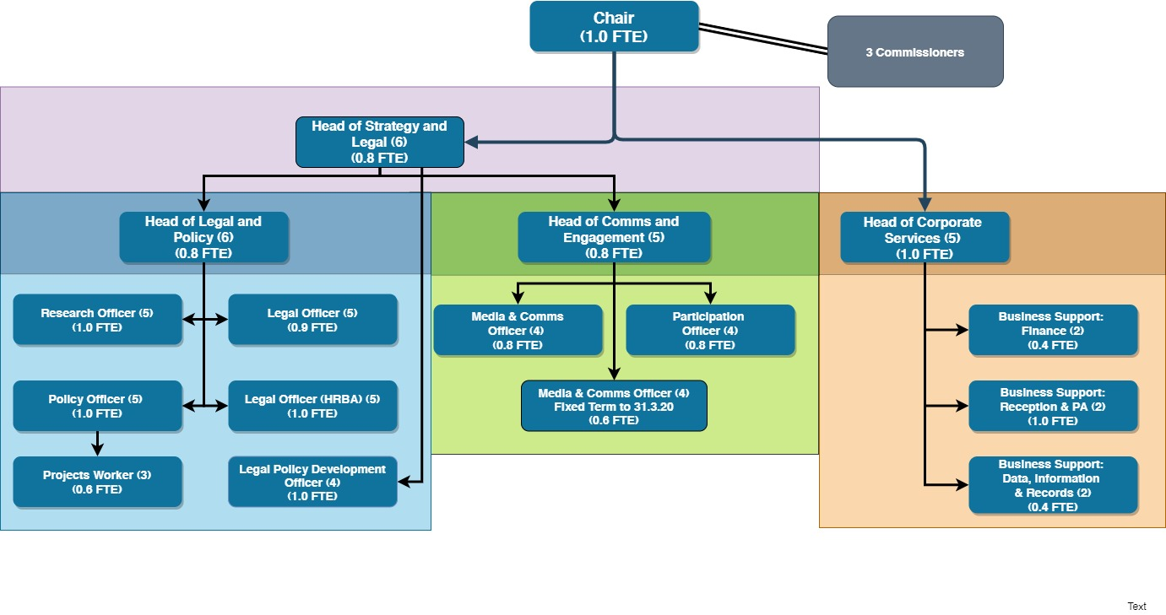

Benefits

Working Hours

Flexible working
The following describes the Commission’s flexible working arrangements under normal circumstances. In the current context the policy has been relaxed and all staff are working wholly remotely.
Flexitime is available to the role holder in accordance with the Commission’s Flexible Working Policy. Flexitime is restricted on a Wednesday when the role-holder is required to work their normal number of hours during core business hours (10am – 4pm).
The role can be worked remotely subject to business requirements being met in relation to in-office contact time with colleagues, managers and external stakeholders as required. The role has been assessed as requiring availability for a flexible office-based presence of around 2 days per week on average. The on average level cannot be guaranteed each week and days worked remotely may vary week to week due to the variability of business requirements. The role-holder is required to be in the office on Wednesdays as above to ensure availability for all staff and team meetings.

Pay structure
This Legal Policy Development Officer role is a grade 4 role within our pay structure.
Grade 6 (£35,586 - £44,322)

Pension
Commission employees are eligible to join the Civil Service Pension scheme. From 1 April 2015, a new Civil Service pension scheme - Alpha - was introduced. Alpha is a Career Average pension scheme.

Annual Leave
30 days annual leave plus 11.5 public holidays (pro rata for part time hours)

Commitment to CPD
The Commission has a strong commitment to training and professional development and you will have access to training courses in core skills as well as policies to support continuing professional development.

How to Apply
To apply for this position, please send a completed application form to the Commission, either:
By email: recruitment@scottishhumanrights.com
By post: FAO Corporate Services
Scottish Human Rights Commission
Bridgeside House
99 McDonald Road
Edinburgh
EH7 4NS
You must complete an application form, CV’s will not be accepted. Applications should demonstrate how you meet the criteria for the role as outlined in the job description and person specification.
If you need to provide information in a different format please contact us to discuss.

Key Dates
The deadline for applications is 12 noon on 2 September 2020
Interviews will take place via video conference, dates may be subject to change but are likely to take place during the week commencing 21 September 2020.

Participation in interview
The Commission’s office is currently closed and all interviews will take place via video conference. If there are any barriers to you taking part in an interview in this form please contact us at recruitment@scottishhumanrights.com.
Applicants must have the right to work in the UK to be eligible to apply.

Equality and Diversity
If you would like to discuss adjustments to the recruitment process that would enable your participation please contact us at recruitment@scottishhumanrights.com

Disclosure and Pre-Appointment Checks
The successful candidate for this post will be asked to apply for Baseline Security Clearance and a Basic Level Disclosure Scotland Certificate and/ or a country equivalent if the candidate has lived in another country in the past three years. We will undertake pre-appointment checks of references, ID, permission to work in the UK and any education certificates listed in the application form. Confirmation of employment will be subject to these checks being completed satisfactorily. The Commission will facilitate and cover the cost of the checks and certificates. If you want to discuss this requirement, in confidence, at any time please contact us at recruitment@scottishhumanrights.com.

