Recruitment Information
Head of Legal and Policy
Fixed - term post to 31 March 2022 (with possibility of extension)
Part time (29 hours 36 minutes per week)

August 2020

About the Scottish Human Rights Commission
The Scottish Human Rights Commission is an independent public body with a broad remit to promote and protect human rights for everyone in Scotland. We are independent of government and parliament.
The Commission works on a range of legal, policy and practical issues which affect people’s human rights in Scotland. Current areas of work include housing, social security, health and social care, policing and prisons, business and human rights, and biometrics.
As well as monitoring law, policy and practice, the Commission also promotes awareness, understanding and respect for human rights. We produce resources to support other organisations to take a human rights based approach to their work, and to help build understanding of human rights among the wider public.

About the Job

General
Job Title: Head of Legal and Policy
Working Pattern: 29 hours 36 minutes per week worked flexibly
Duration: Fixed term to 31 March 2022 (with possibility of extension)
Team: Legal and Policy
Reports to: Head of Strategy and Legal
Location: Based in Bridgeside House, 99 McDonald Road, Edinburgh, EH7 4NS. Currently remote working is in place.
Salary banding: Grade 6 (£57,286 - £70,714 pro rata)
Appointments will usually be made at the bottom of the salary band

Overall purpose
This role will lead the Legal and Policy team of the Commission and provide high-level oversight of the developing human rights legal and policy agenda. The post holder is a member of the Commission senior management team.

Budgets Controlled
This post has delegated responsibility for the budget of the Legal and Policy Team.

Core Areas of Responsibility and Key Activities

Policy and Legal Advisor
To act as senior adviser to the Head of Strategy and Legal and the Commission on all areas of human rights law and policy.
To provide senior sign off on legal and policy work in line with internal protocols.
To support the Head of Strategy and Legal and the Commission with the development of the Strategic Plan and the annual Operational plan, ensuring the organisation’s work is fit for purpose and in line with the Scottish Commission for Human Rights Act 2006.
To ensure that the work of the Commission is in accordance with the Scottish Commission for Human Rights Act 2006.
To advise the Commission on the requirements of the UN “Paris Principles” and international best practice among national human rights institutions.

Programme management
To effectively lead and manage a team of professionals undertaking high quality research, policy analysis and project work in accordance with the Commission’s legal powers, training and capacity building where appropriate.
To be a member of the Commission senior management team and contribute to overall organisational development.
To undertake a senior representational role to a wide range of stakeholders, including media
To work with communications staff of the Commission to effectively promote policy and legal outputs of the Commission.

Programme delivery
To undertake as required leadership and delivery of key areas of programme work in particular in relation to the Commission’s legal powers.

Person Specification

Formal Qualification/s
Law Degree (E)
Masters in Human Rights or equivalent relevant work experience (E)

Knowledge
Demonstrable in depth and up to date applied knowledge and understanding of human rights law, policy and practice, human rights and related issues and the Scottish context (E)

Experience
Scots law qualified lawyer with substantial post qualifying experience working in the field of human rights law and policy and other related areas such as equality and non-discrimination (E)
Demonstrable experience in court litigation including strategic human rights litigation (E)
Proven experience of leading and developing a team of professionals with diverse skills (E)
Experience of working with public authorities and operating in a similar political setting (D)
Extensive representational, networking and public speaking experience at the highest level (D)
Project management experience and skills (D)
Budget management experience (D)

Skills
Well-developed research and analysis skills (E)
Excellent oral and written communication skills in a human rights context (E)
Well-developed research and policy development skills (E)
Well-developed organisational skills (E)
Strong interpersonal skills and a confidential and sensitive approach (E)
Excellent IT skills (D)

Other
Attention to detail (E)
Political awareness (E)
Ability to work independently but also within a small team (E)
Flexible approach (D)

Additional Information
Some international travel may be required.

Potential for Flexible Working
A Flexible Working Role Assessment has been prepared and is available separately.

Review
Every job description in the Commission will be subject to a review in the following situations:
- on an annual basis at the time of the annual appraisal meeting;
- as a result of a change in strategic direction;
- as a result of a team/ operational requirements;
- as a result of agreed performance appraisal needs and objectives; or
- within six months of appointment

Organisational Structure
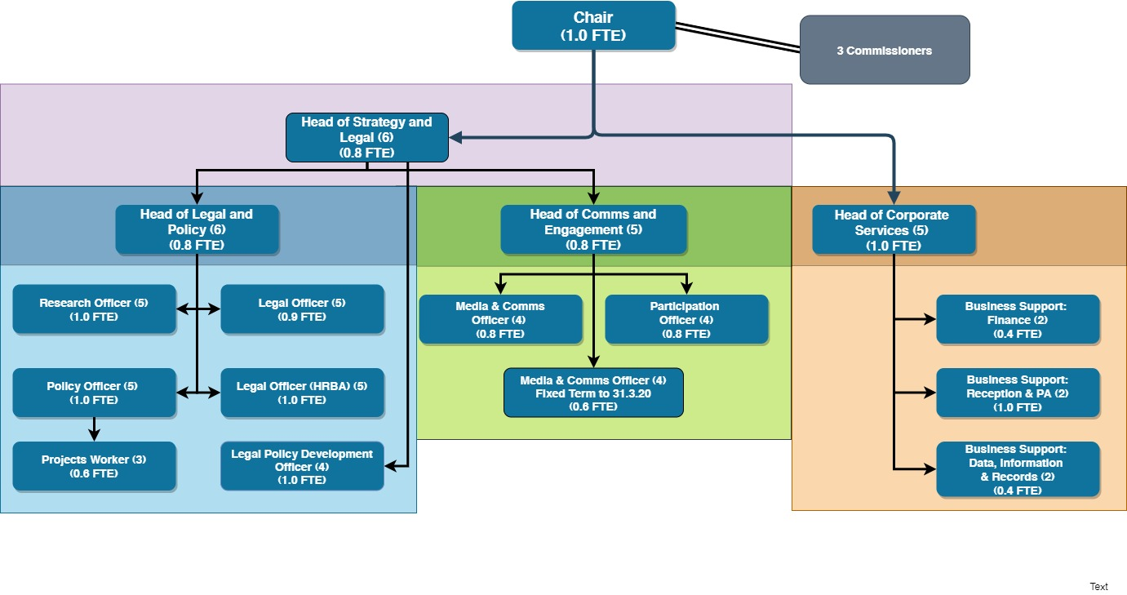

Benefits

Working Hours

Flexible working
The following describes the Commission’s flexible working arrangements under normal circumstances. In the current context the policy has been relaxed and all staff are working wholly remotely.
Flexitime is available to the role holder in accordance with the Commission’s Flexible Working Policy. Flexitime is restricted on a Wednesday when the role-holder is required to work their normal number of hours during core business hours (10am – 4pm).
The role can be worked remotely subject to business requirements being met in relation to in-office contact time with colleagues, managers and external stakeholders as required. The role has been assessed as requiring availability for a flexible office-based presence of around 2 days per week on average. The on average level cannot be guaranteed each week and days worked remotely may vary week to week due to the variability of business requirements. The role-holder is required to be in the office on Wednesdays as above to ensure availability for all staff and team meetings.

Pay structure
This Head of Legal and Policy role is a grade 6 role within our pay structure.
Grade 6 (£57,286 - £70,714 pro rata)

Pension
Commission employees are eligible to join the Civil Service Pension scheme. From 1 April 2015, a new Civil Service pension scheme - Alpha - was introduced. Alpha is a Career Average pension scheme.

Annual Leave
30 days annual leave plus 11.5 public holidays (pro rata for part time hours)

Commitment to CPD
The Commission has a strong commitment to training and professional development and you will have access to training courses in core skills as well as policies to support continuing professional development.

How to Apply
To apply for this position, please send a completed application form to the Commission, either:
By email: recruitment@scottishhumanrights.com
By post: FAO Corporate Services
Scottish Human Rights Commission
Bridgeside House
99 McDonald Road
Edinburgh
EH7 4NS
You must complete an application form, CV’s will not be accepted. Applications should demonstrate how you meet the criteria for the role as outlined in the job description and person specification.
If you need to provide information in a different format please contact us to discuss.

Key Dates
The deadline for applications is 9 am on 31 August 2020
Interviews will take place via video conference, dates may be subject to change but are likely to take place during the week commencing 14 September 2020.

Participation in interview
The Commission’s office is currently closed and all interviews will take place via video conference. If there are any barriers to you taking part in an interview in this form please contact us at recruitment@scottishhumanrights.com.
Applicants must have the right to work in the UK to be eligible to apply.

Equality and Diversity
If you would like to discuss adjustments to the recruitment process that would enable your participation please contact us at recruitment@scottishhumanrights.com

Disclosure and Pre-Appointment Checks
The successful candidate for this post will be asked to apply for Baseline Security Clearance and a Basic Level Disclosure Scotland Certificate and/ or a country equivalent if the candidate has lived in another country in the past three years. We will undertake pre-appointment checks of references, ID, permission to work in the UK and any education certificates listed in the application form. Confirmation of employment will be subject to these checks being completed satisfactorily. The Commission will facilitate and cover the cost of the checks and certificates. If you want to discuss this requirement, in confidence, at any time please contact us at recruitment@scottishhumanrights.com.

