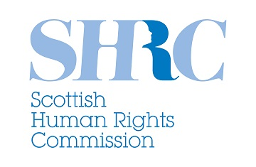
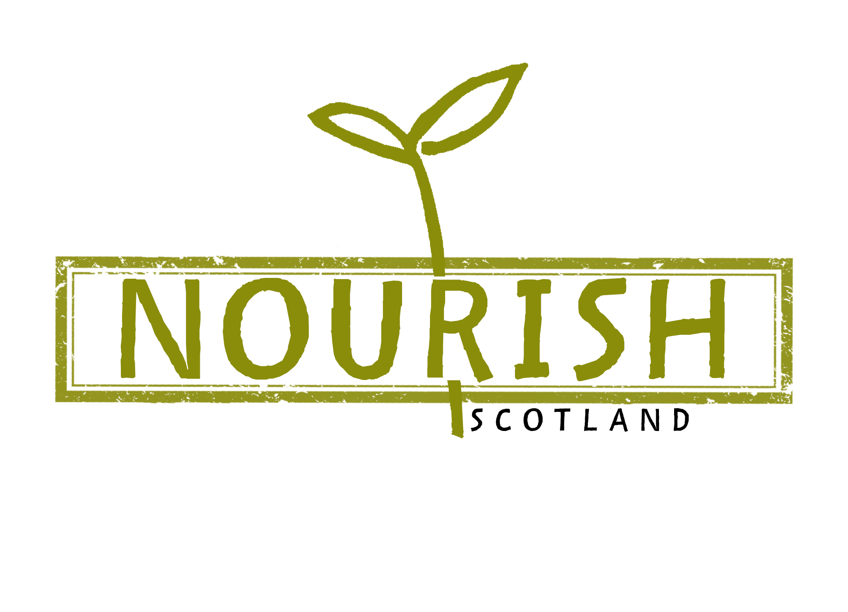

Invitation to Quote:

Animation on the Right to Food

PURPOSE

This brief sets out an opportunity to create a short animation to raise awareness and understanding of the right to food. The animation is being commissioned by the Scottish Human Rights Commission, working in partnership with Nourish Scotland. See appendices 1 and 2 for more information about both organisations.

BACKGROUND

What is the right to food?

Right to food is a basic human right. It is protected internationally by various specialised human rights instruments and guidance. These all provide detailed standards and commentary on countries’ obligations to respect, protect and fulfil the right to food. The complex nature of the laws and guidance around the right to good means it can be a difficult topic to fully understand. For more information see appendix 3.

The general obligations set by the right to food (and other economic, social and cultural rights) are to ensure that the “maximum of available resources” are used to progressively realise the right to adequate food. To realise the right to food, food must be available, accessible and adequate.

Availability - food should be available for sale in markets and shops. Food should be available from natural resources.

Accessibility - food must be affordable. People should be able to afford food for an adequate diet without compromising on any other basic needs, such as school fees, medicines or rent. Physical accessibility means that food should be accessible to all, including people who are physically vulnerable.

Adequacy - food must satisfy dietary needs. Food should be safe for human consumption and free from contaminants including residues from pesticides, hormones or veterinary drugs. Adequate food should also be culturally acceptable so religious and cultural taboos must be accommodated.

Fulfilling these outcomes requires that states respect, protect and fulfil the right to food.

Good Food Nation Bill

The Scottish Human Rights Commission and Nourish Scotland have both called on the Scottish Government to put human rights and the principles of dignity and respect, at the heart of any new legislation on the food system – specifically the Good Food Nation Bill.

Both organisations believe that explicit recognition of the right to adequate food as a human right would ensure that the system plays a fundamental role in: addressing issues of food insecurity, workers’ rights, environmental degradation and lack of land access.

THE BRIEF

Aim

The aim of the animation is to explain the right to food, and how it can be realised, in a simple, engaging and informative way.

Audience

The target audiences for the animation will be:

- the general public – i.e. people whose right to food is affected in practice
- people working in relevant third sector and civil society organisations
- policy makers including politicians and government officials
- people working in public services

Content, tone and message

The animation should convey the following key messages:

- Everyone has a human right to food.
- The right to food is protected by international laws and guidance that Scotland has signed up to follow.
- The Scottish Government is responsible for protecting and progressing the right to food for people.
- Realising the right to food in practice needs a system-wide approach.
- Incorporating the right to food into Scotland’s domestic laws would help to make it reality in people’s lives.

The animation should also explain or illustrate the key elements of the right to food (availability, adequacy, accessibility) described above.

Focus groups are being held with target audiences to identify further key messages and concepts. The Scottish Human Rights Commission and Nourish Scotland will develop a draft script for the animation, but proposals should also include creative support with this aspect of the production process.

The tone should be optimistic, simple, bold and engaging.

The maximum running time should be around three minutes (180 seconds).

Visuals

The style should be impactful and professional. It should complement the style of these existing animations made for the Scottish Human Rights Commission:

- Right to Social Security
- Disabled People’s Rights in Scotland
- Human Rights in Scotland
- Human Rights, Scotland and the United Nations

How will the animation be used?

The animation will be hosted on both the Scottish Human Rights Commission and Nourish Scotland websites, YouTube and social media channels. It will also be used at events and presentations relevant to the topic. We would like to use a selection of stills as memes to encourage people to view the animation on social media.

Accessibility

Both the Scottish Human Rights Commission and Nourish Scotland are committed to making their communications as accessible as possible. This animation should be accessible to people with visual and hearing impairments (e.g. through subtitled and audio-described versions), BSL users and to people with learning disabilities (e.g. through accessible language). Costs and arrangements for providing the range of formats required should be included in proposals.

Timescales

Our indicative timeline for this project is as follows, although we are able to be flexible.

Mon 24 June: deadline for tenders (5pm)
Fri 28 June: contractor appointed
w/c 15 July: creative meeting with SHRC & Nourish Scotland staff
w/c 5 August: final script and storyboards ready for audience testing
Fri 23 August: feedback from audience testing shared
w/c 2 September: script and storyboards revised and approved
w/c 9 September: animation into production
Fri 20 September: final product delivered

Budget

We anticipate a maximum budget of £5,000 including VAT for the production of the main animation. Additional costs for providing the animation in alternative formats e.g. BSL, audio-described should also be included, but should be detailed separately in proposals.

Submitting a bid

Please submit a bid of no more than six pages, outlining:

- The creative approach you would take to this project.
- Your previous experience of bringing complex topics to life through animation.
- Your experience of responding to and engaging with audience testing and feedback processes.
- Your understanding and experience of developing content that takes account of equality, diversity and inclusion considerations.
- Any demonstrable examples of success in supporting organisational objectives, for example evidence that your animation has helped to influence positive change in attitudes or understanding.
- Your approach to ensuring the animation is accessible to our intended audiences.
- Breakdown of costs.

Please submit your bid to stephanie@nourishscotland.org.uk and emma.hutton@scottishhumanrights.com by 5pm on Monday 24 June 2019. Please also direct any questions to Stephanie and Emma via email or call Emma on 0131 297 5750.

Appendix 1: The Scottish Human Rights Commission

“The Commission's general duty is, through the exercise of its functions under this Act, to promote human rights and, in particular, to encourage best practice in relation to human rights.”

Scottish Commission for Human Rights Act 2006, section 2(1)

The Scottish Human Rights Commission is Scotland’s National Human Rights Institution with a statutory mandate to promote and protect human rights for everyone in Scotland. The Commission is an internationally recognised Human Rights Institution with A-status accreditation within the United Nations system.

The Commission has a general duty to promote awareness, understanding and respect for all human rights - economic, social, cultural, civil and political - to everyone, everywhere in Scotland, and to encourage best practice in relation to human rights.

We fulfil this duty through recommending appropriate changes to Scottish law, policy and practice, education, training, guidance, publications, raising awareness and research.

Appendix 2: Nourish Scotland

Nourish Scotland is a registered charity and a food justice NGO. We work in partnership with people with lived experience, producers, community groups, other NGOs, public bodies and other decision-makers to put fair, sustainable, healthy food at the heart of Scotland’s food system.

We campaign for the necessary changes to law, policy and practice to make this a reality. We advocate for a rights-based approach and support Food Sovereignty principles.

Food is at the heart of many of the major crises we collectively face today, from the destruction of our natural world to the pervasiveness of diet-related illness and household food insecurity. These issues have not come about by accident; they are a result of a food system in which power is highly concentrated, and in the hands of a shrinking number of exceptionally powerful organisations, with limited and fragmented government intervention.

Nourish Scotland believes that only a transformation of the whole food system will result in effective and sustainable solutions. Our distinctive contribution is that we read across food issues – health, inequality and social justice, environmental justice, and the local food economy. We also link the levels, supporting grassroots community efforts and influencing national policy and legislation – and using each to inform the other.

Appendix 3: The Right to Food

The right to food is protected in a range of international human rights treaties including: Article 25 of the Universal Declaration of Human Rights as part of the right to an adequate standard of living. It is also enshrined in the 1966 International Covenant on Economic, Social and Cultural Rights (Article 11). As well as General Comment 12 of the UN Committee on Economic, Social and Cultural Rights.

The Scottish Human Rights Commission and Nourish believe human rights provide a legal and objective foundation to the concepts of 'dignity' and 'respect' to be built into the new Scottish food system. Human rights also help to reframe access to food as a right and entitlement to be realised in support of the realisation of all other human rights and broader social justice.

Both organisations believe the Scottish Government should adopt a human rights based approach to the development, delivery and monitoring of accessibility, availability and adequacy of food to ensure the system respects, protects and fulfils everyone’s right to food.

For more information see: http://www.scottishhumanrights.com/news/change-the-law-to-protect-the-right-to-food-for-all/

