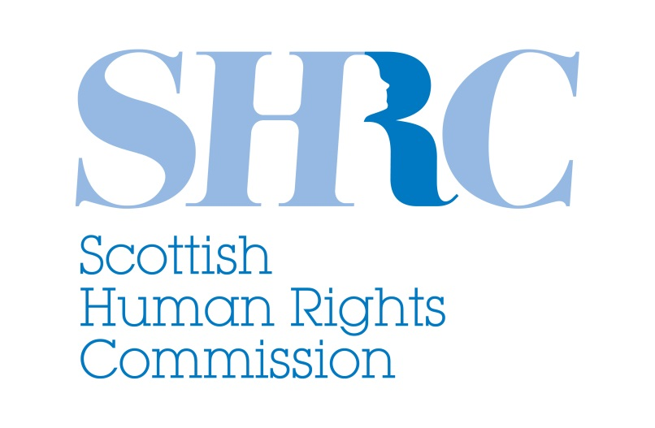

**Scottish Human Rights Commission**

**British Sign Language (BSL) Plan**

**2018-2024**

**DRAFT FOR CONSULTATION**

**1. INTRODUCTION**

**1.1 Introduction**

This is the draft British Sign Language (BSL) Plan for the Scottish Human Rights Commission. The Commission is an independent public body with a statutory duty to promote and protect human rights for everyone in Scotland. This Plan has been produced in line with the requirements of the BSL (Scotland) Act 2015. It sets out actions we will take between 2018 and 2024 to promote the use of BSL in our work**.**

Our draft BSL Plan follows the BSL National Plan, published on 24 October 2017, which was developed through engagement with Deaf and Deafblind BSL users and those who work with them. It is framed around the same long-term goals as the national plan, where these are relevant to the Scottish Human Rights Commission.

The Scottish Human Rights Commission promotes and protects the human rights of everyone in Scotland. The rights set out in the Convention on the Rights of Persons with Disabilities (CRPD) are particularly relevant to the BSL Scotland Act. The Commission is committed to realising the rights of BSL users including those who use the tactile form of the language.

The Commission recognises that BSL is a language in its own right and that BSL users, like everyone else in Scotland, have a right to engage with and access information about our work without unnecessary barriers. We recognise that many BSL users neither use nor understand English and that, for some, written or spoken English is not their first or second language.

**Whenever we refer to ‘BSL users’ we mean D/deaf and/or Deafblind people (those who receive the language in tactile form due to sight loss) whose first or preferred language is British Sign Language.**

The Commission has involved BSL users in developing this draft through joint work with the Scottish Parliamentary Corporate Body, the Commissioner for Children and Young People in Scotland, the Commissioner for Ethical Standards in Public Life, the Scottish Information Commissioner, the Scottish Public Services Ombudsman and the Standards Commission for Scotland. This included collective organisation and participation in two drop-in events for BSL users held at the Scottish Parliament in May 2018, and a review of feedback provided by BSL users through a video booth.

The Commission is committed to continuing to engage with BSL users when it comes to implementing the actions identified in this draft plan, and to gathering feedback on our progress.

The Commission will also contribute to a national progress report on the BSL National Plan in 2020.

We welcome comments on our draft BSL Plan. Please contact Emma Hutton, the lead officer for this plan, with any questions, comments, ideas or suggestions by Friday 14 September 2018. Emma’s contact details are given below. You can give your comments to Emma in any format including video, letter, email, telephone via contactScotland or via social media.

**1.2 Lead officer**

The lead officer for this plan is:

Emma Hutton  
Communications and Participation Manager  
Scottish Human Rights Commission   
Governor’s House  
Regent Road  
Edinburgh  
EH1 3DE

[emma.hutton@scottishhumanrights.com](mailto:emma.hutton@scottishhumanrights.com)  
0131 244 4244  
Twitter: @scothumanrights

British Sign Language (BSL) users can contact us via [contactSCOTLAND-BSL](http://contactscotland-bsl.org/) [cid:image001.gif@01D1966E.ADD680A0](http://contactscotland-bsl.org/)

**1.3 Where to find the BSL version of this plan**

The BSL version of this plan is available:

* on the Scottish Human Rights Commission’s website [www.scottishhumanrights.com](http://www.scottishhumanrights.com)
* on the Commission’s Facebook page
* on the Commission’s YouTube channel

**2: DRAFT BSL PLAN**

**This section sets out the actions we will take to promote the use of BSL in all of the Commission’s work to promote and protect human rights for everyone in Scotland.**

**2.1 Across all our services**

We share the long-term goal for all Scottish public services set out in the BSL National Plan, which is:

*“Across the Scottish public sector, information and services will be accessible to BSL users.”*

By 2023, we will:

* Analyse existing evidence we have about BSL users who currently engage with us, and identify and fill any information gaps so that we can establish baselines and measure our progress.
* Work with BSL users to make content provided on our website and other digital communications channels more accessible to BSL users.
* Engage, support and empower BSL users to participate meaningfully in events, policy development processes and other activities that we undertake.
* Review and improve the range of information about our functions, activities and human rights more generally that is available in BSL.
* Promote the use of the Scottish Government’s nationally funded BSL online interpreting video relay service called contactSCOTLAND-BSL and explore the potential for its greater use.
* Arrange appropriate BSL awareness training for our staff and Commissioners.

**2.2 Our contribution to relevant long-term goals**

|  |
| --- |
| We share all of the long-term goal in the BSL National Plan. The long-term goal for democracy is particularly relevant to the Commission. This goal is:  *“BSL users will be fully involved in democratic and public life in Scotland, as active and informed citizens, as voters, as elected politicians and as board members of our public bodies”* |

To help achieve this goal, by 2023, the Commission will:

* Work with the Scottish Parliamentary Corporate Body to produce information about appointments to the Commission in BSL, and to promote any available appointments specifically to BSL users.
* Take proactive steps to identify, engage and support BSL users to take part in the Commission’s public participation processes and structures including public events, reference groups, surveys and other consultation exercises.
* Ensure that any new information we produce about human rights and the Commission’s work is available in BSL wherever possible and practicable, including our Annual Report, our policy positions and education materials we produce. We will consult with BSL users about which information should be prioritised for production in BSL.
* Review our current stock of information about human rights and the Commission’s work and ensure key items are translated into BSL, in consultation with the BSL community.
* Provide and present information about human rights and the Commission’s work to appropriate forums of D/deaf and Deafblind BSL users.
* Monitor both the quantity and proportion of information we produce in BSL and seek to increase this year-on-year.

**3: WHAT HAPPENS NEXT?**

This is our draft BSL plan.

We will make it available in BSL and share this with BSL users on our website, through appropriate Facebook channels and on YouTube. We will also work with Deafblind Scotland to identify the most appropriate ways to make it available to Deafblind BSL users.

We will work collaboratively with the Scottish Parliamentary Corporate Body and a range of other public bodies to ensure that our draft BSL plan is accessible in the same way as their draft BSL plans, so that BSL users can engage and comment on all of our draft plans together.

BSL users can give us comments on our draft plan by 14 September 2018 using their preferred method of communication including video message, video relay via ContactScotland, email, Facebook, Twitter or any other way.

We will review the feedback we receive by the end of September 2018. A final version of the plan will be published in October 2018 in English and BSL.

Please contact Emma Hutton if you want to continue to be involved as we further develop and implement the actions in our plan.