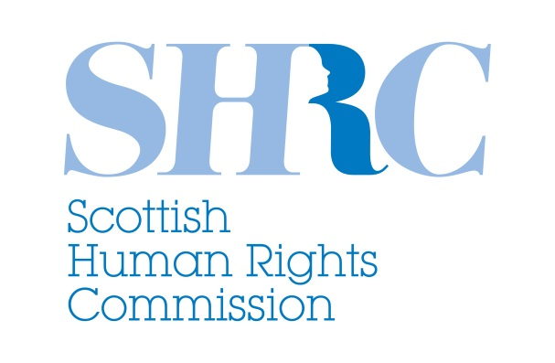
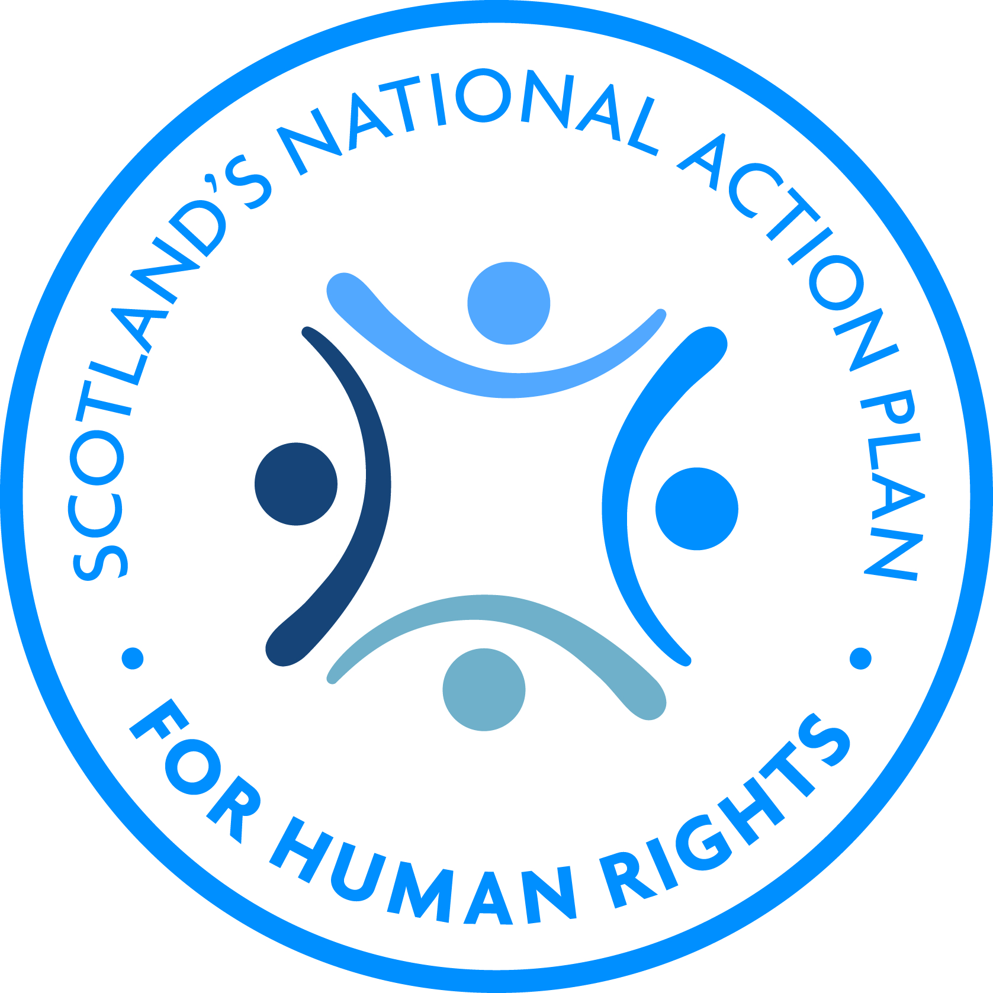

Call for participants: Reference Group on Poverty and Adequate Standard of Living

The Scottish Human Rights Commission is working with our partners to implement Scotland’s National Action Plan for Human Rights, or SNAP. This is a roadmap towards making human rights a reality for everyone in Scotland. SNAP is focussing on a number of issues which affect people’s human rights, including poverty and austerity.

The Commission wants to make sure that both SNAP and our broader work is informed by the voices of people who experience poverty.
We would like to support people who experience poverty to influence decisions which affect them, using human rights as a tool for change. To do this, we are developing and supporting a reference group of people from across Scotland with different experiences of poverty.

The current members of the reference group would like new members to join the group. Anyone with direct experience of poverty is welcome to apply, but to make sure the group represents a range of experiences, current members are particularly interested in including:
- disabled people who experience poverty
- people who have mental health needs and experience poverty
- people who have experienced homelessness
- single parents and families with children experiencing poverty
- people with a job who experience poverty
- people living in rural areas who experience poverty
- asylum seekers and refugees who experience poverty
- people with experience of food poverty
- people experiencing fuel poverty
- people from the south, east and north of Scotland who are experiencing poverty
- people from ethnic minority communities who are experiencing poverty.
To be a part of the group, people should be willing to share their experiences, listen to other people, think about experiences different from their own and have an interest in human rights. People do not need to know about human rights to take part.

We recognise that people may need different types of support to be a part of the group. If you would like to talk about how we could support you to take part, please get in touch. We will be happy to help. We can pre-arrange travel or pay travel expenses. We can also pay other costs involved in taking part, for example support costs or childcare costs.

The first meeting of the group is likely to take place in late August 2015 in Glasgow. Meetings are likely to happen every 6-8 weeks, but dates will be agreed together by group members.

If you are interested in being a part of the group, please complete the form below and send it back to Chloë Trew, Participation Co-ordinator. If you need support to do this, please get in touch with Chloë. Chloë usually works from Monday to Wednesday. Please also feel free to pass this information on to anyone who you think would be interested in this project.

by phone 0131 240 2989 or 07833 402287
by e-mail ActionPlan@Scottishhumanrights.com
by post FAO Chloë Trew, Participation Co-ordinator
Scottish Human Rights Commission
4 Melville St
Edinburgh
EH3 7NS

Name:

Address:

Telephone:

Email address:

I prefer to be contacted by post – phone – e-mail

The kinds of experiences of poverty I want to talk about are:

We would like to know what kinds of support you would need to take part in the group. We have suggested some things below, but we are very happy to discuss other support needs with you.

Travel expenses:

Support to arrange travel:

Support or care expenses for myself or someone I support:

Childcare expenses:

Access requirements (please tell us about these or contact us to discuss these):

Another kind of support (please tell us what this is):

