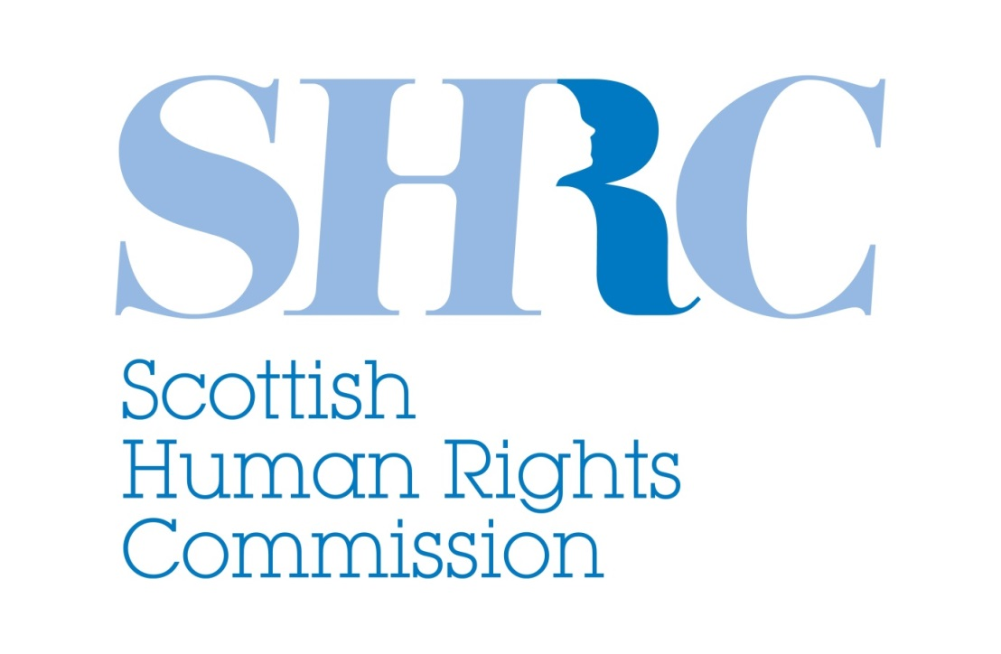

Audience baseline and insight research: understanding and awareness of human rights

Invitation to quote

January 2016

1. Introduction

The Scottish Human Rights Commission is an independent public body, accountable to the people of Scotland through the Scottish Parliament. The United Nations (UN) has accredited the Commission as an “A Status” National Human Rights Institution (NHRI).

The Commission’s duties and powers are set out in the Scottish Commission for Human Rights Act 2006. The Commission has a general duty to promote awareness, understanding and respect for all human rights - economic, social, cultural, civil and political - to everyone, everywhere in Scotland, and to encourage best practice in relation to human rights. We fulfil this duty through recommending appropriate changes to Scottish law, policy and practice; education, training and guidance; raising awareness; and research.

The Commission acts as a bridge between Scotland and the international human rights system. We monitor the implementation of international human rights treaties in Scotland, working closely with civil society to gather evidence of progress and gaps, and to produce recommendations for change. The Commission’s “A Status” accreditation means we can report directly to the UN on human rights issues. The Commission is one of over 100 NHRIs around the world, and one of three in the UK.

The Commission’s third Strategic Plan sets out our five priorities from 2016-2020 including “building a human rights culture in Scotland where human rights are respected, protected and fulfilled.” Among other activities, this involves a programme of work to raise the profile of human rights with a range of audiences including the public, political stakeholders, civil society and public authorities.

2. Objective

To inform and guide our own strategic communications activity and to provide insights to support the civil society organisations we work with, we would now like to commission some audience baseline and insight research. The aims of this research project are to:

- establish a baseline measure of current understanding and awareness of human rights among our public, civil society and public authority audiences;

- develop insight into which messages about human rights are most effective in raising awareness and understanding with these audiences; and

- develop insight into which messages about human rights are most effective in empowering others to protect and promote human rights in Scotland.

3. Scope

This research project will:

- Harness and build on previous methodologies used, and existing research findings and conclusions identified, in relation to public attitudes to human rights in Scotland. Further information will be provided to the successful research agency.

- In line with methodologies above, segment and analyse the Scottish adult population by clusters based on their relative levels of understanding, awareness and attitudes in relation to human rights issues, laws and standards.

- Provide qualitative and quantitative insights into the values held by each audience segment, drivers of their attitudes and views towards human rights, and their demographic characteristics.

- Facilitate the development of up to 40 communications messages for testing with audience segments, then test and evaluate the qualitative and quantitative impact of those messages on each audience segment’s levels of a) understanding and awareness of human rights and b) the Commission’s work to promote and protect human rights.

- Provide qualitative insights into current attitudes, values, drivers of attitudinal change, understanding and awareness, and the impact of different messages on that, held by a selected range of public authority and civil society audiences.

4. Audiences

This research will focus on the following key audiences:

- The population of adults living in Scotland (ideally 16+) as a whole, segmented into at least four clusters in line with previous research methodologies and findings (those opposed to human rights, supportive of human rights, persuadable about human rights, apathetic to human rights), and further segmented by levels of understanding and empowerment when it comes to using human rights.

- People working in health and social care settings, including mental health, and including frontline staff, managers, policy makers and leaders.

- People working in criminal justice settings, including frontline police, probation and prison staff, managers, policy makers and leaders.

- People working in poverty and social justice campaigning, advocacy and service provision settings, including frontline staff, managers, policy makers and leaders.

- People working in local government including frontline staff, managers, policy makers and leaders.

- People working in national public authorities with a monitoring, inspection, investigations and/or regulation function including frontline staff, managers, policy makers and leaders.

5. Methodology

The methodology for this research should incorporate:

- A review of existing research methodologies and findings available relating to public attitudes towards human rights in Scotland, including unpublished research to be provided by the Commission.

- An opportunity for Commissioners, Commission staff and selected partner organisations to participate in the detailed design of messages for testing and in the observation of qualitative elements of the research.

- Appropriate qualitative methodologies to generate baseline insights into key audience attitudes, understanding, awareness and empowerment when it comes to human rights, and drivers / opportunities to improve or change these.

- A nationally representative survey, segmentation, cluster analysis, message testing exercise, regression and key driver analysis of Scottish adults, with weighted boosting to ensure sufficient representation of minority groups.

- Analysis and reporting on findings and key insights by audience segment, sub-segment and demographic profile, presented in a format that enables and facilitates easy-access dissemination both within the Commission and to its wider stakeholders.

6. Outputs

The research should result in the following outputs:

- A full analytical report in Word, PowerPoint and/or PDF format, drawing together and summarising the findings, identifying the segments and themes that will play the biggest role in protecting and promoting human rights, and including an executive summary with key findings.

- All relevant findings expressed in chart, tables and diagrams with details of full results and methodology included as annexes.

- Transcripts/videos of any focus groups or similar qualitative exercises (for internal use only).

- Quantitative data files provided in SPSS or Excel format.

- Reports should be delivered fully proofed and referenced and to a standard ready for external publication .

7. Timetable
[TBC following discussion with appointed agency]
w/c 30 January appoint contractor
w/c 6 February agree detailed methodology, topic guide and timetable
w/c 20 February carry out qualitative elements
w/c 6 March carry out quantitative field work
w/c 13 March draft analysis and report submitted
w/c 18 April final report submitted

8. Budget

The budget for this project is £20,000 – £25,000 inclusive of VAT.

9. Selection criteria

Researchers and research companies should be able to demonstrate:

- A good understanding of the project requirements set out in this tender

- The ability to deliver the objectives of the project to the required timescales

- A substantial track record of successfully carrying out qualitative and large scale quantitative research

- The ability to analyse and report on research findings in ways that support policy and strategy development

- Experience of producing reports for a range of national level audiences including policy makers, civil society organisations, the research community and the general public.

- The ability to produce documents to a high standard of written communication and fit for publication.

- The ability to carry out and report on research to specified deadlines and within budget.

- Value for money

- Compliance with the spirit and the letter of equality and human rights legislation in all aspects of their work

- Compliance with relevant ethical and professional research standards

10. Submission details

Researchers and research companies should submit a short proposal of up to 3,000 words, with accompanying portfolios or CVs. Proposals should be submitted by email to emma.hutton@scottishhumanrights.com and kirsty.innes@scottishhumanrights.com by 10am on Monday 23 January 2017.

The proposal should demonstrate:

- how you will approach the project generally
- a proposed methodology with breakdown of all key elements, rationale for selection and outputs to be generated
- a detailed project timetable
- a breakdown of costs
- details of relevant skills and experience of all key project personnel.

For queries or clarifications, or to request a confidential copy of the previous unpublished research referred to in this brief, please contact kirsty.innes@scottishhumanrights.com (Mon – Wed) or emma.hutton@scottishhumanrights.com (Wed – Fri), or call 0131 244 3550.

