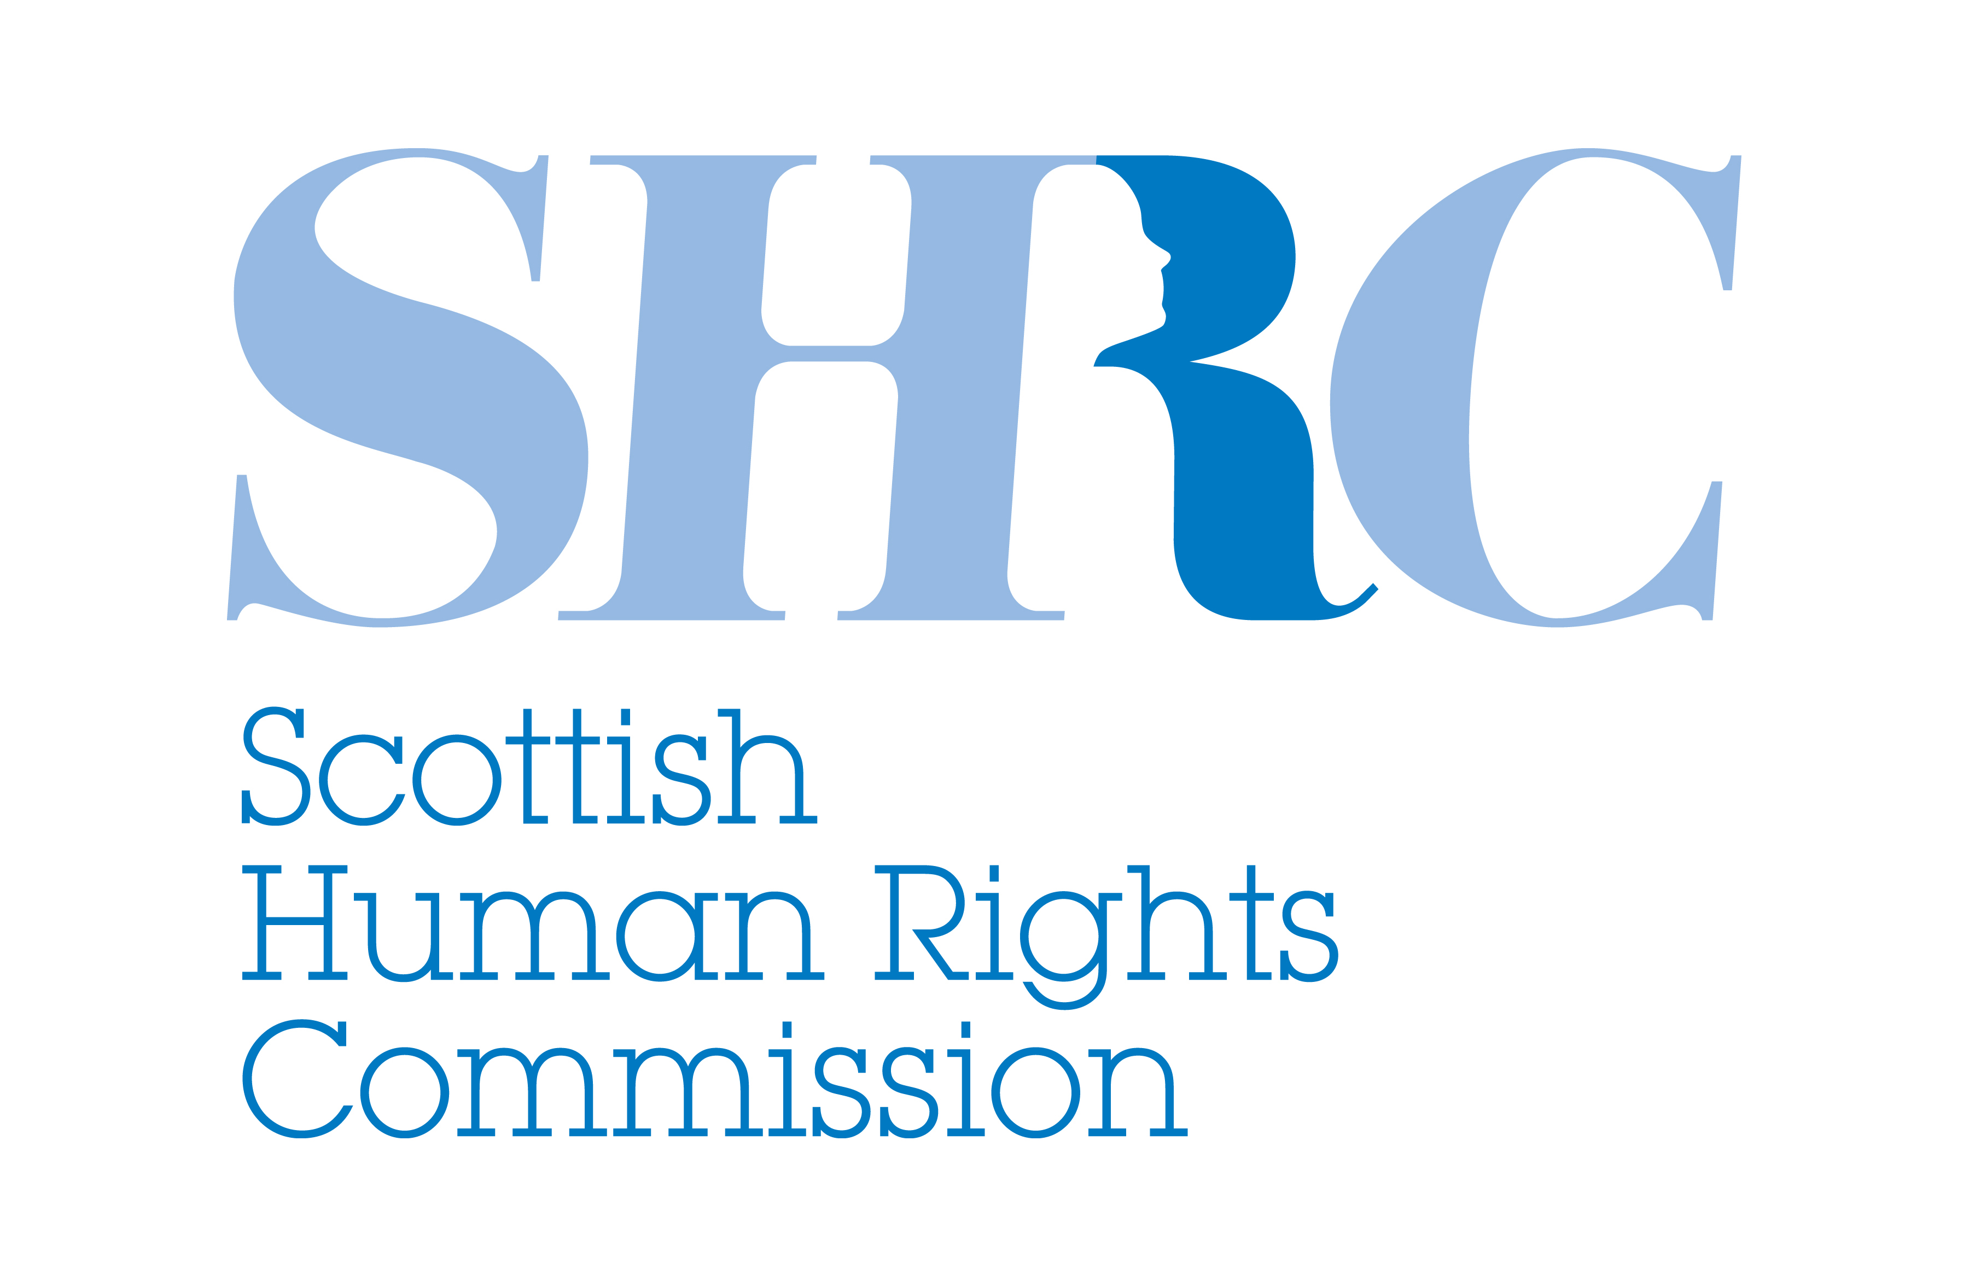

Children and Young People (Scotland) Bill
Written Evidence to the Education and Culture Committee

Scottish Human Rights Commission
26 July 2013

The Scottish Human Rights Commission is a statutory body created by the Scottish Commission for Human Rights Act 2006. The Commission is a national human rights institution (NHRI) and is accredited with ‘A’ status by the International Co-ordinating Committee of NHRIs at the United Nations. The Commission is the Chair of the European Network of NHRIs. The Commission has general functions, including promoting human rights in Scotland, in particular to encourage best practice; monitoring of law, policies and practice; conducting inquiries into the policies and practices of Scottish public authorities; intervening in civil proceedings and providing guidance, information and education.

Introduction

The Scottish Human Rights Commission (the Commission) welcomes the opportunity to contribute to the Education and Culture Committee Stage 1 consideration of the Children and Young People (Scotland) Bill (the Bill). The Commission welcomes the policy intentions behind the Bill.

The Commission makes three recommendations to ensure the best possible outcome for children and young people in Scotland:

- That the Scottish Government recommit to the full and direct incorporation of the United Nations Convention on the Rights of the Child (UNCRC) into Scots law and looks to develop a timetable for incorporation.

- That Section 1 is considerably strengthened and extended to all Scottish public authorities.

- That the Committee ask the Scottish Government to demonstrate how the impact of the Bill on children’s human rights has been assessed, and consider whether the Bill represents an opportunity to promote the use of human rights impact assessment, including child rights impact assessment.

The Commission also highlights a range of key issues of concern that relate to the full realisation of the rights of children and young people in Scotland, which has been raised during the development of Getting it Right? research project and the subsequent participation process to develop Scotland’s National Action Plan for Human Rights (SNAP).

1. Incorporation of the UNCRC

The UNCRC guarantees the full range of human rights—civil, cultural, economic, political and social rights for children. It has achieved almost universal ratification, with the exception of Somalia, South Sudan and the United States of America.

The UK voluntarily undertook to respect, protect and fulfill all of the rights in the UNCRC through the formal process of ratification in 1991. The UK Government, together with the devolved administrations have responsibility for implementing the UNCRC in the UK. As yet, the UK has not fully incorporated the UNCRC into domestic legal systems. The Welsh Assembly, while not incorporating the UNCRC, has adopted a measure requiring “due regard” to be given to the UNCRC and the Scottish Government has pledged to look at options for progressing incorporation.

Article 4 of the UNCRC sets out the general obligations of States Parties with regard to implementation. It requires States Parties to, inter alia:
“undertake all appropriate legislative, administrative, and other measures for the implementation of the rights recognised in the present CRC.”

The UN Committee on the Rights of the Child in its authoritative interpretation of this obligation clarifies that:
“States parties need to ensure, by all appropriate means, that the provisions of the Convention are given legal effect within their domestic legal systems.” The Committee welcomes incorporation as the approach to achieve this. As the Committee clarifies:
“Incorporation should mean that the provisions of the Convention can be directly invoked before the courts and applied by national authorities and that the Convention will prevail where there is a conflict with domestic legislation or common practice.”

The Committee has repeatedly called on the UK to incorporate the UNCRC fully into domestic laws, a call repeated during the Universal Periodic Review of the UK in 2008 and 2012. It has also expressed concern that a number of areas of national law remain inconsistent with the UN CRC, including the low age of criminal responsibility and the law related to corporal punishment of children. Along with a range of international, regional and national human rights bodies and civil society organisations, the Commission too has repeatedly echoed the calls for incorporation of this (and other) international human rights treaty into the Scottish legal system.

Incorporation provides comprehensive and consistent legal protection and would significantly enhance awareness of children’s rights in Scotland. Incorporation would also aid Scottish Ministers in ensuring compliance with the principles and provisions of the UNCRC and their legal duties under the Scotland Act 1998. However, the Scottish Government has clearly stated that it does not intend to incorporate the UNCRC through this legislation. Incorporation of the UNCRC, and its Optional Protocols, is long overdue in Scots law.

In a recent Study on the legal implementation of the UNCRC, UNICEF found that:
“In countries where there has been incorporation (Belgium, Norway, Spain), interviewees felt that children were more likely to be perceived as rights holders and that there was a culture of respect for children’s rights”

This Bill provides an opportunity to give statutory expression to the UNCRC in Scots law to enhance the effective realisation of children’s rights.

The Commission recommends that the Scottish Government recommit to the full and direct incorporation of the UNCRC into Scots law and looks to develop a timetable for incorporation.

2. Section 1 of the Bill : Duties of Scottish Ministers in relation to the rights of children

Section 1 of the Bill places a duty on Ministers to:
‘keep under consideration whether there are any steps which they could take which would or might secure better or further effect in Scotland of the UNCRC requirements’ and ‘if they consider it appropriate to do so, take any steps identified by that consideration’.

This represents a weaker duty than that first consulted upon in 2011. The current provision also falls below the duty contained in the Rights of Children and Young Persons (Wales) Measure 2011 and arguably represents a lesser obligation than that already placed on Scottish Ministers under the Scotland Act 1998 to “observe and implement” international obligations.

The wording of this provision does not reflect the requirements of Article 3 of the UNCRC, which states that
‘…in all actions concerning children, whether undertaken by public or private social welfare institutions, courts of law, administrative authorities or legislative bodies, the best interests of the child shall be a primary consideration’

The Commission considers that the language contained in this provision is too weak and gives too much discretion to the Ministers to ensure compliance. As a consequence both the policy aim and government accountability are likely to be unsuccessful.

Section 1 is one of the key provisions of the Bill. In the absence of full and direct incorporation of the UNCRC this Section should be considerably strengthened and extended to all Scottish public authorities.

Further, Section 6 of the Rights of Children and Young Persons (Wales) Measure 2011 provides a power to amend legislation by order where it is within legislative competence and where it relates to an issue raised through regular reports from Welsh Ministers on the due regard duty. A similar provision may be considered for inclusion in the present Bill. It would be crucial to ensure that any powers to amend legislation were subject to the appropriate level of Parliamentary scrutiny.

The Commission recommends that Section 1 is considerably strengthened and extended to all Scottish public authorities.

3. Human Rights Impact Assessments (HRIA)

The UN Committee on the Rights of the Child has made clear in its General Comments that effective implementation of the UNCRC cannot be achieved by legislative measures alone. There a number of additional measures which are required for effective protection and fulfilment of children’ rights. Key tools to ensure children’s human rights are respected, protected and fulfilled in practice include HRIA and budgetary analysis in legislation, policy and practice related to children.

HRIA is one of the key approaches to achieve the systematic integration of human rights into the policies, practices, procedures and priorities of government, public and private bodies. Following a review of international and national best practice, the Commission promotes an integrated approach to impact assessment and is currently piloting an integrated equality and human rights impact assessment process with Fife and Renfrewshire Councils. Human rights impact assessment is inclusive and draws on the range of international human rights obligations undertaken by the State, including the UNCRC, which should be at the heart of decisions which affect children.

Ensuring that children’s rights are respected in policy and law demands a continuous process of child rights impact assessment to consider the impact of any proposed law, policy or budgetary allocation on children’s rights. This process should be built into all levels of governance. In this respect, we understand that the Scottish Government has not carried out a HRIA on the Bill prior to its introduction in Parliament. The Commission notes that a number of children’s rights organisations including UNICEF UK have also recommended that a child rights impact assessment be included on the face of the Bill. This would have provided a valuable resource to the Education & Culture Committee in their consideration of the Bill through the Parliamentary process.

There are good examples of HRIA, focused on child rights, being introduced in the legislative review process. Sweden, in particular, has had a system of child impact assessment for some years, as part of its wider national child rights strategy. The Flemish Parliament in Belgium requires all draft legislation affecting children to be accompanied by a child impact assessment when presented to Parliament since 1997. Scotland's Commissioner for Children and Young People has developed a comprehensive model of a stand-alone human rights impact assessment focus on children rights.

The Commission recommends that the Committee ask the Scottish Government to demonstrate how the impact of the Bill on children’s human rights has been assessed, and consider whether the Bill represents an opportunity to promote the use of human rights impact assessment, including child rights impact assessment.

Scotland’s National Action Plan for Human Rights
On 10 December 2013, Scotland’s first National Action Plan for Human Rights (SNAP) will be launched. Its purpose is to focus and coordinate action by public, private, voluntary bodies and individuals to achieve human dignity for all through the realisation of internationally recognised human rights. The evidence base for this action plan has been drawn from a three-year research project and subsequent national participation process to identify the key injustices as well as good practices in human rights realisation in Scotland.
This research has highlighted a range of key issues of concern that relate to the full realisation of the rights of children and young people in Scotland. Particular concern was raised about the rights of looked after children, kinship children and care leavers; children with parent/s in prison; children with disabilities, learning disabilities, mental health problems and those with Autistic Spectrum Disorders; children living in poverty, children with additional educational needs; Scottish Gypsy/ Traveller children; and LGBTI young people.
The Children and Young People (Scotland) Bill provides a timely opportunity to address many of the issues relating to children and young people that are raised within Getting it Right? and the Commission strongly recommends that further consideration is given to the issues. The Commission also wishes to emphasise the importance of participation in the reshaping of this Bill. It is critical that participation goes beyond ‘consultation’ and that the voices of those concerned are not just heard but are actively and constructively engaged in reshaping the Bill.

The Commission trusts that these comments will be of assistance to the Committee.

End

For a brief explanation of these see section 5 of this submission.
Scottish Government (2009) Do the Right Thing: A Response by the Scottish Government to the 2008 Concluding Observations from the UN Committee on the Rights of the Child.
UN Committee on the Rights of the Child, General Comment No. 5 General measures of implementation of the Convention on the Rights of the Child, UN Doc. CRC/GC/2003/5, 27 November 2003, Para 19. See also UNICEF (2012) The UN Convention on the Rights of the Child: a study of legal implementation in 12 countries. Available at http://www.unicef.org.uk/.
Ibid, para 20.
UN CRC Concluding Observations on the UK in 2002 CRC/C/15/Add.188 and in 2008 CRC/C/GBR/CO/4
Ibid.
See for example ‘The Future of Human Rights in Scotland’ and Universal Periodic Review Parallel Report to the UN Human Rights Council, available at http://www.scottishhumanrights.com/
Under the Scotland Act 1998 it would be possible for Scotland to incorporate the CRC in relation to devolved matters. Schedule 5 section 7.
Op cit 2.
Scottish Government (2011), Consultation on Rights of Children and Young People Bill.
See for example UN CRC General Comment No. 5 (2003)
For further information see Impact Assessment at http://www.scottishhumanrights.com/ourresources/hreqiamaincontent
Scottish Government (2011), Consultation on Rights of Children and Young People Bill.
UNICEF UK submission to the Scottish Government consultation on the Rights of Children and Young People Bill. 2012
For further information see Unicef (2012) The UN Convention on the Rights of the Child: a study of legal implementation in 12 countries. Available at http://www.unicef.org.uk/. p. 24
Child Impact Reporting (2006). K Hanna et all. Social Policy Journal - Issue 29
The research report Getting it Right? Human Rights in Scotland and the Participation Report can both be found here: http://scottishhumanrights.com/actionplan/participationphase.
Lesbian, Gay, Bisexual, Transgender and Intersex.

