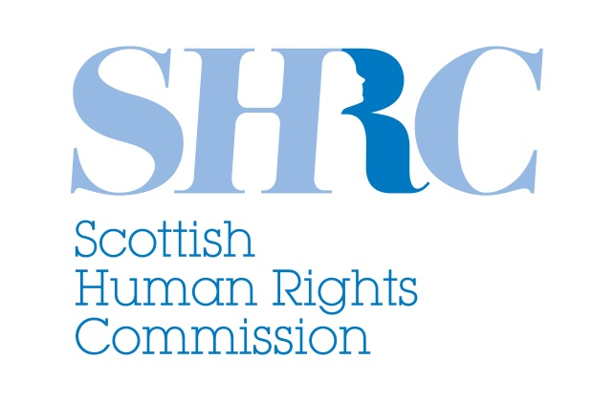

Submission to the Smith Commission
October 2014

The Scottish Human Rights Commission (the Commission) welcomes the opportunity to contribute to the Smith Commission’s work on further devolution of powers to the Scottish Parliament.

As Scotland’s National Human Rights Institution, the Commission draws attention to three key human rights considerations and makes four recommendations.

1. Introduction

During the referendum debate, questions of democracy, participation, equality, social justice and fairness were at the heart of many people’s discussions about the kind of Scotland they wanted to see. Human rights provide a legal framework for realising these values and principles. The devolution of further powers to the Scottish Parliament must be considered within this context.

First, the Commission notes the importance of the right to participation by the people of Scotland in the process of making decisions about any further constitutional reform.

Second, we highlight the need to secure and strengthen the existing human rights framework that holds the Scottish Government, Scottish Parliament and all public authorities in Scotland accountable for the exercise of their powers. Without this, the devolution of any further power holds no guarantee when it comes to advancing the protection of human rights.

Third, we highlight the need for a mechanism to ensure that the exercise of reserved powers takes account of the human rights of people in Scotland, so that the delivery of Scotland’s National Action Plan for Human Rights can be secured.

The Commission recommends that:

- Any future constitutional reform process should ensure the full and effective participation of the people of Scotland.

- The human rights protections, powers and duties contained in the Scotland Act must be entrenched so that current levels of accountability for human rights are secured.

- The Sewel Convention should be given statutory effect, in order to provide a democratic check on reforms to UK human rights laws that would impact on Scotland.

- A mechanism should be established to ensure that the UK Government’s exercise of reserved powers is assessed for its impact on the human rights of people in Scotland.

2. The right to participation

The Commission would like to stress the importance of ensuring the right to participation in the process of considering constitutional reform itself. Before the referendum, the Commission recommended taking a participatory approach in the event of further constitutional reform. We pointed to examples of recent constitutional conventions in Ireland and Iceland which should be considered.

It is unfortunate that the timetable for consideration of further devolution does not allow for meaningful participation by the people of Scotland in this important decision-making process. While we recognise and welcome efforts made by Lord Smith to invite civil society to contribute views, this is no substitute for proper engagement with the population as a whole. The present process falls quite considerably short of the ideal approach to constitutional reform, embodying participative democracy and active engagement of Scotland’s people.

We welcome the commitment by the Scottish Parliament to a wider participation process over the coming months.

Recommendation: Any future constitutional reform process should ensure the full and effective participation of the people of Scotland.

3. Securing and strengthening the human rights framework to provide accountability for the exercise of power

The devolution of any specific power to the Scottish Parliament would not automatically or inherently have a positive or negative impact on the protection of human rights in Scotland. Shifting powers over areas such as welfare, immigration, job creation and taxation would not in itself create opportunities for advancing the realisation of human rights. Achieving that outcome requires accountability for the exercise of power against a human rights framework. Without a secure and strengthened framework guaranteeing legal protection for human rights, outcomes for people would be dependent on political decisions, regardless of which powers were devolved.

The Scotland Act 1998

Under the Scotland Act, the Scottish Government and Scottish Parliament have a duty to act compatibly with the rights contained in the European Convention on Human Rights.

The Scotland Act was carefully crafted to ensure the Scottish Government and the Scottish Parliament’s accountability for human rights. Any reform of the Scotland Act should, at a minimum, continue to ensure present levels of accountability for human rights.

The Human Rights Act 1998

The Human Rights Act requires all public authorities in Scotland to act compatibly with the rights in the European Convention on Human Rights (ECHR). It extends to both reserved and devolved areas.

The Commission notes the significant risk to the existing level of protection for human rights for people in Scotland that exists in light of threats to repeal the Human Rights Act and risk withdrawal or expulsion from the ECHR. Scotland has been consistent in its opposition to the repeal of the Human Rights Act and the development of a weaker British or UK Bill of Rights. The UK Commission on a Bill of Rights found very little support for such moves when they held consultations in Scotland. The Scottish Parliament has consistently expressed its support for the Human Rights Act, ECHR, and Scotland’s National Action Plan for Human Rights (SNAP), a partnership that has cross-party support and extensive commitment and backing from across Scottish civil society and the public sector.

The “Sewel Convention”

The “Sewel Convention” is a political convention which means that the UK Parliament seeks the consent of the Scottish Parliament when it considers legislation that would impact on devolved matters. Such legislation would include the repeal or replacement of the Human Rights Act.

Recommendation: The human rights protections, powers and duties contained in the Scotland Act must be entrenched so that current levels of accountability for human rights are secured.

Recommendation: The Sewel Convention should be given statutory effect, in order to provide a democratic check on reforms to UK human rights laws that would impact on Scotland.

Other international obligations

The UK has made commitments under international law to respect, protect and fulfil human rights. By ratifying international human rights treaties, the UK has undertaken to put in place measures and legislation that are compatible with its treaty obligations and duties. Scotland’s National Action Plan for Human Rights commits the Scottish Government, public bodies and civil society organisations to take action towards the progressive realisation of international human rights.

The Scotland Act empowers the Scottish Government and Scottish Parliament to observe and implement other international human rights obligations in relation to devolved matters. For example, consideration was given recently to incorporating the United Nations Convention on the Rights of the Child

The UK Government retains powers in relation to international obligations to ensure that Scotland does not fall below the standard set by the UK.

However, no mechanism currently exists to take account of the impact of the exercise of reserved powers on the human rights of people in Scotland.

Recommendation: A mechanism should be established to ensure that the UK Government’s exercise of reserved powers is assessed for its impact on the human rights of people in Scotland

The Commission would welcome the opportunity to discuss any of our recommendations in more detail and looks forward to the outcome of the Smith Commission’s work.

Scottish Human Rights Commission
October 2014

