Submission to the Health and Sport Committee
Victims and Witnesses (Scotland) Bill – National Confidential Forum
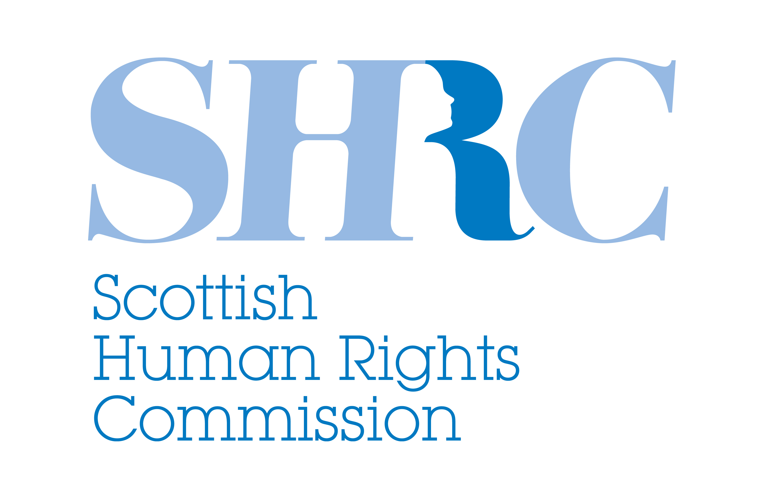
The Scottish Human Rights Commission
9 April 2013

The Scottish Human Rights Commission is a statutory body created by the Scottish Commission for Human Rights Act 2006. The Commission is a national human rights institution (NHRI) and is accredited with ‘A’ status by the International Co-ordinating Committee of NHRIs at the United Nations. The Commission is the Chair of the European Group of NHRIs and it is also a representative of Scotland on the Advisory Panel to the Commission on a Bill of Rights. The Commission has general functions, including promoting human rights in Scotland, in particular to encourage best practice; monitoring of law, policies and practice; conducting inquiries into the policies and practices of Scottish public authorities; intervening in civil proceedings and providing guidance, information and education.

1. Introduction

The Scottish Human Rights Commission (the Commission) welcomes the opportunity to contribute to the Health and Sport Committee’s Stage 1 consideration of the Victims and Witnesses (Scotland) Bill on a National Confidential Forum for survivors of childhood abuse (NCF). As the Committee may be aware the Commission has been engaged in promoting a human rights based approach to justice for survivors of abuse since 2009.

As the Commission outlined in the Human Rights Framework to address historic child abuse in 2010, survivors of serious ill-treatment, such as physical or sexual abuse or serious neglect, which may amount to inhuman or degrading treatment or punishment have a right to an effective remedy, including access to justice and reparation (including as appropriate satisfaction, rehabilitation, restitution, adequate compensation and guarantees of non-repetition). Depending on the nature of the perpetrator and the gravity of the harm the state also has an obligation to ensure effective official investigations or an alternative form of investigation sufficient at least to identify any state responsibility and systemic failures – that is to identify not only what happened (the “right to the truth”) but why it happened (to ensure guarantees of non-repetition).

The Commission continues to pursue the implementation of the full range of recommendations which it made in the Human Rights Framework. These include elements of accountability as well as acknowledgement. In this context we welcome the commitment by the Minister for Public Health, on behalf of the Government, to engage with the process of human rights InterActions which is currently underway with the support of the Centre for Excellence in Looked After Children in Scotland (CELCIS).

The first InterAction meeting on 28 February 2013 brought together survivors of historic child abuse, Scottish Government Minister Michael Matheson and officials, and representatives of local authorities, institutions which provided residential child care, workers associations, foster care organisations, the Bishops Conference, the Conference of the Religious, and a number of religious orders. The meeting agreed a platform for further negotiations in areas related to:
- empowerment of survivors to access justice, including support services;
- experience sharing between institutions and public bodies on steps which they can take to respond through remedies such as apologies and compensation;
- acknowledgement of harm such as through effective apologies;
- accountability of all of those who held responsibilities for the care of children and learning lessons for current and future child care practice.

2. Functions and Powers
The Commission considers that a confidential committee which enables survivors to recount their experience and have them acknowledged and recorded by an official or public body may be an element of satisfaction for some survivors, and as such an element of a broader package of effective remedies. The Commission has consistently reiterated its view that such a confidential forum should operate alongside a range of other options for justice and remedies for survivors.

When Scottish Ministers first announced their plans to hold a form of truth commission on historic child abuse, they indicated that it would “establish the facts”. If the NCF is to achieve that aim it will require some powers of investigation. Similarly, the Government consultation document listed learning lessons to prevent abuse in the future and protect rights more effectively in the future under “purposes of the NCF”. These aims would be more effectively served by a mechanism which was capable of identifying not only what happened but why. That would require powers sufficient to inquire into the operation of prevention and protection regimes at the time.

The Commission notes that Northern Ireland recently established a Historical Institutional Abuse Inquiry which includes an Acknowledgement Forum and an Inquiry Panel. The legislation which established the inquiry include powers to require production of evidence. The Terms of Reference in that process make clear that it is the Inquiry Panel which will make recommendations and findings to “guard against future abuse” including on “findings of institutional or state failings”. The Inquiry is intended to be inquisitorial in nature, rather than adversarial.

3. Status and independence
The Commission has previously expressed the view that the aims of the NCF would be most effectively achieved by a body established solely for that purpose.

Noting that the Mental Welfare Commission has been designated the host body the Commission recommends that everyone involved seek the greatest possible functional independence.

4. Support for participants
In the Human Rights Framework the Commission identified a range of forms of support required to enable survivors and others to participate in such a Forum. These include:
- access of survivors to relevant information related to their care (e.g. addressing barriers faced by survivors in accessing their files).
- psychological support, support workers or advocacy support before and after participants provide testimony, mechanisms and materials to support involvement, capacity to provide testimony by video link. Research also suggests support will be needed for current and former staff of institutions.
- The State has the obligation to protect the physical and mental health of those participating in (or cooperating with) the NCF, as well as the NCF staff and third parties affected by its work, including through taking steps to protect their mental health and protection from attacks on life, physical or mental integrity by private individuals. This may also require training for staff in preparation for exposure to distressing information and situations, and protection against intimidation or reprisals.

5. Any other aspect of the NCF

a. Duty to investigate
The Commission considers that the discretion afforded to members of the NCF to report credible allegations of criminal ill-treatment is too broad. The Commission notes that consideration of the same question in Northern Ireland was clarified as follows: "statutory framework requires that, where allegations of child abuse come to light, these must be reported immediately to PSNI and social services for investigation."

b. Eligibility
The Commission is unconvinced at the blanket exclusion of anyone under 18 from accessing the Forum and sees nothing in the explanatory notes or policy memorandum to justify such a restriction.

International best practice suggests that the NCF should be open to some categories of persons who were indirectly affected by historic abuse such as relatives, including where survivors have died or are incapacitated. The NCF and other remedies may also be available to others whose rights may have been violated, in some circumstances (for example former staff whose due process and privacy rights may have been violated, and relatives of either).

For an overview of the Commission’s work in this area see: http://www.scottishhumanrights.com/ourwork/care/adultprotection
SHRC, A human rights framework for the design and implementation of the proposed “Acknowledgement and Accountability Forum” and other remedies for historic child abuse in Scotland, Glasgow, February 2010, (hereafter Human Rights Framework), http://www.scottishhumanrights.com/application/resources/documents/SHRCHumanRightsFrameworkonAAF.doc
See SHRC and Susan Kemp, A REVIEW OF INTERNATIONAL HUMAN RIGHTS LAW RELEVANT TO THE PROPOSED ACNOWLEDGEMENT & ACCOUNTABILITY FORUM FOR ADULT SURVIVORS OF CHILDHOOD ABUSE, February 2010 (hereafter legal paper).
For more information see www.shrcinteraction.org
See for example evidence presented by the Commission to the Public Petitions Committee of the Scottish Parliament, 29 November 2011, http://news.bbc.co.uk/democracylive/hi/scotland/newsid_9649000/9649897.stm
As the Minister stated at the time "I am pleased to inform Parliament that we have been actively scoping the adaptation of the principles of a truth and reconciliation model. We are committed to that. We are considering good practice examples for establishing a forum to give survivors the chance to speak about their experiences and to help them come to terms with the past. That will provide an invaluable opportunity to establish the facts, learn from the suffering and use the experience to help us protect and provide for children in the future." Adam Ingram MSP, Minister for Children and Early Years, Official Report of the Scottish Parliament, 7 February 2008, http://www.scottish.parliament.uk/business/officialReports/meetingsParliament/or-08/sor0207-02.htm
Consultation document, para 16.
www.hiainquiry.org
Section 9, Inquiry into Historical Institutional Abuse Act (Northern Ireland) 2013.
Historical Institutional Abuse Inquiry for Northern Ireland, Terms of Reference, 18 October 2012.
Ibid.
SHRC, Submission to Scottish Government Consultation on a National Confidential Forum, October 2012, http://www.scottishhumanrights.com/application/resources/documents/SubmissionNCFOctober2012.doc
See Human Rights Framework, p 4.
Ibid.
E.g. Truth and Reconciliation Canada uses a “memory book” to support survivors to make statements. The book provides accessible information on context, the role of the TRC, consent forms and prompt questions.
Duncalf et al, Time for ‘‘Justice’’, Research to inform the development of a human rights framework for the design and implementation of an ‘Acknowledgement and Accountability Forum’ on historic abuse of children in Scotland, Care Leavers Association and Scottish Institute for Residential Child Care. (Hereafter research report), December 2009, p 33, 44.
Moyra Hawthorn, “Historic abuse in residential care: sharing good practice”, In Residence, No 4, Scottish Institute for Residential Child Care, December 2006.
Experience from Ireland, shared during the preparation of this framework suggests that, far from therapeutic, the experience of recalling historic abuse, even in a confidential forum, may have a deleterious impact on survivors’ mental health which in some cases may endure over many months or more. The right to the highest attainable standard of physical and mental health is guaranteed in Article 12 of the International Covenant on Economic, Social and Cultural Rights (ICESCR). To comply with that right, the state must take immediate steps to respect, protect and fulfil (achieve progressively the full realisation of) the right to health. See UN Committee on Economic, Social and Cultural Rights, General Comment No. 14, The right to the highest attainable standard of health : . 11/08/2000. UN Doc. E/C.12/2000/4.
Articles 2, 3 and 8 of the ECHR and ICCPR art 7, UN Convention against Torture and Other Cruel, Inhuman or Degrading Treatment or Punishment Article 16.
UN Set of principles to combat impunity, UN Doc. E/CN.4/2005/102/Add.1, Principle 32.
Victims and Witnesses (Scotland) Bill, Schedule 1A, Part 6, clause 13 (4)-(6).
http://www.niassembly.gov.uk/Assembly-Business/Official-Report/Reports-12-13/20-November-2012/#4 (emphasis added).
Victims and Witnesses (Scotland) Bill, Schedule 1A, Part 3, clause 7(2).
The majority of respondents to the Scottish Government consultation supported the possibility for family members to be involved in the Forum. Others suggested this should be on a case by case basis and that survivors should retain the choice.
Other national human rights institutions developing similar frameworks have also recommended extension of remedies to family members and even communities and descendents. See Australian Human Rights and Equal Opportunities Commission, Bringing them home: national inquiry into the separation of Aboriginal and Torres Strait Islander children and their families, 1997, recommendation 4.

