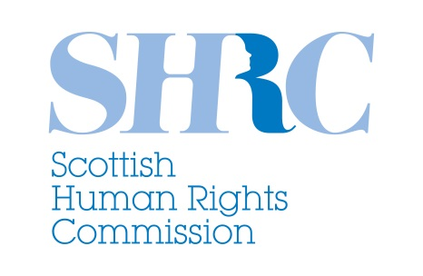

Promoting and protecting human rights in Scotland
Scottish Parliament Elections, 2016

The Scottish Human Rights Commission would like to see all of Scotland’s political parties make the following commitments in their manifestos for the 2016 Scottish Parliament elections:

- Take all possible action to secure the current levels of accountability for human rights that exist through the Scotland Act 1998 and Human Rights Act 1998. This includes rejecting any legislative proposals from the UK Parliament for a British Bill of Rights or repeal of the Human Rights Act 1998, that would weaken human rights protection for the people of Scotland in reserved policy areas.

- Continue to support the long-term implementation, development and monitoring of SNAP – Scotland’s National Action Plan for Human Rights. This includes investing in identified priority actions, integration of SNAP outcomes into the National Performance Framework and alignment of Scotland’s commitment to the United Nations Sustainable Development Goals with SNAP activity.

- Demonstrate progressive leadership to promote and protect human rights by incorporating all of the UK’s international human rights obligations directly into Scotland’s domestic laws.

- Identify and harness all appropriate opportunities to influence and learn from other countries in taking a progressive approach to protecting and realising human rights. This includes at UK, European and global levels.

- Enable and support widespread and meaningful participation by people from across Scotland in identifying and considering opportunities to advance human rights in Scotland’s future.

The Scottish Human Rights Commission promotes and protects human rights for everyone in Scotland. We are an independent public body, accountable to the people of Scotland through the Scottish Parliament. The Commission routinely engages with the Scottish Parliament, Scottish Government and civil society on a wide range of human rights issues that affect people in Scotland. We monitor and report on the implementation of international human rights in Scotland and are accredited as an A-status National Human Rights Institution within the United Nations system.
www.scottishhumanrights.com

