Tackling Poverty Through Human Rights

Innovation Forum

10 December 2014

Event Report

This is a report of “Tackling Poverty Through Human Rights”, an Innovation Forum held as part of Scotland’s National Action Plan for Human Rights.

It has been written for people who took part in the event, people who wanted to take part but could not make it and for anyone else who is interested in this work.

Overview

On a wet and windy Wednesday in December, over ninety people gathered in Govan to talk about poverty as a human rights issue, and to come up with ideas for what to do about it. People with experience of living in poverty in Scotland joined people working for government and public bodies, charities and community groups and people with experience of using human rights to tackle poverty in other countries, to share experiences, ideas and suggestions for action.

The day began with an introduction from Alan Miller, chair of the Scottish Human Rights Commission, who set the day in context. Alan explained that the meeting was taking place on International Human Rights Day which was also, this year, the first anniversary of Scotland’s National Action Plan for Human Rights.

People’s experiences of poverty

Twelve people then shared their personal experiences of living in poverty in Scotland. All of these testimonies were filmed and are available online at www.scottishhumanrights.com

Just a few examples of the powerful experiences that were shared include:

David described his experiences of becoming homeless despite growing up with wealth and privilege and the stigma of relying on soup kitchens and food banks that homeless people and others are experiencing.

Elizabeth and Bernadette, two young Gypsy Traveller women, talked about the experience of “being refused drinking water and having to beg or pay over the odds for it. With no running water, we are forced to use public swimming pools. ... Having no fixed address means we have poverty of access for all services including benefits – but despite this, we are continually accused of being benefit scroungers by the mass media.”

Anne described how “In a land that largely has, you feel the stigma of being a "have not"” when she was growing up without gloves in winter, or a toothbrush, or appropriate clothes for her mum’s funeral.

Experiences of using human rights to tackle poverty

Following a short break, the room then heard from several people with experience of using human rights as a way of tackling poverty and its consequences.

Diana Skelton from ADT Fourth World, a global organisation that works on poverty and human rights, talked about their work to develop a handbook to help people in poverty claim their rights and that sets out steps for Government, businesses and civil society to take to discharge their responsibilities. The handbook aims to make the UN’s guiding principles on poverty and human rights, which were adopted in 2012, more accessible.

Aoife Nolan, professor of international human rights law at Nottingham University, then gave an overview of work taking place on human rights budgeting. She explained how embedding human rights into budget decisions is an important way of putting government values into practice and giving effect to the legal obligations that human rights involve. Aoife set out lessons from other countries, including some of the conceptual, technical and communications challenges they have experienced, but highlighted that with the Scottish Government making a commitment to exploring human rights as part of its equality budgeting process, there is a significant opportunity now in Scotland.

James Harrison from Warwick University and Mary-Ann Stephenson from Coventry Women’s Voices then shared their experiences of a project that has been running for nearly 5 years, looking at the impact of public spending cuts on women in Coventry. They highlighted the importance of collaboration between people affected by spending cuts and academics in identifying the real impact on people’s lives, as well as sourcing academic data. They also stressed that because their analysis takes place at a local level, they have been able to influence local decision makers to make appropriate decisions about spending priorities.

Finally, Dessie Donnelly talked through the experiences of the Seven Towers community in Belfast, who used human rights to hold the local housing department to account and to ensure it used its resources more effectively to realise people’s right to adequate housing. Enabling meaningful participation throughout the whole process by people living on the estate was vital. Equally, gathering evidence about priorities and actions that could be taken, and grounding all of that in a human rights legal framework, helped to bring the housing department to account.

Working together to agree priorities

After hearing from all the speakers, each table in the room discussed whether the examples would work in Scotland, how that could be achieved and what should happen after today. Once each table had identified its suggestions for action, everyone in the room then voted for the top three priorities. These were:

- Setting up a Scottish version of the Seven Towers approach to participation in the practice of rights.
- Holding a campaign to raise awareness of rights for people living in poverty.
- Building human rights impact assessment into budget and policy decisions, possibly piloted in a few areas to begin with.

The day closed with thanks to everyone for taking part and the forming of a reference group of people with experience of living in poverty to help inform and guide the work being taken forward on this through Scotland’s National Action Plan for Human Rights.

A transcript of the whole day and a short film showing highlights of the day are available at www.scottishhumanrights.com, along with individual films of each person who shared their experiences of living in poverty and of speakers from other countries. These can all be found on the Commission’s YouTube channel at www.youtube.com/user/ScottishHumanRights.

The rest of this report gives fuller details of the background and aims for the day, who took part, priorities for action identified and lessons learned for future events taking place as part of Scotland’s National Action Plan for Human Rights.

Why did we hold the event?

“Overcoming poverty is not a gesture of charity. It is an act of justice. It is the protection of a fundamental human right, the right to dignity and a decent life." - Nelson Mandela
Poverty is a human rights issue. It represents a failure to fulfill the right to an adequate standard of living that is established in international human rights law. Other rights, like the right to education, to health and to adequate housing, are also affected by poverty. The opposite of poverty is not wealth, but rather an equal society in which everyone lives with dignity.
The “austerity” response to the economic recession of 2008 has done much to deepen what was already an entrenched problem of poverty in Scotland. Changes to the welfare system, cuts in public spending and rising costs of living have all combined to push more people into poverty. Children, disabled people, women and older people have been disproportionately affected.
Taking a human rights based approach to ensuring adequate standards of living for all is a priority for Scotland’s National Action Plan for Human Rights (SNAP). This event took place on the first anniversary of SNAP’s launch and was organised by the Human Rights Action Group that has been set up to take forward SNAP’s work in this area. Members of the Action Group are listed at the end of this report.

The event aimed to bring together around 100 people including people with direct experience of poverty, policy makers, civil society leaders and activists, public authorities and government, with international experts with experience in using human rights based approaches to tackling poverty.

The event aimed to increase participants’ understanding of the relationship between human rights and poverty and to identify and secure concrete commitments to action in 2015 to address poverty as a human rights issue.

Who took part?

Over one hundred people registered to take part and over ninety people took part on the day. There were a mix of duty bearers, people with direct experience of poverty, civil society organisations, speakers and facilitators, and academics (around a fifth in each category).

Name | Organisation
Adam Reid | Scottish Government (Head of Welfare Reform)
Aimee Ottroh | Poverty Truth Commission
Alan Miller | Scottish Human Rights Commission (Chair)
Alison Hosie | Scottish Human Rights Commission
Alison Petch | Institute of Research and Innovation in Social Science
Allan Young | Poverty Truth Commission
Amanda Ptolomey | Trust Volunteering Inverclyde
Andrew Strong | Alliance Scotland
Anna Marriott | Scottish Federation of Housing Associations
Anne Gordon
Anne McTaggart | MSP
Aoife Nolan | University of Nottingham
Arlene Astley | Advocard
Ayshea Khan | Poverty Truth Commission
Bernadette Williamson | Article 12
Betty Stevenson | Edinburgh Tenants Federation
Binta Ditchburn | Refugee Women's Strategy Group
Bob Thomson | Scottish Left Review
Carla McCormack | Poverty Alliance
Carole Ewart | Human Rights Consortium
Caroline Mockford | Poverty Truth Commission
Christine Duncan | NHS Health Scotland
Clare MacGillivray | Edinburgh Tenants Federation
Colin Clark | University of the West of England
Dave Moxham | STUC
David Cairns | Poverty Leadership Panel
David Holmes | Scottish Government
Dee Flanigan | Scottish Human Rights Commission
Denis Brady | Assistant to Anne McTaggart MSP
Dessie Donnelly | Participation in the Practice of Rights Project
Diana Skelton | ATD Fourth World
Duncan Isles | Scottish Government Human Rights Team
Elaine Downie | Poverty Truth Commission
Elizabeth McDonald | Article 12
Emma Grindulis | Together Scotland
Emma Hutton | Scottish Human Rights Commission
Emma Ritch | Engender
Ghazela Hakeem
Graham Olgivie | Cartoonist
Helen Martin | STUC
Ieva Morrison | Scottish Government
James Harrison | Warwick University
James Trolland | United Nations Association Glasgow
Jean Forrester | Poverty Truth Commission
Jenifer Johnston | Scottish Human Rights Commission
Jill Keegan | Article 12
Judith Robertson | See Me
Kait Laughlin | University of the West of England
Katharine Jones
Katie Boyle
Kavita Chetty | Scottish Human Rights Commission
Kirsten McLean | Scottish Committee for Equity
Laura Harrison
Lauren Bruce | Scottish Human Rights Commission
Lauren Wood | Citizens Advice Scotland
Linda MacDonald | Scotland's Commissioner for Children & Young People
Lindsay Paterson
Lindsey Millen | Close the Gap
Lorraine Cook | COSLA
Lucy Devlin | Poverty Alliance
Luska Jerdin | Scottish Government
Marion Davis | One Parent Families Scotland
Marsha Scott | Engender
Mary-Ann Stephenson | Coventry Women's Voices
Matt Smith | Scottish Human Rights Commission
Meriam Mahi
Olivia Ndoti McMullan | Refugee Women's Strategy Group
Pascal Schien
Patrick Boarse | Poverty Truth Commission
Rachel Moon | Govan Law Centre
Rebecca Marek | Scottish Youth Parliament
Roseanna Teresa McPhee
Ruth Hutton | Scottish Government, Third Sector Unit
Sadie Prior | Poverty Truth Commission
Saaima Khalid | Ethnic Minorities Law Centre
Sandra Stuart | Glasgow Disability Alliance
Sarah Davidson | Scottish Government, Director Communities
Sen Man McLean | Scottish Human Rights Commission
Shamaina Masoud | Poverty Leadership Panel
Sharon Barbour | Scottish Human Rights Commission
Sharon Wright | University of Glasgow
Sheryll Holley
Simon Cameron | Scottish Councils' Equality Network
Tracey Reilly | Nourish Scotland
Tressa Burke | Glasgow Disability Alliance
Trevor Owen | Scottish Government Human Rights Team
Zina Mechkour | Refugee Women's Strategy Group

Invitations to take part were also sent to identified local government representatives (including elected members and officials) and a wide range of public sector duty bearers. We would have ideally liked to see more participation from those who hold duties to protect and fulfil people’s rights, so it was disappointing that this did not happen. Further work will be needed to address this.

What approach did we take?

The event was designed by the SNAP Action Group on Adequate Standards of Living using the “FAIR” human rights framework. This involves:

- Understanding the FACTS – primarily based on the views and experiences of those directly affected
- ANALYSING the human rights at stake
- IDENTIFYING responsibilities and actions – who should do what?
- Concluding with a RECALL of agreed actions and next steps to implement them.

People with direct experience of poverty were invited to take part in the event and the subsequent development of actions and ideas, through networks already established by several Action Group members. The day was structured to start and end with their experiences and to create a safe, comfortable space for people to share their stories and thoughts as equal participants in a process.

People and and projects with experience of using human rights to tackle poverty in other countries were identified and invited to take part by the Scottish Human Rights Commission, based on their knowledge of human rights good practice elsewhere.

People working in organisations with responsibilities to protect and fulfil human rights were identified by all Action Group members and invited to take part by the Scottish Human Rights Commission and others.

Participants were allocated to tables for the whole event, including round table discussions to identify ideas and priorities for action. Each table included a mix of people with different experiences, responsibilities and perspectives. Facilitators were identified by Action Group members.

An interactive ‘vote’ to identify priorities for action took place, with each participant having three votes on an equal basis.

A graphic facilitator captured the key points from each speaker and of discussions that took place at the round table. People were asked to choose the images that resonated with them most, to capture the main themes and ideas emerging from the day (see below).

What priorities for action did people identify?

The table below sets out the priorities for action identified. Some suggestions were very similar, or expanded on more general ideas, and have been grouped together.

Priorities identified | Votes
Empowerment
People who are living in poverty should be involved in the decision making and monitoring processes.  Set up a Scottish version of Participation in the practice of rights project. Bring together local community activists/ organisations doing community work with PPRP to generate awareness & capacity building. | 29
People need to have the knowledge to hold decision makers to account - front line staff need the knowledge and training to realise people’s human rights.  Hold a general campaign on rights: focus on raising awareness of the right to participate as well as the rights of people living in poverty – every day is a struggle, so people have NO conception that they are entitled to rights. Traditional empowerment but in ‘human rights framework language’. | 38
For campaigns – need to simplify the language around human rights to ensure that people know that it is relevant to them. | 13
Build on existing mobilised networks to run human rights campaigns. E.g. Women for Indy network.  Link to the £10m Community Empowerment Fund to human rights to deal with capacity issues. | 9
Ability
Budgets need to apply a human rights lens, be participatory and create a social audit.  Need to embed human rights considerations into the allocation of resources with stated outcomes (e.g. within existing frameworks such as SOAs) – potential role here for the PTC & STUC  Take a couple of pilot areas where budget work can be more participatory and develop a means of providing control over local resources. | 15
Early intervention and assessment of human rights impact need to be carried out before and after policy and budgetary decisions are made.  Build HRIAs into the process & implementation of budgets and policies. | 15
Accountability
Measuring progress in tackling poverty should not just be about economic prosperity.  Measures such as the humankind index and wellbeing indices should be viewed of equal importance in measuring progress in tackling poverty as economic measures. | 12
Thematic
Fair work Campaign  In relation to national employment rights tying into the Fair Work Convention and the planned National Action Plan on Business & Human Rights – develop a participatory campaign around fair/decent work (wage levels, gender pay gap, no zero-hour contracts, in work poverty) | 4

What themes came out of the day?

The following images captured by the graphic facilitator show the themes and ideas that resonated most strongly with people taking part on the day (based on their own selection).

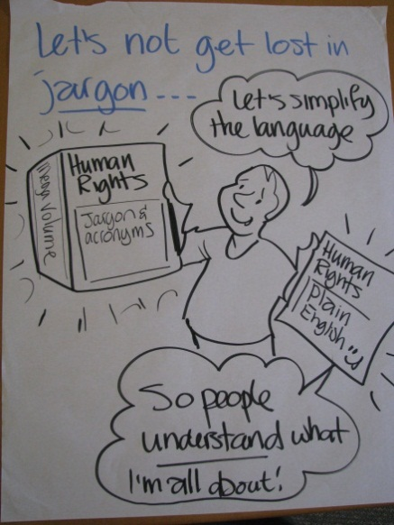 | 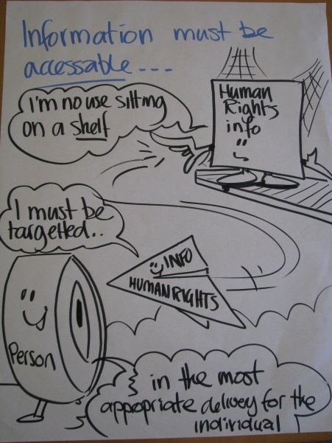 |  | 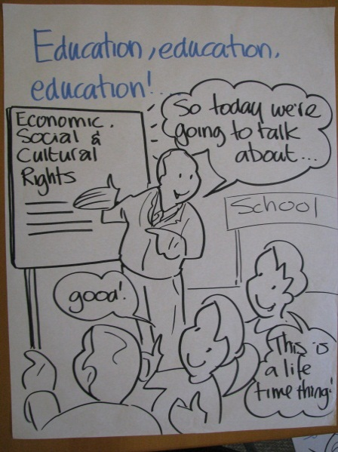
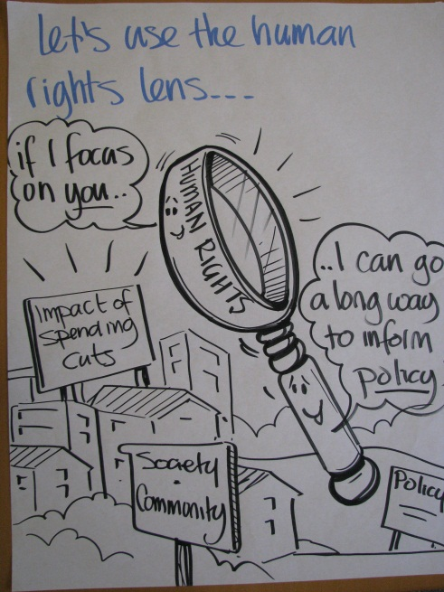 |  | 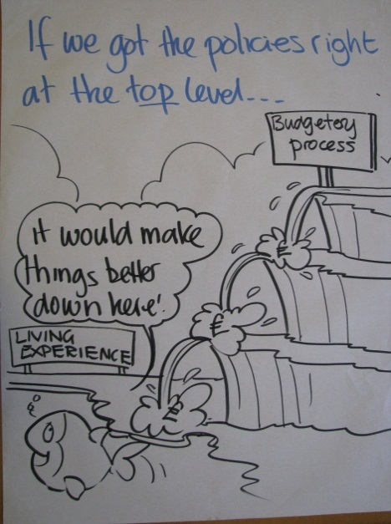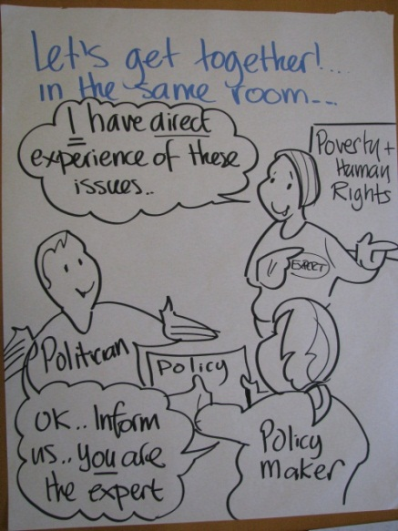 |  | 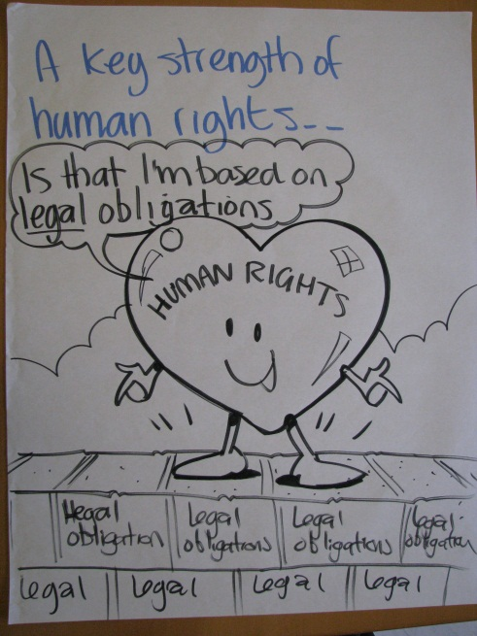

What did we learn for future events?

People taking part in the event were asked to provide feedback after the event, using an online survey tool. Informal feedback has also been provided from some of those taking part.

- Most people (89%) felt their aims had been completely or partly met. People’s aims included understanding how rights can help tackle poverty, getting ideas for concrete actions and innovative approaches that can be taken, and networking with other people and organisations.

- Most people (82%) felt they had received adequate or good information about the event beforehand. However, some people felt they had received confirmation of their place too late and this had been problematic for them.

- The location, accessibility and catering at the venue was generally felt to be good. However, comfort on the day was a problem because of a heating breakdown which meant that the building was very cold.

- Most people felt they had some (41%) or plenty (53%) of opportunity to express their views although there was some feedback that more could have been done to ensure meaningful engagement by everybody in the room in identifying and agreeing priorities.

- Forty per cent of people felt that the event’s objectives were only moderately clear, suggesting that more could have been done, either in advance or at the start of the day, to be explicit about what the day was trying to achieve.

- Most people (72%) felt that the presentations were very useful. Similarly, 65% of people felt the personal testimonies were very useful. The remaining respondents found these sessions quite useful. It was noted that more could have been done to share a broader range of experiences of poverty including the issue of people who are in work and in poverty.

- The group work sessions were felt to be less useful. 47% of people found them very useful, 47% quite useful and 6% not useful at all. There was repeated feedback that it would have been more effective to break the sessions up by mixing in testimony, presentations and group discussion, rather than having them in blocks.

- There were mixed views on how useful the format was as a way of identifying actions to be taken forward – some people found it to be collaborative and engaging and 61% said the format was a good way of identifying actions. Others felt more time was needed for more discussion and that an ‘open space’ style of event would have been more useful.

- Concerns were raised about the lack of representation from those bodies that have responsibility for protecting people’s rights, particularly local authorities.

Some comments from people who took part were:

“I'm not sure the testimonies really represent the best way of people’s lived experience leading and guiding the work. They were a good contribution but I didn’t feel that in our group discussion for example those voices were the ones who were helping decide what should happen next.”

“Great collaborative way of engaging with people using a range of methods - sticky dots, pictures, chat. Not having to write too much on flipcharts gave the chance to just talk about priorities.”

“2 hours of testimonies was a lot. They contained powerful messages but may have been better broken up a bit for more impact - and interspersing being talked at with us talking to each other a bit more. Expert session very useful.”

“It was good but the way we enable participation has to be better devised and more effective at generating real engagement.”

“Too much passive listening to presentations from the front.”

“If structured better with clearer conclusions, the format has good potential.”

What happens next?

Several things are happening to take forward the ideas for action that came out of the event:

The SNAP Action Group on Standards of Living will review what came out of the event and will work with a Reference Group of people with experience of poverty to develop more detailed action plans on each area.

The Scottish Human Rights Commission will produce a series of briefing papers on some of the main issues discussed at the event:

- human rights budgeting
- realising economic, social and cultural rights in Scotland
- human rights-based approach to poverty, in theory and practice

Discussions are taking place between the Participation in the Practice of Rights project and a network of tenants’ associations to explore replicating the human rights based approach used in the Seven Towers community in Belfast.

Further work to engage public bodies in this work is needed, given the low take-up of invitations to take part in the event.

Similarly, more work is needed to address issues around in-work poverty and promotion of the living wage. Some discussion of this took place through this event but more could have been done to raise the visibility of this aspect of poverty in Scotland and the need for action in this area.

