Briefing Paper 4:

Human Rights Budget Scrutiny

Published September 2019
Version 2: Published November 2023

Contents
1. About this document 3
2. What is the national budget? 3
3. Why are human rights relevant to the budget? 3
4. What are human rights obligations? 4
5. What is Human Rights Budget Scrutiny? 5
6. Why do we do Human Rights Budget Scrutiny? 5
7. Who does budget scrutiny? 6
8. How do you do human rights budget scrutiny? 9
9. Why is human rights budget work important for Scotland now? 17
10. The HRBW series 18
11. About the HRBW Project 18
12. Contact 20
13. Appendix 1: Glossary of Terms 21
14. Endnotes 24

“Surely little the State does is more important than constantly using so much of the nation’s work and wealth. Few other governmental activities so consistently affect the everyday life of citizens.”
Heclo and Wildavsky 1981, xi The Private Government of Public Money

About this document
Welcome to the fourth of six papers that explain the “what, why and how” of using human rights to create and scrutinise Scotland’s national budget. A glossary of terms is provided in appendix 1.

What is the national budget?
The national budget is the blueprint for how any government invests in its priorities and is its most important tool for managing the economy. The national budget should include:

- how much money government intends to raise (revenue);
- who and/or where the money comes from (sources);
- how money will be allocated (allocation); and
- how money has been spent (expenditure).

Why are human rights relevant to the budget?
All governments must respect, protect, and fulfil human rights. The way they raise, allocate and spend money plays a key role in this. You can’t guarantee the right to vote if you don’t have an effective electoral system and you can’t guarantee the right to a habitable, accessible, affordable, and secure home without a well-regulated housing sector.

Understanding how a government manages public money also helps to sort the reality from the rhetoric about its commitment to rights. If the government has an obligation to do something specific, then it must be reflected in the budget; it is not just something “nice to consider”. In line with human rights treaties, it is a legal obligation that bind all governments, regardless of who is in power.

Human rights budgeting recognises that budgetary decisions can have materially different outcomes for different groups. Government budgets are not always sensitive to this. In particular, the contributions that households, individuals (especially women) and communities make to the economy—by caring for people for example—are not always recognised because they are not bought and sold through the market. For this reason, it is not uncommon for budgets to reinforce systematic inequalities between groups—in particular, between men and women—and miss out on opportunities to use public financing to improve the position of disadvantaged and marginalised groups.

Good rights-based laws and policies can still result in unacceptable experiences of rights holders if they are not properly resourced. Taking human rights standards into account when developing the budget, is not a magic bullet. It can, however, help us to ask the right questions to support much more effective, transparent, fair, and accountable use of national resources.

What are human rights obligations?
To respect, protect and fulfil human rights, governments must take positive steps to ensure that people’s rights are real. Steps means concrete measures using the maximum of their available resources. These measures should:

- ensure “minimum essential levels” or a “minimum core” of each right;
- increase the availability, accessibility, acceptability and quality of goods and services; and
- progressively realise people’s rights and reduce inequality as soon as possible.

Deliberately retrogressive measures are not allowed. Governments must fully justify the adoption of policies that decrease people’s enjoyment of a right.

Steps taken by the government should:

- ensure the active participation of rights holders,
- respect the principles of transparency, accountability, and non-discrimination; and
- fulfil an obligation to provide effective remedies if things go wrong.

- Briefing Papers 5 and 6 in this series provide more information about human rights principles and standards.

What is Human Rights Budget Scrutiny?
Human rights budget scrutiny or analysis involves examining the public budget to assess a government’s compliance with its human rights obligations. This is done with the central goal of making public budgets more effective in helping to realise human rights, to ensure that everyone can live a life of human dignity. This involves exploring both the budget process: to ensure that it is participative, transparent, and accountable; as well as examining a government’s resource generation, allocation and spend with reference to the agreed human rights standards, as noted above.

Why do we do Human Rights Budget Scrutiny?
It is not uncommon for governments to find that despite having some of their laws and policies developed within a rights framework, that the range of lived experience outcomes of rights-holders remains unacceptable. In other words, there appear to be problems in the implementation of good laws and policies. It is in such situations that human rights budget analysis could be of particular use to help identify why:
The causes of a poor human rights situation can be multiple. Budget work can help identify if budget choices are one of the causes.
Human Rights Budget Scrutiny helps to ensure that the process by which a budget is developed, implemented, and evaluated is fit for purpose; engages those who it affects; and complies with international obligations, both procedural and rights. It allows governments to be held to account for delivering (or failure to deliver) on their human rights obligations through appropriate resource generation, allocation and spend.

A common reason given by governments for being unable to fulfil its human rights obligations (especially economic, social, and cultural rights) is a lack of resources. Human rights budget scrutiny provides a new lens through which that claim can be interrogated. In other words, by asking the government to explain how it believes it has maximised its available resources to deliver its human rights outcomes. Scrutinising a budget through a human rights lens is not just about ensuring that a government is using its existing resources effectively and without discrimination, it is also about questioning if a government has made the effort to generate additional resources and whether those efforts are adequate and equitable.

Who does budget scrutiny?
Well-functioning budget scrutiny is undertaken by a range of actors in an “accountability ecosystem” (i.e., legislators, auditors, citizens, civil society, National Human Rights Institutions (NHRIs) and the media). Formal oversight institutions are a core element of sound financial management. Effective legislatures, auditors and independent fiscal institutions have both the mandate and the resources to ensure that the public budget process is transparent, accountable and enables genuine participation from rights-holders.

These various actors play different roles at different stages of the budget process. In most countries the budget process is a yearlong process and can be broken down into four stages, as shown in Figure 1 below.

Figure 1: The Budget Cycle

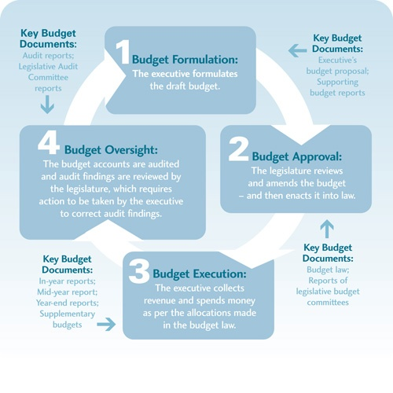
International Budget Partnership

Very few formal or informal oversight actors currently apply a human rights lens to their scrutiny; however, they could be readily adapted to do so.

Legislatures have a role to play at all four stages of the budget process. They can help set the general parameters of the budget (in line with human rights obligations), identify priorities (delivering the minimum core, areas for progressive realisation whilst ensuring non-retrogression), scrutinise budget implementation (through procedural principles and resource generation and allocation, whilst ensuring non-discrimination) and evaluate audit reports (resource expenditure vs allocation, whilst ensuring non-discrimination).

While a distinct role exists for a finance committee of the legislature to examine the overall budget, it is also important that other subject or sectoral committees review budget for their subject area or sector. Critically, all these subject or sectoral committees need to be supported to understand the relevant human rights obligations to their area. This is an important role that can be played by NHRIs and civil society organisations.

Audit institutions have a specific role at the fourth stage of the budget process, where they can assess whether or not resources have been used in accordance with the law and whether a government’s financial procedures have been followed. This assessment should also include compliance with human rights law and human rights procedural obligations.

It is also common for independent auditors throughout the budget cycle to undertake additional financial and performance audits to scrutinise specific areas of government spending for effectiveness and efficiency. Such audits undertaken through a human rights lens would provide valuable understanding of a government’s compliance with its international human rights obligations.

Oversight by an Independent Fiscal Institution is not yet widespread globally; however, they have existed in a small group of countries (such as Austria, Belgium, and the United States) for many years. Over the past decade it has become more common for the creation of such institutions to support the restoration and improvement of government finance credibility and trust by the public in government figures.

The participation of rights holders as an “informal oversight mechanism” (e.g., individual citizens, or members of civil society organisations, as well as members of NHRIs and the media), all help to strengthen the formal oversight institutions. They can provide and shine a light on the perspective of lived experience, in particular, where that lived experience is being failed by poor budgetary processes and/or decisions.

National Human Rights Institutions have a unique role to play in the process of budget scrutiny. As with many aspects of the work of NHRIs, one of their key roles is that of a bridge. One bridge is between the State and civil society. Cooperating with a variety of civil society actors, NHRIs can help to bring an accurate overview of the human rights situation, with recommendations, to governments, parliament, and other State bodies. Another bridge is between the national and international arenas, helping to apply international human rights standards at the national level, with a full understanding of the local context. It is within this context that NHRI can help to support the State, civil society and formal oversight institutions to understand how to view and scrutinise the budget and budget process through a human rights lens.

How do you do human rights budget scrutiny?

Ask the right questions
Good scrutiny starts with asking right questions. This can help the analyst to assess where a government’s budget process has complied with its procedural rights, in other words – to assess if the process is:

- Transparent - Do people have access to adequate, timely and coherent information?
- Participative – Are genuine opportunities offered for rights-holders to engage with and have impact on budgetary decisions?
- Accountable – Are government held accountable for their budgetary decisions?

It can also allow the analyst to assess whether governments have fulfilled their human rights obligations in how they have generated, allocated and spent their resources.

- Generation – Is sufficient revenue generated to invest in realising basic levels of rights for all? Who are resources generated from? Are particular groups unjustly impacted? Is (or could) government revenue increase?
- Allocation - Do allocations prioritise the achievement of basic levels of rights for all? Do allocations prioritise closing the gaps in human rights enjoyment between different groups? Are allocations growing or shrinking? Are reductions justified (in human rights terms)?
- Spend - Do fiscal management systems ensure efficient management of funds allocated? Have funds been redirected in a way that disproportionately impacts particular groups? Have financial management systems improved or weakened over time?

Identify Indicators
Analysing both procedural rights and assessing resource generation, allocation and spend can be aided by the identification and development of good indicators.

Process indicators
Much International best practice exists to support the assessment of budget process (e.g. from the International Monetary Fund (IMF), the World Bank, the Organisation for Economic Co-operation and Development (OECD) and the Global Institute for Fiscal Transparency (GIFT)). One indicator that has been developed to support the monitoring of budget processes for transparency, participation and accountability is the Open Budget Survey, a biennial global indicator of fiscal transparency (timely availability and accessibility of information); effectiveness of accountability mechanisms (legislature, auditor, fiscal institution), and opportunities for public engagement.

As well as the opportunity to participate, another useful process indicator could explore the actual quality of that participative experience. This could include assessing the ease of and inclusiveness of the participation and the perception of impact on budgetary decisions. Utilising, best practice principles for consultative processes (e.g. the Consultation Charter) could help support the development of a robust indicator on the quality of participation.

Finally, most focus thus far has been on the national budget; however, local budgeting processes are equally important. Indeed, in many countries, it is the local authorities or municipalities that make key decisions about which and how local services are funded. Arguably, the realisation of rights in practice and delivery of both a minimum core and progressive realisation of rights is determined at the local level. Therefore, exploring the availability, accessibility, and transparency of budget information at the local level, can support a human rights analysis of budgetary decisions at the local level.

Resource indicators
Table 1 below sets out a range of examples of resource indicators that could be used to scrutinise generation, allocation and spend. In order that they are comparable like for like, it is necessary for many of these indicators (especially allocation) to convert total numbers into rations (e.g., amounts allocated into percentages).

Table 1: Example indicators of resource generation, allocation and spend

Examples for resource generation: | Government revenue as percent of GDP  Tax revenue as percent of government revenue  Different tax types (e.g., income, corporate, VAT) as percent of total tax revenue  Tax (by type) as a share of a taxpayer’s total income  Tax effort: Tax Evasion Gap  Average illicit financial flows  Palma Ration: measure of overall economic inequality
Examples for resource allocation: | Expenditure ratios (percent out of a total) by sector  Expenditure ratios by sub-sector  Per unit or per capita expenditure by sector and sub-sector  Expenditure ratios by country defined minimum core obligations
Examples for resource expenditure: | Variance between budgeted amounts and actual budget outturns  Budget turnaround time in relation to policy commitment  Efficiency of spending, including analysis of transaction costs and leakages

Make Comparisons
Making comparisons with the information gathered via indicators allows a government to compare its place and relative progression or regression both externally, for example to:
- national or international targets or commitments agreed to by the State (e.g., UN Treaties),
- guidelines from international bodies (e.g., UN treaty body General Comments ),
- other comparable countries (e.g., see graph 1 below),
- other parts of the budget (e.g., areas of economic, social, and cultural rights compared to civil and political rights.
- other relevant economic indicators (e.g., nationally defined indicators of economic progress)
- between groups (e.g., equalities and groups with protected characteristics)
  - Helps to identify who is/ is not benefiting – disparities at local levels can help raise red flags of possible discrimination in the distribution of decentralised funds.
  - Calculating per capita allocations can help facilitate by-group comparisons.

Graph 1: Total general government expenditure on social protection, 2016 (% of GDP)

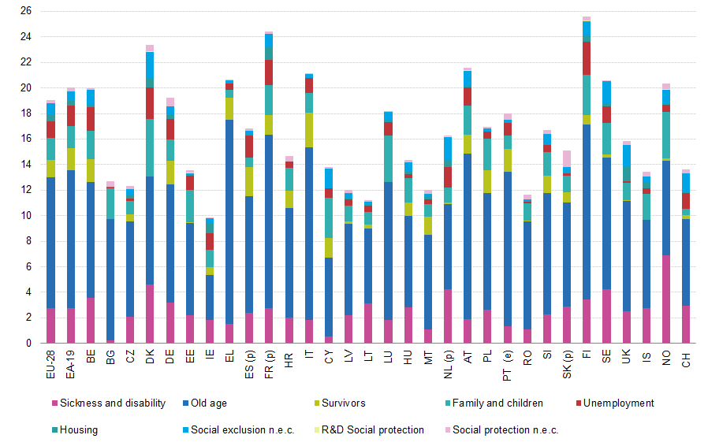

This graph shows the amount that each of the EU 28 countries spent on a range of social protections as a percentage of their Gross Domestic Product in 2016. This graph can be used to highlight which countries on the whole spend more (Denmark, France and Finland), compared to who spends the least (Ireland, Lithuania and Romania); who spends more or less on specific areas of spend e.g. housing or sickness and disability; and how countries compare to the EU average. Changes can then also be monitored over time.

Undertaking such comparisons allows the government to be challenged over how they use and present the use of their resources. This can be a very powerful tool as the case study of Spain presented below shows:

In 2018 at the 6th periodic review of Spain by the UN Committee on Economic, Social and Cultural Rights (CESCR), evidence was presented by a coalition of 36 Spanish civil society organizations and the Centre of Economic and Social Rights.
This evidence showed that the austerity measures that had been adopted by the Spanish government (as the ONLY option), were having a devastating and disproportionate impact on the most vulnerable populations and as such Spain was breaching its human rights obligations.
In their submission, the dominant narrative that government overspending had cause the crisis and that budget cuts were the only option was challenged by the presentation of evidence that 1. Spain’s annual expenditure on social protection was low (compared to other EU countries) and 2. Estimates from the national union of tax inspectors showed that if Spain reduced its black economy by 10% (in line with EU standards), this would have been enough revenue to exceed the entire budget cuts for 2012.

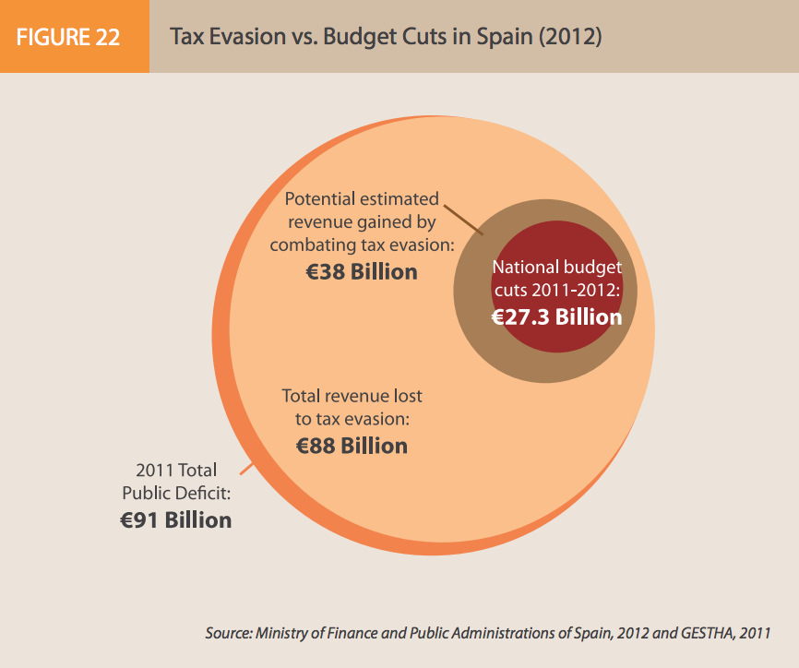
Source

Analyse Trends over time
Analysing trends over time allows a critical examination of a government’s effort to progressively realise rights realisation. Examining trends of time can help to support impact analysis, connecting budget allocation with outcomes, and show what allocation/s have been potential drivers for change. When making such comparisons it is important to make the distinction between real and nominal expenditure. This is crucial to allow for credible commentary on progressive realisation. To enable valid, accurate comparison over time, nominal budget figures need to be “adjusted for inflation”.

Graph 2 below shows trends in average weekly earnings in Scotland and the UK: 1997-2017. It shows that from 1997 until 2008/9 (when the banking crisis hit) the amount of money that people in Scotland and the UK were paid (before tax) increased at or above the rate of inflation – in other words in line with living costs. Things like rent and household bills became more expensive over time but pay increased at the same rate and so was able to match these increases. From 2009, whilst the cost of living has continued to rise, the amount the people are paid has not kept pace with inflation. Therefore, people have less money in their pocket as they have ended up spending a larger proportion of their pay on things like rent and household bills.

£100 cash in 1997 is still £100 cash in 2017, but what it can buy has changed. Things cost more in 2017 and so £100 in 2017 has only the equivalent purchasing power of about £57.80 in 1997, a difference of £-42.20 over 20 years. This highlights why it is important to look at figures adjusted for inflation.

Graph 2: Gross weekly pay in cash and real terms for Scotland and the UK between 1997 and 2017
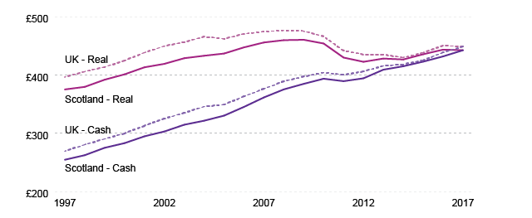

Actual spend
Often what really matters the most is actual spending. If a government has not spent all allocated funds, then it has not made full use of maximum available funds. It is important therefore to consider the following questions:
- Has a government spent what it said it was going to spend during the year? In other words, have allocated funds been spent as planned?
- If allocated funds have not been spent, how have they been reallocated?
- Was the reallocation process transparent, participative, and accountable?
A useful place to start to explore this, if it is possible to identify, is the percentage of unspent funds in a government’s budget.

Why is human rights budget work important for Scotland now?
In 2014 the Scottish Government made a commitment to explore human rights budgeting, although with limited action at the time. However, since 2017 several key activities have acted as a catalyst for developing human rights budgeting:

- The Budget Process Review Group;
- Scottish Human Rights Commission EU funded project on human rights budget work;
- Scottish Parliament’s Equality and Human Rights Committee Inquiry into Human Rights;
- Increased remit of the Equality Budget Advisory Group to include human rights budgeting – Equality and Human Rights Budget Advisory Group;
- Scotland’s National Performance Framework and the forthcoming review of the National Outcomes (and potential to connect to the budget);
- Scottish Government Open Government Action Plans 2018-20 and 2021-2025 with a focus on participation and fiscal transparency;
- First Ministers Advisory Group on Human Rights Leadership and its Recommendations;
- National Taskforce for Human Rights: Leadership Report (2021);
- Equality, Human Rights and Civil Justice Committee Fellowship and report on Human rights budgeting;
- Increased engagement by Scottish Parliament Committees during pre-budget scrutiny with the principles of human rights budgeting;
- Scotland's revised Framework for Tax (2021)
- Scottish Exchequer fiscal transparency project: 2021 to 2025
- New Human Rights Bill for Scotland

There is renewed interest in budget scrutiny in Scotland because of increased fiscal powers and responsibilities devolved to the Scottish Government through the Scotland Acts 2012 and 2016. There is also a commitment to ensuring that Brexit does not harm current human rights protections and that we remain in step with future advances in EU human rights, as well as growing interest in furthering economic, social, cultural, and environmental rights and the promise of new Human Rights legislation which will incorporate a range of international treaties into Scots law.

If the Scottish Government uses its human rights obligations as a framework for its Programme for Government, policy (including taxation policy) and budgets can be based on the progressive realisation of human rights. This will make Scotland fairer, more transparent, and accountable for its decisions on revenue generation, allocation and spend, and much more likely that those decisions will get it right for the most vulnerable and marginalised.

- Briefing Paper 2 provides more information about the Scottish context for human rights budget work.

The HRBW series
The briefing papers in this series are:
- 1: Human Rights Budget Work
- 2: Human Rights Budget Work in Scotland: Why Here, Why Now
- 3: Human Rights Budgeting
- 4: Human Rights Budget Scrutiny
- 5: Human Rights Standards and the Budget
- 6: Budget Process and Human Rights Principles
- 7: Human Rights and Taxation

A collected set of all briefing papers is also available here.

About the HRBW Project
Following a short-term grant from the European Union in 2018, the Scottish Human Rights Commission began a programme of ongoing work to better understand and support wider scrutiny of public spending decisions including budget through a human rights lens. The work has so far:

- developed three process indicators to support scrutiny of national and local council budget processes,
- organised capacity building activities on human rights budget scrutiny,
- engaged in scrutiny of national tax reform,
- and produced Briefings 1-6 in this publication series on the “What, Why, How of Human Rights Budget Work”.

The Commission also cooperates with academia on a collaborative PhD on Minimum core obligations in Scotland.

This programme is supported by a Human Rights Budgeting Working Group which drives and supports this work programme. Members of this group include:

- Dr. Alison Hosie, Research Officer, Scottish Human Rights Commission
- Allison Corkery, Director of Strategy and Learning, The Center for Economic and Social Rights
- Prof. Angela O’Hagan, Senior Lecturer in Social and Public Policy, Glasgow Caledonian University & Independent Chair of the Equality Budget Advisory Group
- Lucy Mulvagh, Director of Policy, Research and Impact, the Health and Social Care Alliance Scotland (the ALLIANCE)
- Prof. Jo Ferrie, Senior Lecturer at the School of Social and Political Sciences, University of Glasgow

Contact
We welcome enquiries about human rights budget work. To discuss, or for more information, please contact:

Scottish Human Rights Commission
Bridgeside House
99 McDonald Road
Edinburgh
EH7 4NS

E: hello@scottishhumanrights.com
T: 0131 297 5750
W: www.scottishhumanrights.com

Appendix 1: Glossary of Terms

Allocation
The amount of money a government sets aside to put towards a project, or programme.

Accountability
Human rights laws create legal duties on governments and public bodies. If governments and public bodies fail to protect human rights, there should be effective and fair ways for people to challenge this, for example through the courts.

Economic, social and cultural rights
Rights to those “goods” which we need to live in dignity, for example rights to health, housing, food, social security.

ESC/ESCR
This is shorthand for Economic, Social and Cultural Rights.

General Comments
These are comments developed by the committees in charge of monitoring the different UN human rights treaties. They tell us how we should understand and interpret human rights.

ICESCR
This is shorthand for the International Covenant on Economic, Social and Cultural Rights. This is a UN treaty which sets out the economic, social and cultural rights we have.

Maximum of available resources
The idea that a country spends as much of its budget as it can on making rights real. This includes ensuring:
- existing resources are used effectively and without discrimination.
- efforts to generate additional resources are adequate and equitable.
- Resources are not only financial, but also human, natural, technological, etc.

Minimum Core
A duty exists on states to ensure the satisfaction of “minimum essential levels” of each right, regardless of their level of economic development. These are usually taken to mean protection from starvation, free primary education, healthcare in emergencies and basic housing. Governments should make sure that people have these at all times. (General Comments help to identify what a minimum core should be for each right).

Non-discrimination
The idea that you cannot treat someone differently based on a “prohibited ground” unless justification is reasonable and objective.
- Treaties list prohibited grounds, but these are not exhaustive.
- The state has an obligation to eliminate de jure discrimination by abolishing “without delay” any discriminatory laws, regulations, and practices.
- De facto discrimination, occurring because of the unequal enjoyment of rights, should be ended “as speedily as possible”.
- Affirmative action or positive measures may be needed to end de facto discrimination.

Non-retrogression
The idea that things should get better, not worse; governments should not take decisions which they know will create setbacks in making rights real. States must “fully” justify the adoption of policies that decrease people’s enjoyment of a right. Must be:
- Temporary,
- Necessary and proportionate (other options more detrimental),
- Not discriminatory and mitigate inequalities,
- Ensure the protection of minimum core content of rights,
- Considers all other options, including financial alternatives.

Process principles
- Steps should be taken in such a way that facilitates the active participation of rights holders.
- “Steps taken” should respect the principles of transparency, accountability, and non-discrimination.
- The state also has an obligation to provide effective remedies, including administrative and judicial ones.

Progressive realisation
The idea that some rights can be made real over time rather than immediately; the United Nations recognises that in some cases it is not possible for governments to ensure that everyone gets their economic, social and cultural rights straightaway. However, governments still have to do all they can.

Respect, Protect, Fulfil
This is a way of describing the different types of duties which governments have towards people’s human rights:
- Respect means that governments must not act in a way that violates people’s human rights E.g., Forced evictions carried out by the state.
- Protect means that governments must protect people’s rights from being violated by the actions of others, E.g. Failing to regulate private housing market.
- Fulfil means that governments must take positive steps to ensure that people’s rights are real. E.g. taking appropriate legislative, administrative, budgetary, judicial, and other measures to:
  - Facilitate: access to right (e.g., through infrastructure, goods, and services)
  - Promote: rights and how to claim them.
  - Provide: when people, for reasons beyond their control, are unable to necessary to realise rights, the state may be obligated to provide it (e.g., through infrastructure, goods, and services).

Endnotes

See the work of the Scottish Women’s Budget Group - Scottish Women's Budget Group | Publications (swbg.org.uk)
See https://www.scottishhumanrights.com/projects-and-programmes/human-rights-budget-work/ for copies of these briefing paper.
See Briefing Paper 3 for more information about human rights budgeting.
Applied Budget Work by Warren Krafchik: https://www.internationalbudget.org/sectors-issues-demographic/human-rights/
https://www.internationalbudget.org/why-budget-work/engaging-stakeholders/
In 2017, the Scottish Fiscal Commission came into being, with its independence set in law. It produces independent, official forecasts with their values based on those set out by the Organisation for Economic Co-operation and Development for Independent Fiscal Institutions which requires independence; transparency; accessibility and openness.
Allison Corkery, 2018, Introduction to Human Rights Budget Work: http://www.scottishhumanrights.com/media/1776/human-rights-budgeting-project-masterclass-presentation.pdf
See: https://www.consultationinstitute.org/consultation-charter-7-best-practice-principles/
Drawn from Allison Corkery, 2018, Introduction to Human Rights Budget Work: http://www.scottishhumanrights.com/media/1776/human-rights-budgeting-project-masterclass-presentation.pdf
This would require a country to have set out, based on international guidance, definition of its country’s minimum core obligations.
For example for ICSER General Comments, see here: https://tbinternet.ohchr.org/_layouts/treatybodyexternal/TBSearch.aspx?TreatyID=9&DocTypeID=11
Source: https://ec.europa.eu/eurostat/statistics-explained/index.php?title=File:Total_general_government_expenditure_on_social_protection,_2016_(%25_of_GDP).png
http://tbinternet.ohchr.org/_layouts/treatybodyexternal/SessionDetails1.aspx?SessionID=1197&Lang=en
http://cesr.org/
See http://cesr.org/spanish-austerity-violates-health-housing-sexual-and-reproductive-health-and-rights
http://www.cesr.org/sites/default/files/FACTSHEET-Spain%28EN%29-June2018-FINAL.pdf
Formula for Adjusting for Inflation: Real Value = Target year’s nominal value X base year’s consumer price index (CPI) / Target year’s CPI. Example: 2019 money in 2008 values: Real Value = (2019 value) X (2008 CPI)/ 2019 CPI
See https://www.officialdata.org/2017-GBP-in-1997?amount=100
https://digitalpublications.parliament.scot/ResearchBriefings/Report/2017/11/21/Earnings-in-Scotland--2017#How-has-pay-changed-over-the-last-twenty-years-
Ibid.
http://www.scottishhumanrights.com/economic-social-cultural-rights/human-rights-budget-work/
https://www.parliament.scot/parliamentarybusiness/CurrentCommittees/106453.aspx
https://www.gov.scot/groups/equality-budget-advisory-group/
https://nationalperformance.gov.scot/national-outcomes
https://www2.gov.scot/Resource/0054/00546407.pdf
https://www.gov.scot/publications/scotlands-open-government-action-plan-2021-25/
https://humanrightsleadership.scot/
https://humanrightsleadership.scot/wp-content/uploads/2018/12/First-Ministers-Advisory-Group-on-Human-Rights-Leadership-Final-report-for-publication.pdf
https://www.gov.scot/publications/national-taskforce-human-rights-leadership-report/
https://sp-bpr-en-prod-cdnep.azureedge.net/published/2022/10/20/862a68a0-a6a9-46cd-9fdb-87cc7a877406/SB%2022-61.pdf
https://spice-spotlight.scot/2023/01/24/budget-bingo-common-themes-in-committees-pre-budget-scrutiny/
https://www.gov.scot/publications/scottish-exchequer-fiscal-transparency-discovery-report/
https://www.gov.scot/news/new-human-rights-bill/
http://www.legislation.gov.uk/ukpga/2012/11/section/25/enacted
http://www.legislation.gov.uk/ukpga/2016/11/contents
Currently the HRA 1998 together with the Scotland Act, protect the rights that are contained in the European Convention on Human Rights in Scotland’s own laws. The rights in the HRA are predominantly civil and political rights.
See https://www.scottishhumanrights.com/projects-and-programmes/human-rights-budget-work/ for copies of these briefing paper.
The Briefing papers can all be found here: https://www.scottishhumanrights.com/projects-and-programmes/human-rights-budget-work/
See https://www.scottishhumanrights.com/media/1903/hrbw-collected-briefing-papers-vfinal.pdf
http://www.scottishhumanrights.com/economic-social-cultural-rights/human-rights-budget-work/
http://www.scottishhumanrights.com/media/1776/human-rights-budgeting-project-masterclass-presentation.pdf
http://www.scottishhumanrights.com/media/1842/human-rights-budgeting-150319-presentation-whole.pdf
http://www.scottishhumanrights.com/media/1882/shrc-response-to-scottish-government-consultation-on-devolved-tax-policy-framework.docx

