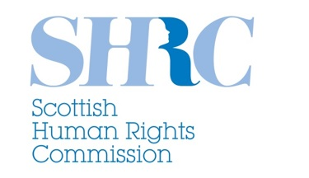
Shaping the work of your Human Rights Commission: Consultation
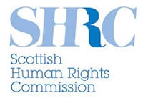
We are the Scottish Human Rights Commission or SHRC for short.

Human rights are the rights and freedoms that everyone should have. They are rights like the right to life and the right to feel safe.
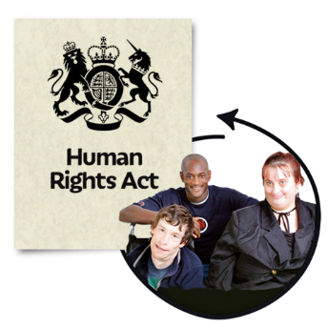

We let people and organisations in Scotland know about human rights.

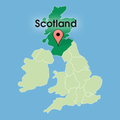
We help look after the human rights of everybody in Scotland.

In this easy read we will tell you about our duties and powers.

We will also tell you about some of the work we have been doing.

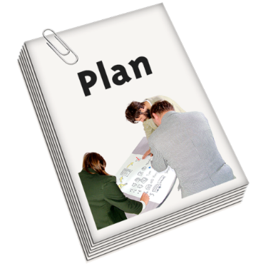

We are writing our Strategic Plan for 2016-2020. This is a plan that sets out what our goals will be for the next 4 years.

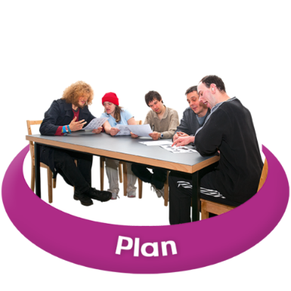

We would like people and organisations across Scotland to help us write this plan.

This easy read is called a consultation. This is because we want to find out what you think we should put in our new plan.

At the end of this easy read there are some questions we would like you to answer and send back to us.
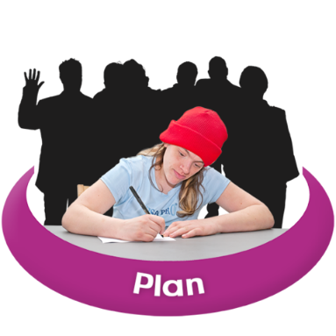
We will look at all of the answers we are sent. We will use this information to help write our plan.

Please send us your answers by 20th November 2015.

By email to: hello@scottishhumanrights.com

By post to:
Scottish Human Rights Commission
4 Melville Street
Edinburgh
EH3 7NS

What is the Scottish Human Rights Commission?

We are an independent organisation.

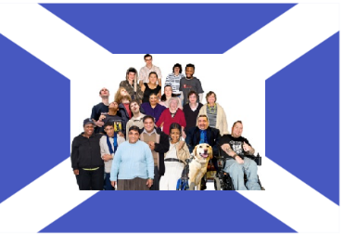
We answer to the people of Scotland through the Scottish Parliament.

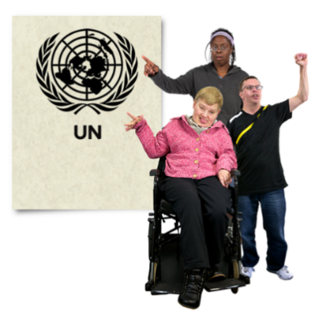
We can report to the United Nations (UN) on human rights issues in Scotland. The UN is a big group of countries who work together to make the world a better place.

We work together with human rights organisations from around the world.

What kind of work do we do?

The SHRC was set up in 2008.

We have worked with the Scottish Parliament and Scottish Government on human rights issues in law and policy.

A policy is a plan which talks about how something will be done or achieved.

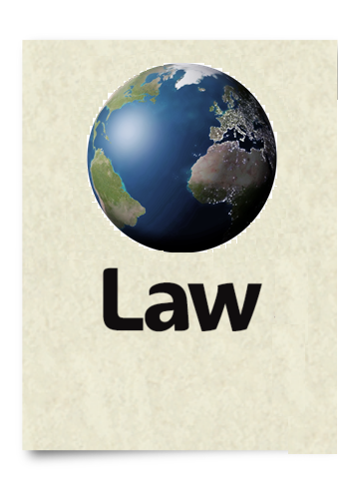
We look at and report on how international human rights laws are working in Scotland.

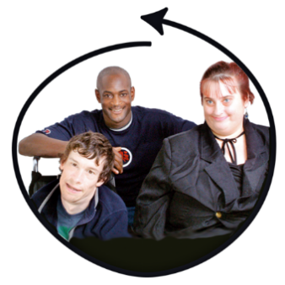
We support organisations to think about how they can include human rights in the work they do.

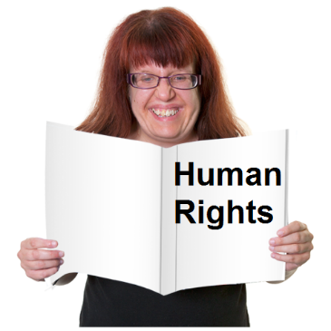
We work on increasing public understanding of human rights. We also do this within communities and groups.

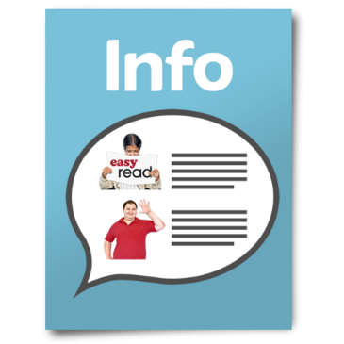

We make information and resources about human rights.

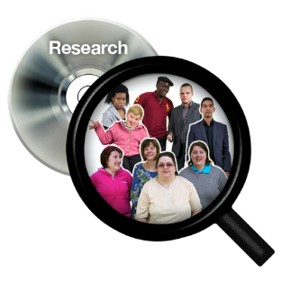
We carry out research. This helps us find out what else we can do to promote and protect human rights.

Who works for SHRC?

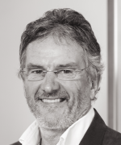
The Chair of the SHRC is Professor Alan Miller. The Chair is the person who leads the organisation.

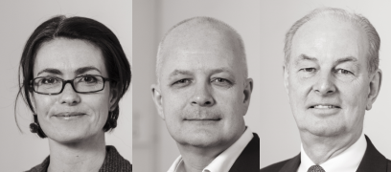
There are 3 part time commissioners. The commissioners work with The Chair to run SHRC.

There are 13 members of staff. They work in 3 teams to support all of the work at SHRC.

What are our duties and powers?

Our duties are the things we must do.
We have a duty to let the people of Scotland know about human rights.

We do this by:
- Giving training

- Making information

- Recommending changes to law, policy and
practice

The European Convention on Human Rights is a law. It protects the human rights of people who live in Europe.

We make sure the rights given by The European Convention on Human Rights are upheld.

Our powers are the things we can do if we wish to.
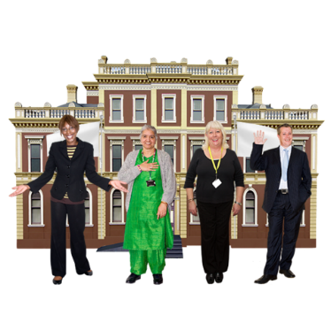
We have the power to look into policy and practice around human rights in Scottish public authorities. This means organisations like councils and NHS boards.

We have the power to go into places like prisons to find out more about human rights.
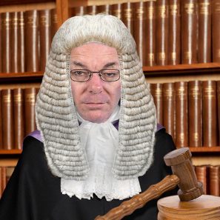
We have the power to get involved in some court cases.

What things can’t we do?

We cannot use our powers to change policy that is made by the UK Parliament in Westminster.

This means policy like immigration (who can come and live in the UK) and defence (the army, navy and air force).

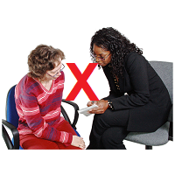
We cannot give advice to members of the public who are wanting to take a human rights case to court.

We were given £933,000 by the Scottish Government to run our organisation in 2014 – 2015. We cannot spend more than this.

What work have we done so far?
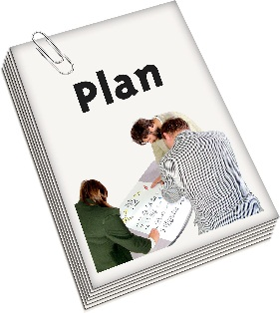
We worked together with other organisations to write a plan that looks after the human rights of everyone in Scotland.
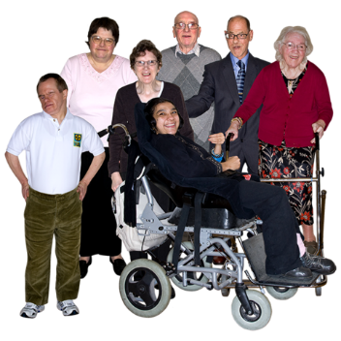

We made training resources and information to do with the care and support of older people.

We made recommendations to Scottish Government to improve law and policy that protects human rights.
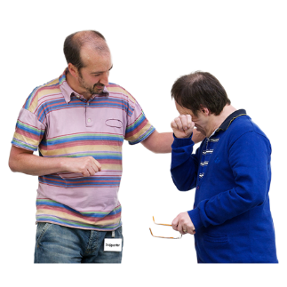

We worked closely with other groups to make a plan to support victims of historic child abuse.
We helped make a website that supports organisations like councils, hospitals and the police to think about human rights in the work they do.
What should our next Strategic Plan focus on?

Your answers to the questions below will help us write our new Strategic Plan.

Question 1

For all parts of this question we want you to think about what is going to happen between now and 2020.

What will be the most important human rights issues in Europe and the wider world?

What will be the most important human rights issues in Scotland?

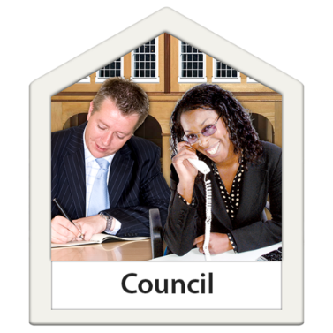

What will be the most important human rights issues in your local authority area?

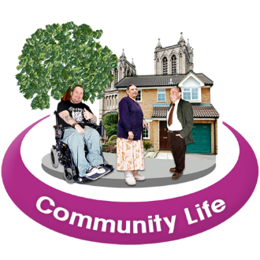
What will be the most important human rights issues in your community?

You can talk about human rights that are important to you and any groups you are part of here.

Question 2
Think about the human rights issues you told us about in Question 1. Which ones are the most important for us to look at between now and 2020?
Please think about what we have told you about our organisation and the type of work we do when answering this question.

Question 3
How can we work better at influencing human rights law and policy in Scotland?

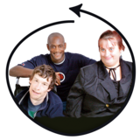
How can we work better to include people and organisations in our work?

We have the power to look at how human rights are being protected and respected in some court cases. How should we use these powers?

How can we learn and share good practice about human rights across the world?

How can we work better to help people and organisations understand human rights?

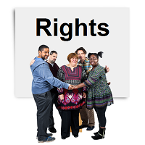

How can we help people and organisations to better promote and protect human rights?

How can we carry out research to find ways of promoting and protecting human rights in Scotland?

How should we let people know about the work we do?

How do you think we can work with all of Scotland’s communities and groups?

How do you think we can be clear and open about the work we do?

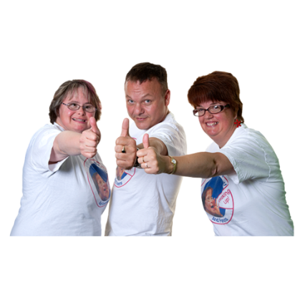

Thank you for taking the time to answer our questions!

Please tell us a little bit about yourself on the form on the next page.

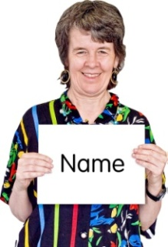 | Your name:
 | Your organisation:
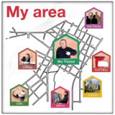 | Which area of Scotland do you live in?
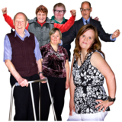 | Are you a member of any groups or campaigns?
Would you like us to keep in touch with you about our work?
Yes No
 | What is your address?
 | What is your email address?

Equal opportunities form
Please fill in as much of this form as you feel comfortable with.
We will separate this form from the rest of your answers as soon as we get it. This means no one will know what you write down.
- Are you?
Female Male
Other gender identity (the way you feel about being a man or a woman)
I’d rather not say

What is your age?
Under 18 55-64
19-24 65-74
25-34 75 +
35-44 I’d rather not say
45-54
- What is your religion or faith if you have
one?

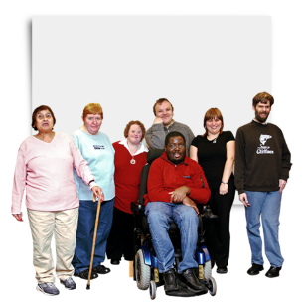
- Do you have a disability?

Yes No I’d rather not say
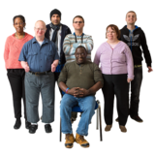
- How would you describe your race or background?

- Are you?
Straight Gay or lesbian Bisexual

Other I’d rather not say

