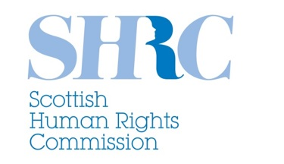
Help with human rights
Who are we?
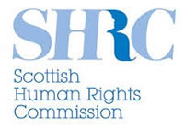
We are the Scottish Human Rights Commission or SHRC for short.

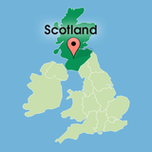

We are an independent organisation. We help look after the human rights of everybody in Scotland.

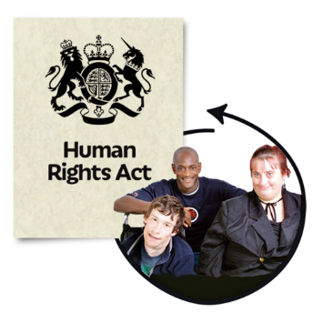
We let people and organisations in Scotland know about human rights.

What are human rights?
Human rights are the rights and freedoms that everyone should have.

Some of our human rights are:

The right to respect for your private life.

The right to respect for your family life.

The right to vote.

The right to freedom of religion.

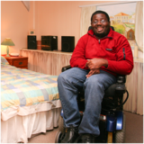
The right to a good enough standard of living.

The rights you have at work.

The right to education.

How are human rights protected?
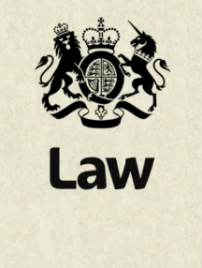
Some human rights are protected in Scottish law.

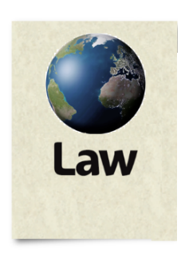
Some human rights are protected in international agreements the UK has signed up to.

Some organisations think about human rights in all of the work they do. This is another way of protecting rights.

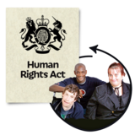
The Human Rights Act is a law about our rights. Some of the rights it protects are the right to life and the right to privacy.

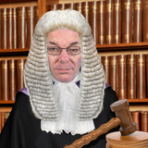
The Human Rights Act means that you can defend your rights in the Scottish courts.

Taking a human rights case to course can cost a lot of time and money.

You should ask a lawyer for advice early on.

The Law Society of Scotland should be able to give you details of lawyers. Their contact details are on page 7 of this easy read.

Help with human rights problems
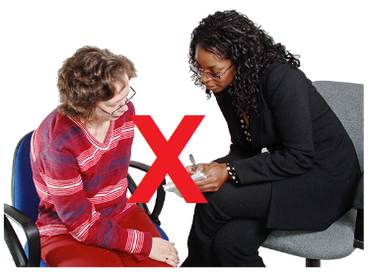
SHRC cannot give advice to individuals about human rights.

We work closely with other organisations and services that can give help and advice.
There is a list of these organisations and services over the page.
Advice and help services
General advice:
The Equality Advisory Support Service (EASS) gives advice and help about equality and human rights.

Website: www.equalityadvisoryservice.com
Helpline: 0808 800 0082
Textphone: 0808 800 0084

The Citizens Advice Bureau gives free advice on a wide range of issues.

Website: www.cas.org.uk
Helpline: 0808 800 9060
Legal advice:
The Law Society for Scotland can help you find a human rights lawyer.

Website: www.lawscot.org.uk
Phone number: 0131 226 7411

Email: lawscot@lawscot.org.uk

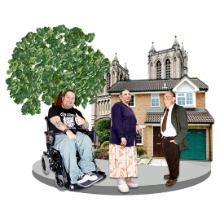
There are Community Law Centres across Scotland. They are usually charities who give legal advice about issues like housing and welfare.
A list of community law centres can be found on our website at www.scottishhumanrights.com

The Scottish Child Law Centre gives free legal advice for and about children.

Website: www.sclc.org.uk
Advice line: 0131 667 6333

Email: enquiries@sclc.org.uk

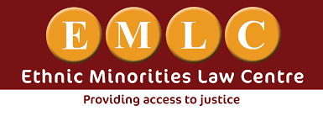
The Ethnic Minority Law Centre gives free legal advice on human rights issues to do with immigration and asylum.

Website: www.emlc.org.uk
Phone number: 0141 204 2888 or 0131 229 2038

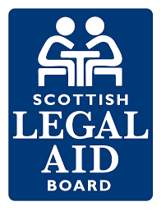
The Scottish Legal Aid Board can give you information on legal aid. This is money given by the government that helps people pay for a lawyer.
Website: www.slab.org.uk

Phone number: 0131 226 7061

Email: general@slab.org.uk

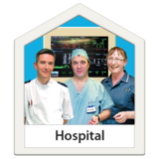
Making a complaint against a public body
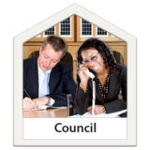
Public bodies include government departments, schools, hospitals and councils.
All public bodies have a complaints procedure. This tells you what to do if you are unhappy with the service you have been given.

The complaints procedure will be on their website. It should be followed before you take the matter further.
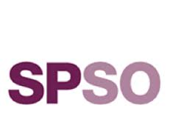
If you have done this but feel the problem has not been sorted out you can contact the Scottish Public Services Ombudsman.

Website: www.spso.org.uk

Phone number: 0800 377 7330

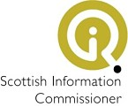
The Scottish Information Commissioner can help with freedom of information requests. Freedom of information is the right members of the public have to ask public bodies for information.
Website: www.itspublicknowledge.info

The Police Investigations and Review Commissioner for Scotland looks at complaints from the public about the police.

Website: www.pirc.scotland.gov.uk

Phone number: 0808 178 5577

Children’s rights
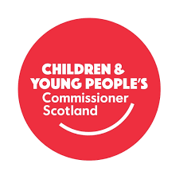
Scotland’s Commissioner for Children and Young People looks after the rights of children and young people in Scotland.
Website: www.sccyp.org.uk

Phone number: 0800 019 1179

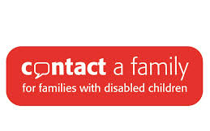
Contact a Family gives information, support and advice to the families of children with disabilities.

Website: www.cafamily.org.uk
Phone number: 0131 659 2930

Health, mental health and care
The Patient Advice and Support Service is an independent service which gives information and support to patients and their carers.
Website: www.patientadvicescotland.org.uk

The Mental Welfare Commission give advice on mental health issues.
Website: www.mwcscot.org.uk

Phone number: 0131 313 8777

The Scottish Association for Mental Health (SAMH) give advice on mental health issues.

Website: www.samh.org.uk

Phone number: 0141 530 1000

Care Information Scotland is a phone and website service giving information about care services for older people.
Website: www.careinfoscotland.co.uk

Phone number: 08456 001 001

The Care Inspectorate work to make sure people get good care and support. They can look into complaints people make about the care and support they get.
Website: www.careinspectorate.com
Phone number: 0345 600 9527

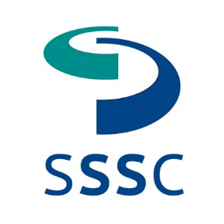
The Scottish Social Services Council is responsible for raising standards in the Scottish social services workforce.

Website: www.sssc.uk.com
Phone number: 0345 60 30 891

Historic abuse
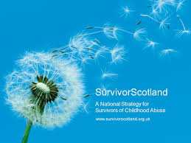
SurvivorScotland give support to anyone who has been affected by historic abuse in care. Historic means things that happened in the past to people when they were children.

Website: www.survivorscotland.org.uk
Helpline: 0800 121 6027

Housing
Shelter Scotland give advice to people on all kinds of housing problems. This means things like homelessness and renting rights.
Advice line: 0808 800 4444
Website: http://scotland.shelter.org.uk/

Immigration and asylum
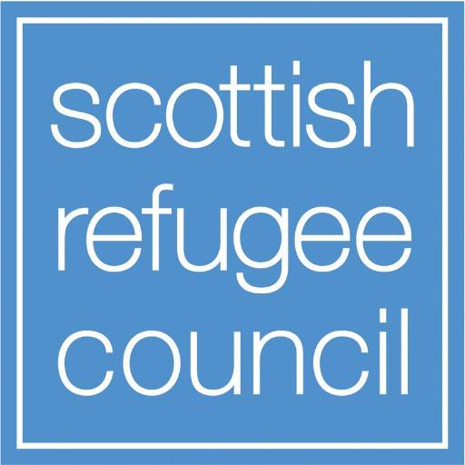
The Scottish Refugee Council gives advice and information to asylum seekers and refugees living in Scotland.
Website: www.scottishrefugeecouncil.org.uk

Phone number: 0141 248 9799

Older people’s rights

There is a Scottish helpline for older people.
Website: www.ageuk.org.uk/scotland

Phone number: 0800 4 70 80 90
Women’s rights

Scottish Women’s Aid works to stop domestic abuse. They give information and support to women affected by domestic abuse.

Domestic abuse is when a family member or someone in your home hurts you.

You can find the contact details of your local Women’s Aid here: www.scottishwomensaid.org.uk/advice-information

The National 24 Hour Domestic Abuse Helpline can be reached on 0808 2000 247.

Help to access advice
The Scottish Independent Advocacy Alliance works with people who need support to talk about their needs and make their own decisions.

Website: www.siaa.org.uk

Phone number: 0131 556 6443

Frequently asked questions
Can you help with my human rights problem?
We do not run an advice service.

We cannot represent individuals or take on their cases.
We can tell you about organisations who may be able to help you.

What does the Scottish Human Rights Commission SHRC do?
We work on human rights issues that affect lots of people.
We respond to Scottish Government consultations on issues that affect human rights. A consultation is when people and organisations are asked what they think about something.
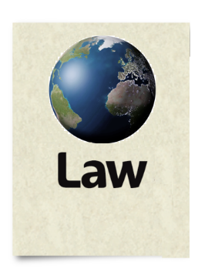
We look at and report on how international human rights laws are working in Scotland.

We are working together with other organisations to put Scotland’s National Action Plan for Human Rights into action.

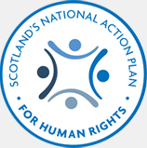
This plan is called SNAP for short. SNAP works to make sure human rights are real for all of us.

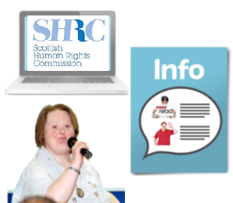

We work on increasing public understanding of human rights.

Can you recommend a human rights lawyer?

We do not keep a list of lawyers.

We cannot recommend a lawyer to you.

The Law Society of Scotland can help you find a lawyer. Their contact details are on page 7 of this easy read.

I’ve tried everywhere you have suggested and no one can help. What do I do now?
We understand this can be very upsetting. It can sometimes seem as if no one is willing to help.
The Scottish Independent Advocacy Alliance can help you to find a local organisation who may be able to help you. Their contact details are on page 19 of this easy read.

How do I take a case to the European Court of Human Rights?
A legal case goes through the courts in the UK first.

You can apply for your case to be heard in the European Court of Human Rights if you think your human rights have still not been upheld.

Your lawyer should be able to give you advice on this.

Contact the Scottish Human Rights Commission
Website: www.scottishhumanrights.com
Phone number: 0131 244 3550

Email: hello@scottishhumanrights.com

