Scottish Human Rights Commission
Governor’s House
Regent Road
Edinburgh
EH1 3DE

Tel: 0131 244 3550
Email: hello@scottishhumanrights.com

Getting to Governor’s House

Location and directions

The Commission is based in Governor’s House on Regent Road, close to the east end of Princes Street.

From the east end of Princes Street continue on to Waterloo Place and straight ahead to Regent Road. Governor’s House is approximately 200 metres along on the right, directly opposite Calton Hill. Access is via a driveway marked ‘Private, Governor’s House’

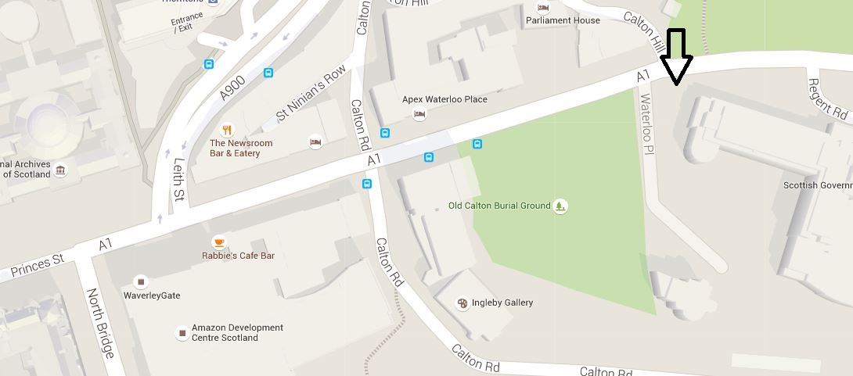

Accessibility

The driveway to Governor’s House is 150 metres long and very steep. If you use a wheelchair or mobility aid, or have difficulty walking uphill, we can arrange access via a taxi. You can also book a free parking space with us.

Public transport

Governor’s House is in the city centre with nearby access to many bus routes. Edinburgh Waverley Station is 5-10 minutes walk away. The nearest tram stop is on York Place, 5-10 minutes walk away.

To plan your trip call Traveline Scotland on 0871 200 22 33 or visit http://www.traveline.info/

Cycling

St Andrew's House is within 1km of the National Cycle Network, which can be reached by greenways running along Princes Street. More information on the National Cycle Network is available on the Sustrans website.
Cycle parking for visitors is available at provided at the front entrance of Governor’s House.
Parking

There are a small number of parking spaces available at the front of Governor’s House. These can be pre-booked with the Commission.

